



United Nations Development Programme
Country: Indonesia
PROJECT DOCUMENT

Project Title: Capacity Development for Implementing Rio Conventions through Enhancing Incentive Mechanisms for Sustainable Watershed/Land Management
UNPDF Outcome(s): Outcome 5: Strengthened climate change mitigation and adaptation and environmental sustainability measures in targeted vulnerable provinces, sectors and communities
UNDP Strategic Plan Outputs:
1.3: Solutions developed at national and sub-national levels for sustainable management of natural resources, ecosystem services, chemicals and waste.
2.5: Legal and regulatory frameworks, policies and institutions enabled to ensure the conservation, sustainable use, and access and benefit sharing of natural resources, biodiversity and ecosystems, in line with international conventions and national legislation.
Expected CP Outcome(s): 2.1 Responsible national institutions and relevant stakeholders are more effective in managing environmental resources
Expected CPAP Output(s): 2.1.1 Government, private sector and CBO partners have coherent and effective policy frameworks, action plans, implementing arrangement and funding arrangement to sustainably manage terrestrial ecosystems
Executing Entity/Implementing Partner: Ministry of Environment and Forestry
Implementing Entity/Responsible Partners: Directorate of Planning, Evaluation, and Watershed Management, Ministry of Environment and Forestry, United Nations Development Programme

Total resources required : US$ 7,480,000
Total allocated resources : US$ 7,480,000
- Regular UNDP (TRAC) : US$ 50,000
- Other:
  - GEF : US$ 1,880,000
  - Government
  - Cash : US$ 0
  - In-kind : US$ 5,500,000
  - UNDP In-kind : US$ 50,000

Programme Period : 2011-2015
Strategic Plan Outputs (2014-2017) : 1.3 & 2.5
Atlas Award ID : TBC
Project ID : TBC
PIMS # : 5224
Start date : 2015
End Date : 2019
Management Arrangements : NIM
PAC Meeting Date : TBD
Brief Description
This project will strengthen a targeted set of policy, legislative, and economic instruments as stronger incentive mechanisms for mainstreaming global environmental obligations. Specifically, the project will do so through the integration of global environmental values and principles within planning frameworks for integrated water resource management (sustainable watershed management). With this focus, the project will strengthen targeted foundational capacities (systemic, institutional, and individual) to reduce pressure on natural resources through competing land uses, identify and test innovative financing mechanisms for sustainable forest management targeted to protecting watersheds, as well as to mainstream synergies and best practices for monitoring impacts and assessing ecosystem services.

Table of Contents
A. Situation analysis 4
A.1 Country Eligibility 4
A.2 Sustainable Development and Global Environmental Values 5
A.3 Country Drivenness 8
A.3.a National Capacity Self-Assessment 10
A.3.b Policy and Legislative Context 11
A.3.c Institutional Context 14
A.3.d Non-State Stakeholders 18
A.3.e Gender Issues 20
A.3.f Barriers to Achieving Global Environmental Objectives 22
B. Strategy 23
B.1 Programme and Policy Conformity 23
B.1.a Guidance from the Rio Conventions 29
B.1.b Project’s Target Contribution to Global Environmental Benefits 30
B.2 Project Rationale 30
B.2.a Linkages with other programmes and projects 31
B.3 Project Goal and Objective 33
B.4 Expected Outcomes and Key Indicators 35
B.4.a Key Indicators 36
B.5. Project Components, Outputs, and Activities 37
B.6 Sustainability, Replicability, Risks, and Assumptions 54
B.6.a Sustainability 54
B.6.b Replicability and Lessons Learned 55
B.6.c Risk and Assumptions 56
B.6 Stakeholder Involvement Plan 58
C. Project Results Framework 59
D. Financing 77
D.1 Financing Plan 77
D.2 Cost-Effectiveness 78
D.3 Co-Financing 78
D.4 Total Budget and Work Plan 81
E. Management Arrangements 84
F. Monitoring Framework and Evaluation 87
G. Legal Context 94
Annex 1: Risk Log 96
Annex 2: Capacity Development Scorecard 102
Annex 3: Social and Environmental Screening 115
Annex 4: Project Monitoring Quality Assurance 123
Annex 5: Integrated Results and Resources Framework per the UNDP Strategic Plan 132
Annex 6: Provisional Work Plan 134
Annex 7: Outcome Budget (GEF Contribution and Co-financing) 146
Annex 8: Terms of References 149
Annex 9: Agreement on the provision of support services (Draft) 158
Annex 10: Supplemental Provisions to the Project Document 161
Annex 11: Site Selection Process 167
Annex 12: GEF Land Degradation Tracking Tool 169
Annex 13: References 179
SIGNATURE PAGE 181
Acronyms and Abbreviations
ACM | Adaptive Collaborative Management
APR | Annual Progress Report
BAPPENAS | National Development Planning Agency
BMKG | Agency for Meteorological, Climatological, and Geophysics
CBD | Convention on Biological Diversity
CCA | Common Country Assessment
CCCD | Cross-Cutting Capacity Development
CCD | Convention to Combat Desertification and Drought
FCCC | Framework Convention on Climate Change
GEF | Global Environment Facility
GEF Sec | Secretariat of the Global Environment Facility
GIZ | German Society for International Cooperation
GoI | Government of Indonesia
M&E | Monitoring and Evaluation
MDG | Millennium Development Goal
MEA | Multilateral Environmental Agreement
MEF | Ministry of Environment and Forestry
MoA | Ministry of Agriculture
MHA | Ministry of Home Affairs
MPW | Ministry of Public Works
NCSA | National Capacity Self-Assessment
NGO | Non-Governmental Organization
NPD | National Project Director
NPM | National Project Manager
PIF | Project Identification Form
PIR | Project Implementation Review
PMU | Project Management Unit
REDD+ | Reducing Emissions from Deforestation and Forest Degradation
RCU | Regional Coordinating Unit
UNDP | United Nations Development Programme
UNPDF | United Nations Partnership for Development Framework

A. Situation analysis

A.1 Country Eligibility
- Indonesia is eligible to receive technical assistance from UNDP, and is thus eligible for support under the Global Environment Facility (GEF). Indonesia ratified the United Nations Framework Convention on Climate Change (FCCC) on 23 August 1994, the United Nations Convention on Biological Diversity (CBD) on 26 November 1994, and the United Nations Convention to Combat Desertification and Drought on 31 August 1998. In addition to these conventions, Indonesia also ratified the Kyoto Protocol on 3 December 2004, thereby committing itself to stabilizing global greenhouse gas emissions for the period of 2008-2012. Moreover, to protect biodiversity from the potential risks posed by genetically modified organisms that are the product of biotechnology, Indonesia subscribed to the Cartagena Protocol on Biological Safety on 3 December 2004.
- Furthermore, in addition to the three Rio Conventions, Indonesia has also demonstrated its commitment to the global environment through the accession or ratification of several other multilateral environmental agreements (MEAs) that call for the protection and sustainable use of natural resources. These include:
- Convention on International Trade in Endangered Species of Wild Fauna and Flora CITES (28 March 1979)
- World Heritage Convention (1 January 1989)
- Vienna Convention for the Protection of the Ozone Layer (26 June 1992)
- Convention on Wetlands (8 August 1992)
- Basel Convention on the Control of Trans-boundary Movements of Hazardous Wastes and Their Disposal (3 December 2004)
- International Treaty on Plant Genetic Resources for Food and Agriculture (1 January 2006)
- Stockholm Convention on Persistent Organic Pollutants (28 September 2009)
- Nagoya Protocol on Access to Genetic Resources and the Fair and Equitable Sharing of Benefits Arising from their Utilization, adopted by the Conference of the Parties to the Convention on Biological Diversity (24 September 2013)
- Rotterdam Convention on the Prior Informed Consent Procedure for Certain Hazardous Chemicals and Pesticides in International Trade (24 September 2013)
- In keeping with the GEF Cross-Cutting Capacity Development Results Framework, this project sets out to meet a key set of underlying capacities (individual, organizational, and systemic) that are common to all three Rio Conventions. Specifically, this project will strengthen a targeted set of policy, legislative, and economic instruments as stronger incentive mechanisms for mainstreaming global environmental obligations. The project is also consistent with the objectives of the GEF’s Strategy on Land Degradation under the Fifth Replenishment, specifically LD-3 that calls for the building of capacities to reduce pressure on natural resources through competing land uses, the development of innovative financing mechanisms for sustainable forest management targeted to protecting watersheds, as well as to mainstream synergies and best practices for monitoring impacts and assessing ecosystem services.
- This project is in line with the United Nations Partnership Development Framework’s (UNPDF) Outcome 5, which is to have strengthened climate change mitigation and adaptation and environmental sustainability measures in targeted vulnerable provinces, sectors and communities. The project is also congruent with the Outcome 2 of the UNPDF, which calls for full participation of civil society in the strengthening of democratic processes” resulting in pro-poor, gender responsive, peaceful, more equitable and accountable resource allocation and better protection of vulnerable groups” (GoI; UN, 2012).

A.2 Sustainable Development and Global Environmental Values
- Indonesia is located in between the Pacific and Indian Ocean and spans two continents: Asia and Australia/Oceania. It is the largest archipelagic country in the world, consisting of 17,508 islands. Of these islands, 13,466 are rather small. Over half of these small islands do not have names, and only 7% are permanently inhabited (Republic of Indonesia, 2015). The five largest islands of Indonesia are: Sumatra, Java, Kalimantan, Sulawesi, and Papua. Indonesia has a tropical climate with two seasons. The dry season spans from April to October and the monsoon season spans from November to March. Indonesia lies across the range of the Inter-tropical Convergence Zone. Due to this location, its rainfall is influenced by different large-scale climate phenomena, such as El Niño Southern Oscillation (Republic of Indonesia, 2015). Since Indonesia is located in the highly seismic Pacific Ring of Fire, it also experiences numerous earthquakes.
- The population is estimated at 242 million with 12% of the population living in poverty and 50% of the nation living near the poverty line (World Bank, 2014a). About 50% of the population lives in rural areas and their livelihoods depend on the agricultural sector (World Bank, 2012). The Human Development Index is 0.684 (2013) ranking the country as 108 out of 187 countries (UNDP, 2013). Indonesia’s population increased from 119 million in 1971 to 237 million in 2010. However, the annual growth rate decreased from 1.98% in 1980-1990 to 1.49% in 2000-2010.
- Indonesia has approximately 187 million ha of land territory, approximately 60% of which is forest, making it the third largest area of tropical rainforest in the world. Seventy percent of this land, or about 131 million hectares, is designated as state-owned forest area. The remaining land mass is privately owned. The National Forestry Plan 2011-2030 divided the 131 million hectares of designated forest area in the following manner: 26.8 million hectares is reserved for forest conservation, 28.8 million hectares is reserved for natural forest and peat land protection, 13.5 million hectares is to be rehabilitated, 32.6 million hectares is reserved for permanent production forest, 24.4 million hectares is reserved for temporary production forest, and 17.9 million hectares is reserved for conversion into non-forestry activities including agriculture, estate crops, settlements, and other development (Ministry of Forestry, 2011). Indonesia also has 23% of the world’s mangroves. The Government estimates that, for each year between 2006 and 2012, around 5.99 million hectares of forest were deforested (Republic of Indonesia, 2015).
- Indonesia possesses large reserves of freshwater, accounting for approximately 6% of the world’s freshwater. There are about 5,500 main rivers, and 65,000 sub-rivers in Indonesia. Many of the rivers are used for transportation and other human activities. Despite the availability of fresh water, many areas in Indonesia have suffered from an inadequate supply of water. Total water demands of the country are 1,074 m³/sec. This water is used for irrigation, domestic use, and municipal and industrial usages. During a normal year, the lowest availability of water is 790 m³/sec. As the population grows and economic development increases, this deficit is likely to increase.
- Indonesia meets its energy needs by using various types of energy including: oil, coal, electricity, natural gas, liquefied petroleum gas, and biomass. The primary energy used is petroleum, followed by natural gas, coal, and electricity. Energy consumption in Indonesia has been growing along with economic and population growth (Republic of Indonesia, 2015).
- Indonesia has the largest economy in Southeast Asia and is an emerging market economy of the world. It is a member of G-20 major economies The GDP in 2012 was 8,230 trillion Rupiah (around US$ 851 billion). The three economic sectors are industry, which accounts for 47% of the economy, services, which accounts for 39 %, and agriculture, which makes up 15%. Industry consists of mining, manufacturing, extraction, and construction. Mining accounted for around 12% of gross domestic product in 2011. Other important sectors in Indonesia are energy and forestry. The energy sector fuels economic activity and creates revenue for the government from the sale of natural resources. According to the National Forestry Plan (2011-2030), Indonesian forests also support the livelihood of 48.8 million people (Ministry of Forestry 2010).
- Despite its strong economic growth, Indonesia still faces many socio-economic development issues. As mentioned above, over 30 million people live in poverty and the rate of poverty reduction is decreasing. Also problematic is Indonesia’s rapidly rising rates of inequality. Its Gini coefficient has risen from 0.32 in 1999 to 0.41 in 2012. Over 65 million people living above the poverty line are highly vulnerable to falling back into poverty. Further complicating the issue is the fact that employment growth has been slower than population growth.
- Rapid urbanization has also led to several problems. Public services remain inadequate; for example, only 68% of the population has access to sanitation facilities. Cities are struggling to keep up with urbanization, and there are vast regional differences. Currently, Indonesia is doing poorly in several health and infrastructure related indicators. Contributing to the problem are fuel subsidies that reduce the budget for infrastructure and social protection (World Bank, 2012; World Bank, 2014a). Rapid economic development and urbanization have also led to a large amount of sewage, industrial pollution, and air pollution. As a result of pollution and inadequate treatment and infrastructure, approximately 30% of the population consumes unsecured and unhealthy drinking water.
- To address a number of these socio-economic issues, one of the objectives of the Government’s 2015-2019 Medium-Term National Development Plan is to deliver a potable water supply to the entire population of Indonesia. Targets include the construction of water supply systems and rainwater reservoirs throughout the country, and increasing access to water taps throughout metropolitan areas. Another national commitment is to increase access to basic sanitation needs by building wastewater infrastructure in 430 cities/districts (serving 34 million people), building communal wastewater treatment systems in 227 cities/districts (serving 3 million people), and building new sanitation landfills in 341 cities/districts (Republic of Indonesia, 2015).
- Indonesia faces environmental issues of deforestation, pollution, land degradation, and over-exploitation of marine and terrestrial resources/species. The main drivers of deforestation and biodiversity loss are international demand, poverty, population pressure, and poor governance. Internationally, there is great demand for Indonesia’s resources such as fish, palm oil, timber, timber products, gold, oil, and gas. To meet this demand, resources are often harvested illegally and in an unsustainable manner.
- One major driver of deforestation and biodiversity loss is palm oil production. Palm oil is Indonesia’s most important agricultural export (UNDP, 2015). The total area of planted palm for harvest exceeds 9 million hectares. Palm oil production is leading to significant habitat loss and degradation. On Kalimantan, land is being converted for palm oil production. This accounts for 26% of the deforestation on Kalimantan from 2005 to 2010. The resulting habitat loss, degradation, and pollution are also driving terrestrial biodiversity loss and species extinction in Kalimantan’s forests. Aside from deforestation, palm oil production causes extensive land degradation and soil erosion associated with forest fires and peat land drainage. Additionally, the application of fertilizer causes water contamination, which harms biodiversity and the local community’s livelihoods (UNDP, 2015).
- The extent of degraded land in Indonesia is increasing rapidly, particularly in the arid zones and due largely to shifting cultivation, misuse of land resources, and over-grazing. As a result, otherwise productive lands have become unproductive as well as diminishing the hydrogeology of the broader watershed. Of the total 458 watersheds in Indonesia, 60 are heavily degraded, 222 are in critical conditions, and the others are potentially being degraded due to improper land use. The Ministry of Forestry has listed 108 priority watersheds to be restored, of which 15 have been slated for improvement in the 2015-2019 Medium-Term National Development Plan.
- Another environmental issue is highlighted in the protected areas system. While the Government of Indonesia has established a large area of national protected areas (for example, on Sulawesi alone there are 63 terrestrial protected areas which make up about 67% of the island) the management remains weak. In fact, the majority of Sulawesi’s forests are considered to be severely degraded. It is estimated that 59.2% of Sulawesi’s lowland rainforests are severely degraded (UNDP/GEF, 2014). The degradation is due to the widespread disregard for protected area’s boundaries and illegal exploitation of resources.
- Illegal activities diminishing land and biodiversity include, logging, harvesting of forest products, wildlife trade, hunting of bush meat, and poaching. These illegal activities threaten Indonesia’s biodiversity, including Indonesia’s endangered species such as the black crested macaques (a primate), anoa (Bubalus quarlesi and Bubalus depressicornis, a type of water buffalo), and babirusa (Babyrus spp in the pig family), and Paedocypris progenetica (a cyprinid fish found in peat swamps and blackwater streams).
- Another environmental issue affecting Indonesia is pollution. In addition to significant pollution from agriculture and urbanization, pollution from mining copper, nickel, and gold is problematic. This pollution leads to habitation degradation and threatens biodiversity and natural resources. A 2007 Ministry of Environment report found that of 35 tested rivers, all were found to be unsafe as a drinking water source. The pollution was caused from industry, agriculture, and households. Air quality in Indonesia is also worsening due to pollution from transportation, forest fires, and industry. Air quality is worse in big cities such as Jakarta, Surabaya, Semarang, Bandung and Medan. Urban pollution is leading to damage to coral reefs near growing cities such as Jakarta.
- One major environmental threat Indonesia faces is climate change. Climate change is expected to result in a warmer climate, more severe storms, longer droughts, rising sea levels, coral bleaching, and ocean warming, to name just a few outcomes. Aside from these changes, climate change is expected to negatively impact agriculture, human health, biodiversity, and livelihoods (ODI/CDKN, 2014). Indonesia is particularly vulnerable to climate change due to its geography and poverty issues. It is predicted that the agricultural sector will be hardest hit by climate change. Other areas that are likely to be negatively affected are health, fisheries, the marine sector, coastal areas, and small islands. According to the National Agency for Disaster Management, 85% of the national disasters that occurred in Indonesia are due to the impacts of climate change. Changing climate variability has resulted in a high intensity of rainfall in a shorter period of time, consequently reducing the capacity of soil to retain the water stock.
- In 2010, Indonesia was ranked as the third largest greenhouse gas emitter in the world, in large part because of the extensive forest fires at the time. Eighty-five percent of Indonesia’s greenhouse gas emissions are the result of land use activities, with 37% due to deforestation and 27% due to peat fires (National Council on Climate Change, 2010). In 2010, Indonesia’s total GHG emissions for CO₂, CH₄ and N₂O without land use, land use change and forestry (LULUCF) and peat fires was 869,929 Gt CO₂-e. If LULUCF is included the total GHG emissions were 1,616,464 Gt CO₂-e. The main sectors contributing to the emissions are: land use change, energy, waste, agriculture, peat fires, and industry (Republic of Indonesia, 2015).

- Indonesia accommodates the second highest value of biodiversity and endemism in the world. While Indonesia makes up only 1.3% of the land surface of the world, it has over 3,305 known species of amphibians, reptiles, birds, and mammals, and has over 29,375 species of vascular plants (World Bank, 2014). According to Indonesia’s Biennial Update Report, it is estimated that Indonesian has over 515 species of mammals, which makes up 12% of the world mammals, 1531 species of birds, or 17% of the birds in the world, 511 species of reptiles, 270 species of amphibians, and 121 species of butterflies. Additionally, Indonesia has over 2,800 species of invertebrates and 4,000 species of trees. Indonesia also has six sites designated as wetlands of international importance. In addition to this diversity, Indonesia is home to extensive coral reef ecosystems (FAO, GEF, 2014).
- Indonesia’s extensive biodiversity is seriously threatened. Of all the coral reefs, only 30% are considered to be in good or excellent condition. Of the country’s original 25 million ha of peat land, only 15 million ha remain. Wildlife is threatened by the rapid deforestation and the unsustainable use of ecosystem services and products. Indonesia has faced a number of challenges in addressing the issues of the loss of biodiversity, climate change and land degradation. To overcome these threats, the Government developed numerous policies such as the Indonesia Biodiversity Strategy and Action Plan, the National Action Programme for Combating Land Degradation in Indonesia, and numerous forestry and climate change initiatives.
- Indonesia has also built a large GEF portfolio of environmental projects, funded by the GEF and other donor agencies. The Government has also designated protected areas, and undertaken numerous other initiatives, such as REDD+. Initiatives related to coastal and marine management are ongoing, such as the Coral Reef Rehabilitation and Management Programme, the Coral Triangle Initiative, a mapping of priority areas for rehabilitation and utilization in marine and coastal areas, and mangrove rehabilitation management initiatives.

A.3 Country Drivenness
- In place of the United Nations Development Assistance Framework (UNDAF), Indonesia prepared the United Nations Partnership for Development Framework (UNPDF), which covers the period of 2011-2015. It is designed to support the country’s effort to meet national development objectives, in particular poverty alleviation, as well as global development objectives as outlined in the Millennium Declaration and the Millennium Development Goals. The three UNPDF objectives are to enhance capacities to deliver benefits, services and economic opportunities for improved livelihoods, promote participation and protect the rights of the poor, and to strengthen national and local resilience to climate change (GoI; UN, 2012).
- The Government has developed several national development strategies including the 2005-2025 Long-Term National Development Plan, the vision of which is a “green” Indonesia, the 2015-2019 Medium-Term National Development Plan, and the 2011-2025 Master Plan for the Acceleration and Expansion of Indonesia’s Economic Development. This new master plan aims to increase growth, increase equity, and transform Indonesia into one of the top ten economies of the world. The plan is based on three strategies, which include promoting centers of growth in each major island group, promoting synergies between the centers of growth, and enhancing connectivity by building human capacities and increasing research and development investments (World Bank, 2012).
- Indonesia is currently undertaking a number of initiatives to address poverty issues, from targeted social development interventions to improve the delivery of basic services, to more integrated social and environment initiatives that engage the private sector and local communities. The 2012-2025 Master Plan for the Acceleration and Expansion of Indonesia Poverty Reduction aims to improve, further, and integrate a wide range of programmes and policies to reduce the poverty. The goal of this plan is for Indonesia to reach a 4-5% poverty rate by 2025. The plan focuses on two main areas, health, and education.
- Presidential Regulation Nº 10 (2010) on Accelerating Poverty Alleviation established three clusters of programmes to hasten poverty alleviation. The first cluster includes: the Subsidized Rice for the Poor Programme, the National Health Insurance Programme, the Family Hope Programme, the Cash Transfers for Poor Students, and the School Operational Assistance Programme. Cluster two includes the Community Empowerment Poverty Alleviation Programmes/National Programme for Independent Community Empowerment, which entails 12 poverty alleviation programmes. Cluster three includes the Credit for Businesses Programme.
- The Acceleration of Poverty Reduction regulation also established an ad hoc national working group, which is chaired by the Vice President, to accelerate poverty reduction. The working group is responsible for designing and integrating poverty reduction policies and programmes into national development plans, as well as overseeing their implementation.
- With direct relevance to the three Rio Conventions, Indonesia has prepared important national assessment reports and strategies that reflect the country’s progress to date and priorities to meeting global environmental outcomes. For the CCD, the Government developed the National Action Programme for Combating Land Degradation in Indonesia in 2002. This programme is part of the National Development Programme. The objective of this programme is to identify the factors contributing to land degradation and to ascertain measures to mitigate the effects of drought and combat degradation.
- The National Action Programme (NAP) for Combatting Land Degradation is aimed at strategizing a national programme of action to address drought mitigation and relief promote partnership with local community, particularly in the driest provinces in Indonesia, namely East Nusa Tenggara, West Nusa Tenggara, and Central Sulawesi (Sulteng). The Government of Indonesia has also developed a number of programmes on community-based forest and watershed management that aim to address the inequitable distribution of benefits from forest resources as well as to address the very low level of coordination among stakeholders and sectors, both of which are major underlying causes of land and forest degradation.
- Through the 2015-2019 Medium-Term National Development Plan, the Government has committed approximately US$ 300 million to rehabilitate degraded forest and land in 108 watersheds located in 400 districts (33 provinces). Over and above this amount, the Government has committed an annual contribution from the Reforestation Fund under the national budget and Forestry Special Allocation Funding to undertake reforestation and land rehabilitation at the district level.
- With respect to the Framework Convention on Climate Change, Indonesia has set voluntary targets for reducing greenhouse gas (GHG) emissions by 26% through domestic resources, and up to 41% with international support by 2020. To operationalize these GHG reduction targets, the Government developed the National Action Plan to Reduce Greenhouse Gas Emissions and the Provincial Action Plans to reduce Greenhouse Gas Emissions. With the exception of one of the country’s 34 provinces, all have completed their action plan.
- These provincial action plans guide line ministries in planning, implementation, monitoring, and evaluation, while the National Action Plan guides provincial governments in formulating and implementing regional action plans for reducing GHG emission. The national and provincial plans also guide the community and private sector in the planning and implementation of GHG emission reduction initiatives. The Government has also completed the Second National Communication and is in the process of completing the FCCC Third National Communication.
- Indonesia’s National Action Plan for Climate Change Adaptation is a cross-cutting thematic plan that is designed to (i) guide mainstreaming climate change adaptation issues into the national development planning process,(ii) guide sectoral and cross-sectoral climate change adaptation in the short-term (2013-2014), medium-term (2015-2019), and long-term (2020-2025); (iii) guide short-term priority adaptation actions; and (iv) guide sector and local government in developing adaptation actions as well as efforts to design communication and coordination systems. The National Action Plan on Climate Change Adaptation also strengthens endeavors under the National Action Plan to Reduce Greenhouse Gas Emissions. It is part of Indonesia’s national development framework; it is meant to be a planning guide, it is not a document with formal legal power. One benefit of the Action Plan for Climate Change Adaptation is the improved coordination between line ministries and other stakeholders, such as the private sectors, non-governmental organizations, international cooperation agencies, universities, and research institutes.
- For the CBD, the Government developed the National Biodiversity Strategy and Action Plan and has recently updated it to align with the new global biodiversity targets. The National Biodiversity Planning to Support the Implementation of the CBD 2011-2020 Strategic Plan in Indonesia project concluded in 2014. The objective of this project was to reinforce the framework for implementing Indonesia Biodiversity Strategy and Action Plan and to mainstream Indonesia’s obligations under the Convention on Biological Diversity into its national development and sectoral planning frameworks. Prepared in 2014, Indonesia’s Fifth National Report to the CBD includes a chapter that responds to progress made to achieve the Aichi Targets.

A.3.a National Capacity Self-Assessment
- Indonesia completed its National Capacity Self-Assessment (NCSA) in 2005. The NCSA was implemented in five stages. The first stage was the inception process. The second stage focused on collecting data on the country’s national implementation of the three conventions. The third stage involved determining the capacity building priorities and carrying out an assessment of the implementing capacity of each convention. The fourth stage focused on an assessment of the cross-cutting interactions of convention implementation. The final stage involved developing a draft Action Plan.
- The NCSA processes identified priority thematic issues that cut across the Rio Conventions, which include: deforestation, land, coastal and marine degradation, and drought and floods. In particular, the degradation of land and watersheds is accelerating because of growing population, urbanization, unsustainable use of natural capital, changing climate, weak governance, limited transparency in procedures, and lack of inclusive decision making processes.
- The NCSA identified three types of barriers that explain Indonesia difficulty in fulfilling the obligations of the Rio Conventions, namely: systematic, institutional, and individual barriers. The main barriers at the system level include inadequate policy, law, regulation, and implementation. More specifically, these barriers consist of non-legally binding formal documents, only partial implementation of the action plan for each convention, political statements endorsed by government institutions that do not support the goals of the convention, and the fact that the legislative and regulatory frameworks remain weak.
- Barriers at the institutional level include: (i) institutional mandates; (ii) coordination, collaboration, and cooperation; (iii) communication, education, public awareness and information exchange including technology transfer; and funding. Financial barriers stem from the fact that the frameworks to set and promote economic incentives to address the Rio Conventions are absent. In Indonesia, ecosystem services do not have a set monetary valuation system, thus consumers do not receive the proper price signals. Additionally, existing subsidies, taxes, and other fiscal measures distort the true values of the environment/ecosystems, thereby fueling the unsustainable use of natural capital. Individual barriers include low individual expertise and motivation, and low levels of awareness and information exchange (State Ministry of Environment, 2005).
- The NCSA proposed a number of recommendations to improve Indonesia’s fulfillment of its obligations under the three Rio conventions and their respective protocols. The recommendations include:
- Review and develop the implementation, reaffirming authority among central and regional levels
- Develop a general regulation on the economic incentives, which are valid for the three conventions
- Develop a dispute settlement procedure, through an out of court settlement for each convention
- Develop a networking mechanism for the three conventions (including updating, standardization, access to and exchange of information)
- Formulate and develop an environmental court system
- Formulate and revise the related regulation in implementing the three conventions by taking into account the economic instrument
- Review, revise and harmonize the regulations and policies related to each convention
- Develop a regulation under Law Nº 23 related to the definition of environmental degradation, criteria, conflict settlement mechanism, and compensation
- Improve the capacity of police investigators, Government Officer Investigator/Environmental Officer Investigator and legal practitioners
- Develop an effective law enforcement system related to the three conventions
- Develop an effective dissemination system that reaches all stakeholders in terms of development of legislation
- Develop the national committee for each convention
- Establish and develop a coordinating mechanism at national and regional levels for each convention
- Improve effective information exchange and access through the establishment of a fast and appropriate mechanism, thus reducing bureaucracy, and through the development of clearing houses for the three conventions
- Optimize the human resource management (recruitment, placement, career path, sanction and award system) in implementing the three conventions
- Optimize the use of financial resources (domestic and foreign) that every stakeholder adopts
- Maximize funding access, exploring domestic and foreign nongovernment financial resources
- Disseminate an annual report on the progress to meeting line ministries’ strategic plans and other national reports to the public
- Identify training needs related to the implementation of each convention then develop a training strategy related to the implementation of each convention
- Implement education and training on how to apply each convention
- A number of these recommendations are no longer applicable however. Since 2005 there have been numerous policy changes in Indonesia. For example, in 2007 Indonesia hosted the FCCC COP-13, which produced the Bali Action Plan, which consists of four pillars to address the global climate change issues. These pillars include mitigation, adaptation, finance, and technology transfer, including capacity building. Six months after the Bali COP-13, the Government established the National Council on Climate Change. According to the Presidential Decree Nº 46/2008, the National Council on Climate Change was mandated to coordinate, facilitate, and synchronize line ministries, NGOs, the private sector, academia, researchers, and other stakeholders to undertake climate change mitigation and adaptation policies and measures. Additionally, the National Council on Climate Change was also required to develop a carbon trade mechanism and, with the approval of FCCC, act as the vocal point for FCCC negotiations. However, in 2015 the National Council on Climate Change was terminated and its mandates were transferred into the newly established Ministry of Environment and Forestry (MEF).

A.3.b Policy and Legislative Context
- Indonesia’s commitment to the environment begins at the highest legal level, through its Constitution, signed in 1945. Article 33 states that the national economy should be carried out with an environmental perspective. Article 28H provides for the right of everyone to enjoy a healthy environment.
- Currently, Indonesia has thousands of regulations and legislation related to environmental management and protection. Law Nº 5/1990, the Natural Resources Conservation and Ecosystem Law, was the first law after Indonesia’s independence to cover ecosystem and species-level conservation. The law provides for two types of protection. The first one covers the establishment and management of two types protected areas, i.e., Nature Reserves and Wildlife Sanctuaries, and Natural Conservation Areas. This law also protects individual species through the regulation of the identification of endangered species and by enforcing sanctions for endangered species related crimes.
- One key national legal instrument is Act Nº 32 of 2009 the Environmental Protection and Management Act. The goal of this law is to further environmentally sustainable development through environmentally focused planning, management, maintenance, and restoration. This is to be achieved through an environmental inventory, an establishment of ecoregions, and the formulation of environmental protection and management plans.
- Indonesia’s National Action Plan to Reduce Greenhouse Gas Emissions (2011) is an example of the country’s commitment to reduce GHG emissions by 26% (from business as usual) by 2020 through national efforts, and by 41% with international support. One objective of this plan is to design national and local programmes to reduce the GHG emissions, focusing on forestry, peat lands, energy, and agriculture. Currently, Indonesia has thousands of regulations and legislation related to industrial development, transportation, and environmental management, all of which have important implications for reducing GHG emissions. The National Action Plan is plan calls for addressing deficiencies in these sectors and the alignment with the 2005-2025 Long-Term Development Plan and the 2015-2019 Medium-Term National Development Plan.
- Presidential Regulation Nº 71/2011 on the Implementation of National GHG Inventory in Indonesia mandates that different bodies of the government produce national, local and corporate GHG inventories annually. Under the regulation, line ministries prepare sectoral GHG inventories and report them to the former Ministry of the Environment. The newly merged Ministry of Environment and Forestry coordinates and prepares the national GHG inventory for submission to the FCCC. The goals of this decree are to increase the use of local emission factors, guarantee that quality control and quality assurance are applied to data and GHG emission calculation and mitigation activities, and to promote the coordination of GHG inventory efforts by ministers at the national level, governors at provincial level, and by mayors/regents at district/municipal level.
- One fundamental forestry and land degradation law is the Forestry Law Nº 41 of 1999. Article 4 of this law states that all Indonesia forests and associated natural resources are controlled by government for the prosperity of the people. Forests are divided into three management categories: Conservation Forests, Protection Forests, and Production Forests. This law also guides land management practices to minimize land degradation through land rehabilitation practices that are based on specific biophysical conditions as well as through stakeholder participatory approaches that help empower local communities.
- Presidential Regulation Nº 37 came into effect in 2012 and specifically regulates watershed management integration from up-stream to down-stream areas. This regulation aims to rehabilitate and increase the carrying capacity of degraded watersheds, thus increasing the water quality, quantity and sustainability for the benefit of individuals. This regulation underlines the importance of integrated watershed management, which necessitates including cross-sectored line ministries at the central government, and local authorities at the provincial, district/city levels, as well as community participation. The integrated watershed management is carried out on the basis of existing spatial planning and the water resources management scheme in accordance with the laws and regulations. In 2014, the Parliament adopted Regulation Nº 23/2014 on Autonomy, which returns autonomy back to the provincial authorities. From the perspective of watershed management, this is a positive step, as this autonomy will allow provincial governments to manage an integrated watershed that is administratively occupied by several district authorities.
- One of the most controversial issues related to watershed management is the recent withdrawal of Law Nº 7/2004 regarding water resource management by the Constitutional Court. One of the justifications to the withdrawal is that the law resulted in a monopolization of water resources by domestic and foreign investors for commercial purposes. This monopolization contravened Article 33 of 1945 Constitution. After its withdrawal, government regulation on water resource management reverted to Law Nº 11/1974 on irrigation. As of mid-2015, the Ministry of Public Works (MPW) is working on a new regulatory framework for water resource management.
- This change in law has led to positive and negative outcomes for Indonesia. One positive outcome is that the access to water has been returned to the state-owned and public domain, for the greatest benefit of Indonesia’s people, as stipulated in the 1945 Constitution. One negative outcome is that production levels and the distribution of water are no longer guaranteed due to restrictions on investors. Private and foreign investors, in particular, are no longer allowed to continue their business in this sector. Instead, the local state-owned company Perusahaan Daerah Air Minum will be responsible for taking care of production and distribution.
- The Forest Administration and the Formulation of Plans for Forest Management (regulation 34/2002) was designed to be the implementing regulation for three parts of Law 41/1999. This regulation was the first extensive clarification, since the enactment of Law 41/1999, on the national Government’s regulatory framework for forest-related activities such as the classification of state-controlled forest lands and the harvesting, processing, and marketing of forest products. This regulation gave the national Government far-reaching authority to control timber extraction in areas designated as production forest. Specifically, the regulation gave the Minister of Forestry sole authority to issue commercial timber utilization permits.
- With growing deforestation concerns, the Government has approved numerous other forestry laws. Presidential Instruction 10/2011, which calls for the Suspension of Granting of New Licenses and Improvement of Governance of Natural Primary Forest and Peat Land, was signed in 2011 to reduce greenhouse gas emissions from deforestation and forest degradation. This instruction placed a two year moratorium on issuing of licenses. In 2013, Law Nº 18 extended the moratorium for another two years, and delivers on an agreement with the Government of Norway to reduce GHG emissions. It was signed to improve forest and peat land governance forest to reduce emissions from deforestation and forest degradation.
- The Prevention and Eradication of Deforestation (2013) protects Indonesia’s forest and establishes severe penalties for illegal logging or occupying forest areas protected by the government. As part of the 2010-2014 Strategic Plan of Ministry of Forestry, the Government set a target to establish 600 forest management units in five years (12 per year). These units are responsible for both managing and monitoring forests, and involving local communities in forest management.
- In June 2012, the Government issued their National REDD+ Strategy, the long-term goal of which is to transform Indonesia’s forests and land, through implementation of appropriate policies for sustaining economic and ecosystem service functions, into a net carbon sink by 2030. The institutional arrangements to implement this strategy changed as a result of the creation of the new Ministry of Environment and Forestry (See paragraph 60).
- The Spatial Planning Law 26/2007 requires spatial planning (land use planning) for all provinces and districts. This law also requires that ecological considerations be taken into account through strategic environmental assessments.
- To address biodiversity concerns, the Government has passed numerous laws and policies. Regulation Nº 28/2011, Management of Nature Reserves and Conservation Areas encourages management of protected areas in ways that both conserve biodiversity and help to increase the welfare of local communities. Indonesia also has numerous species-specific national strategies and action plans aimed at protecting biodiversity. For example, in Sumatra there is the National Strategy and Action Plan for Sumatran Tiger, Rhinoceros, Orangutan, and Asian Elephant. There is also a strategy and action plan for human-wildlife conflict.
- Other key environmental policies include:
- Regulation 19/1999 regarding Control over Marine Pollution and/or Damage
- Regulation 27/1999 regarding Environmental Impact Assessment
- Regulation 41/1999 regarding Air Pollution Control
- Regulation 4/2001 regarding Environmental Damage and/or Pollution Control related to Forest and Land Fire
- Regulation 74/2001 regarding Toxic and Hazardous Substances
- Regulation 82/2001 regarding Water Quality Management and Water Pollution Control

A.3.c Institutional Context
- The proposed project will cover the issues of biodiversity, land degradation and climate change, which are intricately linked with overall national development. These global environmental issues are also central in promoting inclusive and equitable growth, which has been one of top priorities for the Government. Due to the multi-faceted nature of the project, a multitude of stakeholders will be engaged. The key government stakeholders in Indonesia are a number of governmental ministries and agencies.
- The main government ministries that perform the functions of environmental management are: the Ministry of Environment and Forestry, the Ministry of Agriculture (MoA), the Ministry of Public Works, and the National Development Planning Agency (BAPPENAS). In January 2015, through Regulation Nº 16/2015, the new administrative Government formulated a new ministerial structure. The Ministry of Environment merged with the Ministry of Forestry, and was named the Ministry of Environment and Forestry. The Regulation also officially terminated the mandates given to the REDD+ Agency and the National Council on Climate Change, and subsequently transferred their mandates into the newly established Ministry of Environment and Forestry. Before the merger, the former Ministry of Forestry had a specific programme and targets covering all nature reserves and conservation areas across Indonesia. This programme was not changed under the merger. The programme identifies 12 priority provinces and 51 priority national parks.
- In 2009, the Government established the National Forestry Council. This advisory body of the former Ministry of Forestry is comprised of numerous stakeholders, including government officials, private sector, and other key stakeholders, which among other tasks, is responsible for mediating land conflicts. From a legal aspect, the Council is weak because it was not established by a Presidential Regulation, but rather a decree of the Ministry of Forestry. This council will remain the same under the new structure.
- With the new structure, the MEF will take over the climate change focal point from the National Council on Climate Change. Thus, the MEF is in charge of managing the three Rio Conventions, and the focal points for reporting to the Conventions. Additionally, the MEF will host the National GEF Secretariat office in the near future. The MEF is also responsible for coordinating implementation with other institutions at the national and local level.
- As part of the new structure, the Directorate General of Forest Protection and Nature Conservation has been renamed as the Directorate General of Natural Resource Conservation and Ecosystem, and granted the same mandates and responsibilities as before. These mandates include planning and implementing policy related to forest protection, nature conservation, forest protection, protected area management, biodiversity conservation and nature recreation. Responsibility for the forest fire control was transferred into the new Directorate General of Climate Change.
- Under the old structure, within the Directorate General of Forest Protection and Nature Conservation, the Directorate of Utilization of Environmental Services from Conservation Areas and Protection Forest used to be in charge of the development of norms, standards and criteria for evaluating environmental services, marketing, promoting nature conservation, planning, and implementing policy related to ecotourism in protected areas. The Directorate for Conservation Areas and Management of Protected Forests used to be responsible for developing norms, standards, criteria, and procedures for protected areas. This directorate was also responsible for protected area management, wetland monitoring, and development of buffer zones surrounding national parks. The Directorate of Biodiversity Conservation used to be responsible for safeguarding biodiversity. This directorate also used to develop norms, standards, criteria and procedures for implementing biodiversity conservation initiatives. The Directorate of Investigation and Forest Protection used to be in charge of forest crime prevention and law enforcement. This directorate used to gather reports on illegal logging, poaching, forest arson, encroachment, and illegal mining cases. Additionally, this directorate used to offer training for forest rangers and used to provide manuals for wildlife identification. All of these functions will remain the same until the new names and structure of the Directorates under the MEF are settled.
- With the new ministry structure, the Directorate General of Watershed Management and Social Forestry has been renamed Directorate General of Watershed Management and Forest Protection. As mentioned above forests in Indonesia are divided into three management categories: Conservation Forests, Protection Forests, and Production Forests. The Directorate General of Watershed Management and Forest Protection is responsible for formulating and implementing policies on watershed management, Protection Forest management, Plantation Forest and its maintenance, rehabilitation of terrestrial water ecosystem, forest and land rehabilitation, and soil and water conservation. Additionally, the Directorate General of Watershed Management and Forest Protection is responsible for developing criteria, standards, and procedures for watershed management and forest protection management. Moreover, the Directorate General of Watershed Management and Forest Protection is in charge of coordinating and synchronizing their tasks, supervising the implementation of watershed management policies. The Directorate General of Watershed Management and Forest Protection appointed the Directorate of Watershed Planning and Evaluation as the focal point for CCD.
- At the regional and provincial level, the former Directorate General of Watershed Management and Social Forestry is now the Unit for the Implementation of Watershed Management Unit. In 2014, Law 32/2007 was changed through Law 23/2014 that gave authority for forest management from the district government to the provincial government. There are 36 Watershed Technical Implementation and Management Units currently in operation, covering more than 400 watersheds in Indonesia. In addition, there is a Watershed Technology Research Center located in Surakarta, Central Java, which is working to provide technical guidance on the basis of scientific findings.
- The National Development Planning Agency (BAPPENAS) is responsible for national economic and development planning. Additionally, it is responsible for developing strategies and policies for financial allocation for the various sectors of the national economy, including mainstreaming and coordinating the environmental programmes and budgeting them into the national development planning system. This includes the 2005-2025 Long-Term National Development Plan, the 2015-2019 Medium-Term National Development Plan, and the Annual Development Plan. Through Regulation 61/2011, BAPPENAS is required to formulate the National Action Plan to Reduce Greenhouse Gas Emissions at national and provincial level. Presently, BAPPENAS is also working on formulating the concept of Intended National Determined Contribution. This is part of the latest FCCC agreement, in which every participating country is asked to help reduce the global GHG emission in order to meet the 2020 reduction target.
- Responsibilities related to climate change mitigation are divided among ministries. With respect to the National Action Plan to Reduce Greenhouse Gas Emissions, the BAPPENAS coordinates inputs from line ministries and reports progress to the Coordinating Ministry for Economy. Other ministries plan, implement, monitor, and evaluate the National Action Plan to Reduce Greenhouse Gas Emissions activities under their responsibilities.
- The Ministry of Agriculture is responsible for conservation and use of agriculture resources. In the context of the Rio Conventions, and land degradation in particular, the MOA is responsible for formulating and implementing policy for land management, land degradation, irrigation, finance, fertilization and pesticides, and provision of agricultural machinery. The Directorate General of Agriculture Facilities and Infrastructure is responsible for executing the MOA’s tasks. Additionally, the Agency for Agriculture Research and Development is in charge of providing data and information, as well as research findings related to climate change adaptation and mitigation, and biodiversity in the agricultural sector. Based on research findings, the implementation of climate smart agriculture, i.e., producing agricultural crops and green food with low GHG emission, while at the same time conserving soil for sustainable production, has resulted.
- Under the auspices of the Agency for Agriculture Research and Development, there are at least three research institutes and two research centers working on environment-related research topics. These research institutes include: the Indonesia Agricultural Environment Research Institute located in Jakenan, Central Java, the Indonesia Soil Research Institute based in Bogor, and the Indonesia Swampland Agriculture Research Institute in South Kalimantan. The two research centers are the Indonesia Research Center for Biotechnology and Genetic Resources and the Indonesia Center for Agricultural Land Resources Research and Development. The three research institutes along with the Indonesia Research Center for Biotechnology and Genetic Resources are working under the coordination and supervision of Indonesia Center for Agricultural Land Resources Research and Development
- The Ministry of Home Affairs (MHA), in particular the Directorate General of Regional Development and the Directorate General of Regional Autonomy, is responsible for formulating and implementing national policy on decentralization, and maintaining regional administration, provincial and district development. In the context of Rio Conventions, the Ministry of Home Affairs, among others ministries, is in charge of supervising sustainable development undertaken in provincial, and district/city governments located in watershed areas. The MHA is an important stakeholder that can help mediate conflicts of interests among provinces, districts, and municipalities in terms of unsustainable land use.
- The Ministry of Public Works is responsible for infrastructure development and spatial planning. It develops initiatives for disaster-risk preparedness, and management in response to disasters such as floods, droughts, and mudslides. This ministry has also develops approaches for flood mitigation, and records data on the water balance for each major island.
- The Indonesia Agency for Meteorological, Climatological, and Geophysics (BMKG) is responsible for formulating national policy and technology in the area of meteorology, climatology, and geophysics. This agency is also responsible for providing a database and information on these three areas as they relate to climate change and disaster risks management in particular. The Agency for Meteorological, Climatological, and Geophysics also conducts research, analysis, and training on meteorology, climatology, and geophysics.
- The Indonesian Institute of Science is the governmental authority for science and research. It is made up of 47 research centers from various fields including social and natural sciences. The former Ministry of Forestry collaborates with the Indonesian Institute of Science for species conservation work.
- Indonesia has a highly decentralized governance structure. It is composed of 34 provinces. These provinces are divided in regencies and cities, which are further subdivided into districts. There are 398 districts, 93 cities, and 6,694 sub-units. There are also 69,429 village units. A number of government bodies operating at both the national and local levels are responsible for natural resource and environmental management, working with local community organizations, and in some cases partnering with NGOs to undertake specific activities. Since 2002, the Government has been decentralizing natural resource management and environmental activities. Thus, provincial and district authorities play a critical role in environmental efforts.
- Indonesia has undertaken numerous actions to increase coordination and collaboration between groups. In the forestry sector, coordination efforts include the Coordinating Group of Indonesian Forestry. Stakeholders that participate in this group include international forestry donors/agencies, the private sector, NGOs and the Ministry of Forestry. As part of this effort, a working group is assigned to coordinate planning and implementation of land rehabilitation and watershed management.
- To increase coordination in forest fire and disaster management, in 1995, the National Co-ordination Team for Land and Forest Fires Control was formed. With the newly established Ministry of Environment and Forestry, the Team may be headed by the Director General of Climate Change. However, this is yet to be confirmed. The National Disaster Management Coordination Board was also established to increase co-ordination, consultation and information exchange. Coordination efforts are also made within projects within Indonesia such as GEF funded projects, and REDD+.
- To facilitate better coordination of climate change mitigation and adaptation efforts, the Minister of National Development Planning issued Decree Nº Kep.38/M.PPN/HK/ in March 2012. This Decree established the Climate Change Coordination Team that is made up of a steering committee and six working groups which include agriculture, forestry and peatlands, energy, transport and industry, waste management, and other supporting and cross-sectoral issues. This team coordinates across line ministries at the central level.
- The Watershed Management Coordination Forum is an institutional arrangement among the Government of Indonesia as the regulator, an operator that is an institution that has the responsibility for the daily operation or management of a certain watershed; a developer whose function is to create and manage infrastructure and facilities for integrated water resource management; and the user, which comprise all those social actors (individuals and civil society organizations). The latter user is divided into two groupings: those that need water as a public good, e.g., agriculture, and those that need water as an economic good, e.g., urban sector. Such a coordination forum was established for the Brantas watershed, which has the authority to propose and decide on water allocation plans as it seeks to balance demand for agricultural development. (Rahmawati, Yustika, Ashar, & Santoso, 2014).
- Despite these efforts, coordination is not systematic among key initiatives, leading to inefficiencies and unnecessary redundancies; as well as missed opportunities for synergies and learning of best practices. There is a need to establish a mechanism for systematic coordination and a greater exchange of information and knowledge.
- There are a number of relevant programmes and projects in addition to those mentioned above and those currently under implementation or planned (see B.2.a below) upon which this CCCD/SLM project benefits from. The Climate Change Unit of the Fiscal Policy Agency of the Ministry of Finance has conducted the Climate Public Expenditure and Institutional Review, and produced the Mitigation Fiscal Framework Report. The Government has expressed keen interest to proceed with specific Climate Public Expenditure and Institutional Review follow-up actions and has requested the UNEP Poverty-Environment Initiative support. The UNEP Poverty-Environment Initiative preparatory phase has been initiated. A Preparatory Initiation Plan has been developed in conjunction with the UNDP CO, and outlines key PEI activities for 2013/2014 and is a precursor to the development of a Project Document for a long-term programme. The key development partners in Indonesia for this work include DFID and AusAid.
- The Strengthening Community Based Forest and Watershed Management (SCBFWM) Project was a USS 7 million GEF project that ran from 2009-2014 and was implemented by the Ministry of Forestry with assistance from UNDP. The main objective of SCBFWM was reducing forest and land degradation to restore watershed functions and ecosystem services. The project improved six critical watersheds/sub-watershed located in nine districts of six provinces covering approximately 500,000 ha with different biophysical, and social characteristics in Indonesia.
- The project also performed important roles in facilitating and coordinating the cross-cutting stakeholders and sectors into integrated watershed management programs. One hundred forty-eight Community Based Organizations (CBOs) were involved in protecting the forests and restoring degraded lands through various activities during the project’s execution. Additionally, more than 2.7 million trees were planted during the course of the project which is equivalent to 6.8 thousand hectares of degraded land. The project promoted biodiversity conservation sites by protecting endangered, endemic, and valuable species, such as Styrax Sumatran in North Sumatra, and Pimpinella purwacan in Central Java. One of the valuable outcomes and lesson learned of this project is the establishment of a watershed management regulation at a district level. The project has successfully supported the District of Banjarnegara, Central Java in realizing such a regulation.
- Indonesia is now completing the Third National Communication to be reported to the United Nations Framework Convention on Climate Change by the end of 2015. The National Communication reports is funded by the National Communications Support Program, which is of GEF funded project jointly managed by UNDP and UNEP. The primary objective of the National Communications Support Programme is to provide technical and policy support for preparing National Communications. Besides this communication, Indonesia is also preparing the Biannual Update Report as requested by UNFCCC. The Biannual Update Report will be financed as a component of National Communications Support Programme.

A.3.d Non-State Stakeholders
- In Indonesia, numerous non-state stakeholders play important roles in environmental management. These other stakeholders include NGOs, the private sector, and academic institutions that are important to ensuring the long-term sustainability of the project. Stakeholders are not only present at the national level, but at the field level, i.e., districts and city levels. Among the stakeholders from the academic and research community are representatives from the Forest and Nature Conservation Research and Development Center, and the Forest Research Institutes.
- Universities and research institutions have been the driving force for creating innovative solutions for sustainable land management and other multidisciplinary approaches. Universities have also accumulated collections of environmental data. In addition to these collections, universities provide trainings on environmental management to both undergraduate and graduate students, many of whom later work for environmental NGOs. Members of universities also serve as members of the working groups for the REDD+ Taskforce.
- A number of environmental non-governmental organizations are working with the government to strengthen capacities for improved environmental governance and management, such as awareness-raising, land rehabilitation, and monitoring of drought. These include The Nature Conservancy, World Wide Fund for Nature and Natural Resources, Fauna and Flora International, World Conservation Society, and Zoological Society of London work. A number of NGOs are also acting act as implementing partners on certain GEF-funded projects and serve as members of working groups for the REDD+ Taskforce. NGOs such and contribute to environmental protection. The private sector is making an effort to become more environmentally friendly, but their contribution often remains deficient due to the lack of comprehensive incentive mechanisms. A selection of important non-governmental organizations include:
- Abdi Insani Foundation
- AMASUTA
- Conservation International
- Indonesian Agriculture Meteorology Association
- Indonesian Biodiversity Foundation (Yayasan Keanekaragaman Hayati)
- Indonesia’s Farmer Association
- Indonesia Indigenous Community Alliance
- Indonesian Soil Conservation Society
- Indonesian Tropical Nature Body
- Indonesian Water Partnership
- KATOPASA Foundation
- Kehati
- Nature Resource Conservation Group
- Sustainable Development Foundation (Yayasan Pembangunan Berkelanjutan)
- The Nature Conservancy
- Pelangi Foundation
- Wahana Lingkungan Hidup

Table 1: Indonesia's ministries and their mandates as of March 2015
Ministry | Mandate
Ministry of Environment and Forestry | The MEF is responsible for biodiversity conservation, protected area and wildlife management, forest management and REDD+, and climate change mitigation and adaptation. In addition, the MEF is responsible for coordinating all activities related to environmental issues, watershed management, land degradation, undertaking compliance monitoring and supervision, and investigating environmental criminal cases. The MEF is also responsible for protecting, rehabilitating, and conserving soil and water.
Ministry of Agriculture | The MOA is responsible for conservation and the use of agricultural resources, formulating and implementing policy for “climate smart” agriculture, agricultural land management, irrigation, fertilization and pesticides, and provisions of agricultural machinery. In addition, the MOA undertakes research activities to support mitigation and adaptation of climate change impacts to agricultural sector, and carries out research on biotechnology and genetic resources.
National Development Planning Agency | The National Development Planning Agency, otherwise known as BAPPENAS, is responsible for national economic and development planning, as well as the development of strategies and policies in determining financial allocations for the various sectors of the national economy. BAPPENAS is also in charge of coordinating the implementation of the National Action Plan to Reduce Greenhouse Gas Emissions as well as the Sub-National Action Plan to Reduce Greenhouse Gas Emissions. BAPPENAS helps develop the National Adaptation Plan, in coordination with line ministries, and the Intended Nationally Determined Contribution as part of Indonesia commitment to help reduce greenhouse gas emissions.
Ministry of Public Works | The MPW is responsible for infrastructure development and spatial planning. The MPW also develops initiatives for disaster-risk preparedness, and management in response to disasters such as floods, droughts, and mudslides In a watershed area, the MPW is responsible for water utilization and distributing water to the end users.
The Ministry of Home Affairs | The MHA is responsible for formulating and implementing national policy on decentralization, as well as maintaining regional administration, provincial, and district development. The MHA also supports the national programme on land rehabilitation, and coordinates, promotes and endorses the programme in coordination with other ministries.
Agency for Meteorological, Climatological, and Geophysics | The AMCG is responsible for formulating national policy and technology in the area of meteorology, climatology, and geophysics. The AMCG is also responsible for providing a database and information related to meteorology, climatology, geophysics, and climate change-related issues to the end users, including researchers and academia.

- There are a number of problems that hinder the operations of government ministries to address environmental issues. These include insufficient funding, a limited flow of information, weak coordination, and weak technical staff capacities. The latter include insufficient manpower for enforcement and monitoring, limited technology, and inadequate training and awareness-raising on environmental issues. This includes low awareness of high-level decision makers about the value of environmental resources which has resulted in the environment being undervalued and not incorporated into planning decisions. An additional barrier is the implementation of the Ministry of Environment and Forestry’s mandate to coordinate the planning and implementation of environmental compliance and enforcement among sectoral agencies. The merger that resulted in the creation of the Ministry of Environment and Forestry has resulted in a reduction of the new ministry to coordinate, as sectoral ministries do not have the mandate to manage coordination functions among line ministries.
- Another factor hindering the operations of government ministries to address environmental issues is the recent restructuring of the ministries. The long-term effects of the new ministerial structure are unclear. However, from a climate change perspective this decision has led to some concerns.
- The restructuring regulation officially terminated the mandates given to the REDD+ Agency and the National Council on Climate Change, and subsequently transferred the mandates into the newly established MEF. In the five years of its existence, the National Council on Climate Change was successful in meeting the national objectives and satisfying the international commitments, including capacity building, climate awareness, finance issues, technology transfer, and other climate change mitigation and adaptation policy analysis and measures. Transferring lessons learned from these experiences into the newly established MEF may be very challenging for Indonesia since there is no established transition period for the transfer of duties, tasks and responsibilities. Likewise, the termination of the REDD+ Agency, and inclusion of its mandates into the MEF may pose difficulties for Indonesia. Without a transition plan, a decreasing capacity and capability, as well as reduced national and international commitments to the implementation of REDD+ may result.
- Notwithstanding that the integration of the REDD+ Agency into the MEF is not in accord with the Letter of Intent signed by Norway and Indonesia, it is an effort of the Government to integrate sustainable forest management into initiatives on a national level (Lang, 2015). It is unclear if this decision will lead to any complications for Indonesia.
- One of the challenges facing the MEF at the moment is that current administrative procedures do not allow the transfer of employees and experts from the National Council on Climate Change and the REDD+ Agency into the MEF. Additionally, the merging process is slow, due to internal problems. This results in numerous uncertainties. To aid the merging process, the MEF recently established an ad hoc team on climate change management to help the Minister of the MEF identify on going activities, duties, responsibilities, and commitments that used to fall under the National Council on Climate Change and the REDD+ Agency. The team is composed of select former staff members of the National Council on Climate Change, the REDD+ Agency, the Ministry of Environment, and the Ministry of Forestry. The team is chaired by the former Executive Chairman of the National Council on Climate Change, who is also the Climate Change Special Envoy for the President of Indonesia. The ad hoc team will operate until the Director General of Climate Change is appointed. It is expected that all of the Director Generals of the MEF will be appointed by mid- 2015.

A.3.e Gender Issues
- In much the same way that the GEF is supporting countries to mainstream the global environment into their national sustainable development planning frameworks, so too are they calling for gender equality issues to be mainstreamed in the GEF-funded capacity development interventions. This strategy is consistent and complementary to UNDP’s 2014-2017 Strategic Plan that similarly calls for projects implemented by UNDP to meet high standards to meeting gender equality criteria. Similarly, UNDP has prepared important guidance on their policy on Gender Equality, notably the UNDP Gender Equality Strategy 2014-2017 and Powerful Synergies: Gender- Equality, Economic Development and Environmental Sustainability.
- Gender mainstreaming from a project construct requires deliberate action to address the policy and institutional barriers that marginalize women. Culture is certainly an important issue. Often, women experience minimized or restricted access to economic and social benefits equal to their male counterparts. Awareness-raising and alternative roles for women offer an opportunity for them to play a greater role in promoting ethical approaches to sustainable development. The GEF policy for mainstreaming gender in the projects that they finance call for three requirements to be met (GEF, 2013):
- Gender mainstreaming and capacity building within GEF staff to improve socio-economic understanding of gender issues
- A designated focal point for gender issues to support development, implementation, monitoring and strategy on gender mainstreaming internally and externally
- Working with experts in gender issues to utilize their expertise in developing and implementing GEF projects
- In Indonesia, gender equality is an issue. Indonesia has a Gender Inequality Index of 0.494, placing it at 106 out of 148 countries. While political participation has increased from 11% in 2004 to 18% in 2009, it remains low (UNDP, 2013). Income disparity is present. In 2008, the gender wage gap was 13.7%. This income inequality, along with unequal access to credit, control of property and natural resources, and higher unemployment, (53.3% of women as compared to 86.2% for men are in formal employment) makes women more vulnerable to chronic poverty. Women also have limited access to health care, leading to a high maternal mortality ratio of 228 per 100,000 live births in 2012 (UNICEF Indonesia, 2012). This ratio is possibly two to three times higher in eastern Indonesia, where there is a higher occurrence of infectious diseases, such as malaria, and a weaker health system. Indonesia enjoys relatively high gender parity in education with an average 6.5 years for women, and 7.6 years for men. The literacy rate for women is 86% as compared to 94% for men.
- The Social Institutions and Gender Index measures discriminatory social institutions such as the attitudes, practices, and formal and informal laws that restrict women’s and girls’ access to rights, justice, and empowerment opportunities. This index includes five dimensions: discriminatory family code; restricted physical integrity; bias towards having male children; limited resources and assets; and restricted civil liberties. Overall, Indonesia has a medium ranking for discrimination against women in social institutions (OECD, 2015).
- Violence against women is a real concern in Indonesia. The violence is due to poverty, gender stereotypes, and lack of justice for women. Trafficking is also a serious problem. While the Government has created numerous laws to address the violence, such as a zero-tolerance policy, a Law on Domestic Violence (2004), the Victim Protection Law (2006), and the Law on Anti-Trafficking (2007) implementation is uneven. Local authorities do not always recognize national legislation and priorities, thus women face obstacles obtaining justice. Additionally, women face discriminatory laws regarding family, marriage, clothing, morality and religion, and behavior. The rise of religious fundamentalism and the enactment of discriminatory local legislation have also negatively impacted women’s rights (UN-REDD Programme, 2012).
- Gender issues will be one of the social issues that will be monitored throughout project implementation per good practice (Demetriades, 2007; Moser, 2007). Project activities were designed and are to be implemented in a way that will ensure an appropriate gender balance in terms of participation, such as the gender of the consultants contracted under the project, stakeholder representatives in the learning-by-doing workshops, as well as the equitable distribution of benefits through the pilot exercises, as relevant.
- The 2000 Presidential Instruction Nº 9 on Gender Mainstreaming calls for government agencies to mainstream gender in their policies, programmes and activities. In response to this decree, the four ministries of National Development Planning, Finance, Interior, and Women’s Empowerment and Child Protection developed the 2011 National Strategy for Accelerated Gender Mainstreaming (Pengarusutamaan Gender/PUG). This strategy acts as guidelines for ministries to address gender priorities during processes of planning, implementation, monitoring, and reporting.
- At the time of project initiation, UNDP gender markers will be tracked. These will be tracked on an annual basis as part of the Annual Progress Report/Project Implementation Review. Other gender-relevant markers will be identified and tracked as appropriate:
- Total number and percentage of full-time project staff that are women
- Total number and percentage of Project Board members that are women
- The number and percentage of jobs created by the project that are held by women
- Total number and percentage of women that actively engaged in substantively in learning-by-doing workshops, dialogues, and key consultations and meetings

A.3.f Barriers to Achieving Global Environmental Objectives
- While a number of efforts are underway, Indonesia is still suffering from bottlenecks that hamper the effective implementation of the Rio Conventions. One major hurdle to overcome is the weak legislative and regulatory frameworks. The current set of legislative and regulatory instruments (e.g., laws, by-laws, codes) for the Rio Conventions are not optimal because they lack the power of enforcement, and regulations on the utilization of natural capital. Furthermore, the approach to incremental improvements of the legislative or regulatory instruments is not a given, as evidenced by the cancellation of a 2004 water resource management law that, despite its unintended impacts, was far more comprehensive than the 1974 law on irrigation that the Government reverted to.
- Although numerous policies and programmes exist, they are often not mainstreamed into the national, provincial, and local development planning processes. Additionally, there are often insufficient systemic and institutional capacities for planning and managing initiatives. Furthermore, a monitoring and evaluation mechanism is not established in many cases. Thus, management and enforcement remains weak.
- Further hindering the management and enforcement of natural resources is the low level of coordination between relevant agencies. There is also inadequate communication and coordination between the national and regional levels of government. As a highly decentralized government, there is often overlap, and conflicting policies and priorities. Given the regional differences in poverty, regional and national needs are often at odds. Given the geography of Indonesia, the distribution of forest, wildlife, and resources extends beyond protected area borders and across different provinces. These institutional weaknesses collectively are contributing to an overall incomplete system of collaborative environmental governance. A major factor contributing to this is the weak commitment from relevant institutions and key stakeholder representatives to collaborate and coordinate their programmes and interventions.
- Exacerbating this inadequate coordination is the dissonance between geographic boundaries and administrative boundaries. In fact, one of the main challenges in managing watersheds at the field level is the incompatibility of watershed boundaries with administrative boundaries. This incompatibility results in difficulty in structuring accountability and securing participation of stakeholders who live in different administrative boundaries. Additionally, the disconnect leads to difficulty in development planning, implementation, and monitoring within the administrative boundary.
- Related coordination issues include the resistance of a number of government officials to work with and include NGO representatives in decision-making. As a result, planners and decision-makers do not seize opportunities to access and use better data and information, leading to weaker decisions regarding the global environment.
- Another barrier that limits the effective implementation of the Rio Conventions is the lack of leadership, and ownership of initiatives, of government officials. Further complicating this situation is the recent merger of the Ministry of Environment with the Ministry of Forestry. As of mid-2015 there is still confusion and uncertainty regarding several important aspects of the Ministry of Environment and Forestry, including staffing and roles, and importantly leadership, ownership, and accountability.
- Limited financial and technical resources are an important barrier to making plans that better reflect the complexity of the human-ecologic nexus that also define the linkages between the local and global environments. Planning frameworks and associated decision-making are thus generally devoid of economic incentives to address the Rio Conventions, and existing subsidies, taxes, and other fiscal measures distort the true values of the environment and natural ecosystems.
- Another factor limiting the Indonesia’s ability to address environmental issues is the lack of awareness of high-level decision makers about the value of biodiversity. Due to this lack of awareness, biodiversity issues have not been made a priority, have not been considered as resources that are economically important, and have not been mainstreamed into economic sectors. A widespread lack of awareness and understanding among the public about numerous environmental issues, such as the reason for are protected areas, also inhibits implementation on the conventions.
- Other major challenges include weak and patchy engagement of the private sector in sustainable management practices, and poverty, combined with the international demand for Indonesia’s natural resources, that leads to illegal activity.

B. Strategy

B.1 Programme and Policy Conformity
- This project fits with the GEF-5 Cross-Cutting Capacity Development Strategy, specifically to provide resources for reducing, if not eliminating, the institutional bottlenecks and barriers to the synergistic implementation of the Rio Conventions. This particular project is in line with CCCD Programme Frameworks 2, 4, and 5, which call for countries to: (i) generate, access, and use information and knowledge; (ii) strengthen capacities to implement and manage global convention guidelines; and (iii) enhance capacities to monitor and evaluate environmental impacts and trends, respectively.
- The core strategy for CCCD projects utilizes a learning-by-doing approach to engage national stakeholders and encourage ownership of key cross-cutting issues facing the country in order to develop and implement feasible and replicable solutions. In addition to coordinating efforts with other government institutions, CCCD projects also strive to create linkages with other initiatives from national and international development partners. Inherent in this strategy is the effort to institutionalize capacities, to the extent possible, thereby reducing the loss of lessons learned and good practices that are available for improved decision-making and planning.
- This project is primarily aligned with GEF-5 Land Degradation Objective 3, which is to reduce pressures on natural resources from competing land uses in the wider landscape. Secondarily, the project will also contribute to meeting GEF-5 Land Degradation Objective 4, which is to increase capacity to apply adaptive management tools in sustainable land management. Table 2 shows the linkage between the expected outcomes of the GEF-5 LD Objectives and key project outputs.

Table 2: Linkage between GEF-5 Land Degradation objectives with key CCCD/SLM project outputs.
LD-3 Objective: Reduce pressures on natural resources from competing land uses in the wider landscape | CCCD/SLM Project Outputs
Expected Outcome: Enhanced enabling environments toward harmonization and coordination between sectors in support of sustainable land management | Output 1.3: SLM mainstreamed into targeted development policies/strategies. This output consists of activities that will integrate better practicable models of sustainable land and watershed management into Indonesia's sector planning processes. This includes developing a roadmap for mainstreaming Rio Conventions obligations into regional SLM policies and strategies as well as developing policy tools on linkages between sector development and global environmental policies.
 | Output 1.4: Strengthened institutional mechanisms for improved coordination and collaboration. This output carry out a set of activities that are intended to improve project performance by creating synergies among institutions and other social actors
 | Output 2.5: Strengthened SLM/SWM institutional mandates for the global environment. This output focuses on the strengthening of institutional capacities (complementing the individual/technical capacities of outputs 2.3 and 2.4) by strengthening the mandates of organizations' mandates to better concord with Rio Convention obligations.
Expected Outcome: Good sustainable land management practices in the wider landscape demonstrated and adopted by relevant economic sectors | Output 2.1: High value sustainable watershed management plan selected and feasibility study; Output 2.2: Pilot mainstreaming activities at selected sites. These outputs contain a set of activities to demonstrate on-the-ground best alternative SLM practices that reflect the both global environmental outcomes as well as key socio-economic priorities, building on the working of output 1.3, among other project outputs.
LD-4 Objective: Increase capacity to apply adaptive management tools in sustainable land management | CCCD/SLM Project Outputs
Expected Outcome: Increased capacities of Countries to fulfill their obligations in accordance with the provisions under the UNCCD | Output 1.1: Targeted policies, legal and regulatory instruments are amended. This output includes a set of activities specifically designed to facilitate and catalyze systemic capacities for Indonesia to meet Rio Convention obligations, e.g., activity 1.1.3: formulate appropriate policy and legislative amendments.
 | Output 2.3: Training programme on improved methodologies and analytical skills; Output 2.4: Improved monitoring and evaluation frameworks to measure and facilitate compliance. These two outputs serve to strengthen technical capacities to use new and improved skills to carry out better SLM practices that will be demonstrated in output 2.2 (among other best practices). Activities under this project will also strengthen technical skills to monitor and enforce compliance to Rio Convention obligations.
 | Output 2.5: Strengthened SLM/SWM institutional mandates for the global environment. This output focuses on the strengthening of institutional capacities (complementing the individual/technical capacities of outputs 2.3 and 2.4) by strengthening the mandates of organizations' mandates to better concord with Rio Convention obligations.
Expected Outcome: Improved project performance using new and adapting existing tools and methodologies | Output 2.3: Training programme on improved methodologies and analytical skills; Output 2.4: Improved monitoring and evaluation frameworks to measure and facilitate compliance. These two outputs serve to strengthen technical capacities to use new and improved skills to carry out better SLM practices that will be demonstrated in output 2.2 (among other best practices). Activities under this project will also strengthen technical skills to monitor and enforce compliance to Rio Convention obligations.
 | Output 1.2: Best practice economic instruments and resource mobilization. This output will identify innovative financial tools that are intended to institutionalize best practices for sustainable land management.
 | Output 1.4: Strengthened institutional mechanisms for improved coordination and collaboration. This output carry out a set of activities that are intended to improve project performance by creating synergies among institutions and other social actors.
 | Project Management: The project will take an adaptive collaborative management approach, which requires that stakeholder representatives actively participate in the project decision-making structures. The project will also take a learning-by-doing approach to engage national stakeholders and encourage ownership of key cross-cutting issues facing the country in order to develop and implement feasible and replicable solutions.

- This project is not an enabling activity, and thus will not carry out activities related to reporting to the Rio Conventions or monitoring the country’s GEF portfolio. Furthermore, the project will contribute to transformational changes and sustainability by mainstreaming sustainable land management (and other global environmental criteria) into the 2015-2019 Medium-Term Development Plan, and relevant sub-national regulation and policies.
- This project is also consistent with other sustainable watershed management approaches. Sustainable watershed management refers to the process of organizing and guiding the use of land and other resources in a watershed to provide desired goods and services without harming the resources. While sustainable land management necessitates an integrated approach to natural resources management which focuses on the factors influencing decisions about land use at the local, national, and regional levels, watershed management takes a more holistic approach, integrating land and water considerations. It is this primary focus on water that distinguishes sustainable watershed management from sustainable land management.
- In Indonesia, the terms used to refer to the concept of sustainable watershed management vary. One phrase that is utilized is integrated water resource management. This concept refers to a collaborative, integrated, holistic process that advances the coordinated management and development of water and land resources in order to maximize economic and social welfare while simultaneously protecting the sustainability of vital ecosystems. (FMER, 2013; Ko, Choi, & Triwecko, 2011; Rahmawati, Yustika, Ashar, & Santoso, 2014). For the purposes of this project document, sustainable watershed management is used instead of integrated water resource management in order to distinguish current business as usual approaches in Indonesia from those being proposed here to strengthen the global environmental character of watershed management.
- This integrated approach focuses on planning and management at the river basin, watershed, coastal, and transportation system scale. It focuses on both upstream and downstream, supply and demand, and is inclusive of multi-jurisdictional stakeholders. This integrated approach has been utilized in other efforts in Indonesia, such as efforts by the Global Water Partnership, the FAO, WWF Indonesia, and the World Bank. This project is also consistent with the UNDP/GEF Strengthening Community-Based Forest and Watershed Management project that called for the creation of an Integrated Watershed Management Plan.
- Like other cross-cutting capacity development projects, this project offers cost-effectiveness by promoting harmonization and operational effectiveness in the implementation of Rio Convention obligations, as well as a more holistic approach to strengthen sustainable capacities. This is achieved by directing more focused efforts to shared capacity needs. Specifically, CCCD projects direct focused attention to eliminating or reducing capacity bottlenecks that may not otherwise be sufficiently addressed by focal area (thematic) projects.
- This project aims to strengthen Indonesia’s absorptive capacities that are necessary to sustain environmental outcomes. Unlike other larger focal area projects, these outcomes are not limited to one specific Rio Convention, but instead address all three. The overall sustainability of CCCD projects is fortified by their emphasis on adaptive collaborative management (ACM), which places a high value on stakeholder engagement
- Indonesia is fully committed to meeting its obligations under the MEAs and the proposed project is intended to facilitate an important step towards developing the capacities for an effective national environmental management framework. More specifically, the project, directly or indirectly, addresses the following articles under the Conventions: FCCC (Articles 4 and 5), CBD (Articles 6, 7, 14, 19, and 22), and CCD (Articles 4, 5, 8, and 10).
- The successful implementation of this project will be indicated by a number of output, process, and performance indicators, all of which are intended to demonstrate that the operational principles of the GEF’s capacity development are met. Table 3 summarizes the project's conformity with the 11 operational principles of capacity development identified in the GEF Strategic Approach to Capacity Building.
Table 3: Conformity with GEF capacity development operational principles
Capacity Development Operational Principle | Project Conformity
Ensure national ownership and leadership | The project was designed in response to the Government’s request to strengthen the underlying capacities for meeting and sustaining both national and global objectives related to sustainable watershed management and the three Rio Conventions. The recent institutional changes as reflected by the merger of the Ministries of Environment and Forestry serves as an opportunity to support the government’s objective of improving their institutional effectiveness and efficiency. At the beginning of project development, a stakeholder workshop was help to review the project design to confirm the project strategy and ensure the appropriate alignment. The project’s national implementation modality serves to reinforce the project’s national ownership and leadership. Operationally, this will be reflected by the Project Management Unit being placed with the Ministry of Environment and Forestry, specifically, the Directorate General for Watershed Management and Forest Protection. A Project Board will be created, comprising of senior officials as well as representatives from non-state organizations to provide project implementation oversight.
Ensure multi-stakeholder consultations and decision-making | The project will use multi-stakeholder and expert consultative reviews and analyses to reach consensus on decisions to mainstream global environmental objectives into relevant sustainable watershed management policies and programmes. Project implementation will take an adaptive collaborative management approach, which requires that stakeholder representatives actively participate in the project decision-making structures, such as the Project Board. Project champions will be critical to mobilize active engagement and support to implement project activities.
Base capacity building efforts in self-needs assessment | Indonesia’s NCSA identified the limited cooperation among institutions to integrate management objectives across the three Rio Conventions. This includes low public awareness of the complex relationships between land management to meet the multiple objectives of water resources, forests and forestry, and flood and drought mitigation and management.
Adopt a holistic approach to capacity building | The project's strategy is to focus on a priority watershed and high value watershed management plan in order to test the application of best practices and innovative approaches for mainstreaming global environmental objectives. This allows the project to take a more comprehensive approach to watershed management, further strengthened by improving current socio-economic priorities, including gender equality objectives.
Integrate capacity building in wider sustainable development efforts | By integrating Rio Convention provisions into a sustainable watershed management plan, and piloting and testing its early implementation, this project will demonstrate the value of mainstreaming to strengthen the environmental sustainability. The project will direct capacity building activities (e.g., training and learn-by-doing mainstreaming exercises) towards the formulation of locally-tailored land and watershed management activities and their implementation.
Promote partnerships | The very nature of cross-cutting capacity development and sustainable watershed management requires collaboration and coordination among Indonesia’s government ministries and agencies beyond those under the Ministry of Environment and Forestry. Indeed, the inadequacy of partnerships and cooperation was identified as contribution to overlapping and duplication of resources. Equally important will be the partnerships that are strengthened with non-state organizations such as academic and research institutes, non-governmental organizations, civil society organizations, and the private sector as the project engages them in the development and testing of targeted watershed management plans and related activities.

Table 3 (cont.): Conformity with GEF capacity development operational principles
Accommodate the dynamic nature of capacity building | The project's implementation arrangements include the creation of a Project Board that will convene regularly (once every four months and then as needed) to oversee the performance of capacity development activities, manage risks, and to approve appropriate modifications to the project activities (with approval from UNDP Senior Technical Advisor).
Adopt a learning-by-doing approach | The inherent cross-cutting nature of the sustainable watershed management to meet global environmental objectives under the three Rio Conventions requires extensive multi-stakeholder consultations in order to carry out the required mainstreaming activities. The project calls for many learning-by-doing workshops.
Combine programmatic and project-based approaches | This project will take both a bottom-up and top-down approach to Rio Convention mainstreaming. A programmatic approach will be embraced by taking a landscape management approach that is defined as a watershed, and strengthening the policy and programme frameworks for its sustainable management. The implementation of this project will require close and careful coordination with other programmes and projects underway in the same landscape as well as at the broader national policy level that informs sustainable watershed management. This will require strong project management arrangements that will facilitate cost-effective communication, coordination, and collaboration between and among local, regional, and national stakeholders and their related institutions.
Combine process as well as product-based approaches | The project’s execution process is the adaptive collaborative management approach, which is organized to ensure that representatives from all stakeholder groups are represented early in the decision-making process. The project will engage as many social actors that play or will potentially play a role in implementing various components of a sustainable watershed management plan and programme. A very important part of the project design is the creation of expert and peer reviewers to ensure the technical quality, validity, and legitimacy of project analyses and products. The learning-by-doing approach (a project process) to the project activities is critical to helping institutionalize the technical capacities built.
Promote regional approaches | The regional approach is a central feature of this project, focusing on a single, high value watershed that is managed by two or more regional governments. The project will test the mainstreaming of key best practices for meeting and sustaining global environmental outcomes within the framework of a sustainable watershed management plan that are to be implemented at the local and regional level, with the necessary policy and legislative support from the national level. By and large, the pilot activities will take place at the regional and local levels, and create important momentum for their replication and scaling up.

B.1.a Guidance from the Rio Conventions
Table 4: Capacity development requirements of the Rio Conventions
Type of Capacity | Convention Requirements | FCCC | CBD | CCD
Stakeholder Engagement | Capacities of relevant individuals and organizations (resource users, owners, consumers, community and political leaders, private and public sector managers and experts) to engage proactively and constructively with one another to manage a global environmental issue. | Article 4  Article 6 | Article 10  Article 13 | Article 5  Article 9  Article 10  Article 19
Organizational Capacities | Capacities of individuals and organizations to plan and develop effective environmental policy and legislation, related strategies, and plans based on informed decision-making processes for global environmental management. | Article 4  Article 6 | Article 8  Article 9  Article 16  Article 17 | Article 4  Article 5  Article 13  Article 17  Article 18  Article 19
Environmental Governance | Capacities of individuals and organizations to enact environmental policies or regulatory decisions, as well as plan and execute relevant sustainable global environmental management actions and solutions. | Article 4 | Article 6  Article 14  Article 19  Article 22 | Article 4  Article 5  Article 8  Article 9  Article 10
Information Management and Knowledge | Capacities of individuals and organizations to research, acquire, communicate, educate and make use of pertinent information to be able to diagnose and understand global environmental problems and potential solutions. | Article 4  Article 5 | Article 12  Article 14  Article 17  Article 26 | Article 9  Article 10  Article 16
Monitoring and Evaluation | Capacities in individuals and organizations to effectively monitor and evaluate project and/or programme achievements against expected results and to provide feedback for learning, adaptive management and suggesting adjustments to the course of action if necessary to conserve and preserve the global environment. | Article 6 | Article 7 | Article 4  Article 5

B.1.b Project’s Target Contribution to Global Environmental Benefits
- This project will be among the set of innovative and transformative projects under the Global Environmental Facility (GEF) that will demonstrate the pursuit of sustainable development through sectoral policies that help better deliver global environmental benefits as well as meeting their national socio-economic objectives. In Indonesia’s case, this will be by mainstreaming and strengthening global environmental values into a high priority sustainable watershed management plan that will be selected from among the 15 priority watersheds identified in the 2015-2019 Medium-Term National Development Plan. This will necessitate complementary and parallel mainstreaming exercises with other national and regional development plans and programmes. At the end of the project, a key set of foundational capacities are expected to be delivered by improving procedures and analytical skills for monitoring and measuring global environmental outcomes. This will be supported by improved policy and legal instruments, such as by-laws (the project will not formulate laws).
- An important set of global environmental benefits will accrue by demonstrating best practices and other innovations for managing the country’s watersheds in a way that provides sustainable socio-economic benefits at the same as protecting critically endangered endemic species in their natural landscape. Other global environmental benefits will be to catalyze sustainable land management in a way that increases carbon sequestration and contributes to a net reduction of greenhouse gas emissions. This will include, for example, mobilizing afforestation and reforestation programmes that will serve the dual role of minimizing and/or preventing land degradation.

B.2 Project Rationale
- This project sets out to strengthen the underlying systemic, institutional, and individual capacities necessary to help Indonesia not only meet global environmental objectives under the three Rio Conventions, but importantly to sustain these outcomes. This project will also meet key objectives under the Sustainable Land Management programme, with activities directed to catalyzing and institutionalizing best practice and innovative approaches for managing watersheds to deliver both national water resource priorities as well as global environmental values.
- Strategically, this project’s design is informed by the need to seize opportunities to create synergies with multilateral environmental agreements other than the three Rio Conventions. By taking a landscape level approach defined by a particular watershed, the project will identify the full set of environmental weaknesses and gaps that result in ineffective and unsustainable watershed management. This assessment will be among the very first of the technical activities to be undertaken, with particular attention to global environmental obligations. The GEF National Capacity Self-Assessments and the GEF Strategy on Cross-Cutting Capacity Development recognize that the global environment builds upon the national/local environmental and sustainable development, and that improved capacities for implementing the CBD may also be the same for implementing the Convention on the International Trade of Endangered Species and the Ramsar Convention on Wetlands of International Importance. See (Bellamy & Hill, 2010) and (Hill, Rife, & Twining-Ward, 2015) for further discussion on synergies across environmental thematic areas.
- The baseline of the project is informed by both the progress being made in Indonesia (see linkages with other programmes and projects) as well as the weaknesses and threats that the country still faces for managing natural resources for the benefit of the global environment. An important baseline is the recent merger of the Ministry of Environment and Ministry of Forestry, which includes a restructuring and re-ordering or institutional mandates and authorities for natural resource management. This includes the recent integration of the REDD+ agency within the institutional structure of the MEF, despite this not being in accordance with the agreement with the Government of Norway.
- A key rationale of the project is based on the weak enforcement of the country’s legislative and regulatory frameworks. This CCCD/SLM project intends to fill key gaps in the country’s capacities currently not or under-met by other environment or GEF-funded projects. Another challenge that the project will help address is the weakness of the country’s existing financial and economic instrument, e.g., subsidies, taxes, fees, and fines, that do not sufficiently as deterrent to unsustainable natural resource use.
- The uniqueness of this project is centered on its cross-cutting nature. Other projects currently under implementation focus on strengthening targeted capacities under one of the three Rio Conventions, and thus have a relatively narrower system boundary than the CCCD programme approach. The recent merger of the Ministry of Environment and Ministry of Forestry offer an opportunity to support the government’s capacities and efforts to take a more integrated and synergistic approach to natural resource management, with particular attention to strengthen global environmental outcomes. In the absence of the project, there remains a likelihood that land and watershed management would continue to focus on their traditionally narrow thematic constructs.
- The innovativeness of the project comes about by using sustainable watershed management as the basis for mainstreaming global environmental values. Beginning with the exercise of mainstreaming best practices and other innovative approaches that would be piloted, the project would take a vertical integration approach to strengthening the technical capacities needed to implement and sustain best practices. The project would also strengthen the appropriate policy and legislative instruments to reinforce a supportive enabling environment.

B.2.a Linkages with other programmes and projects
- There are a number programmes and projects that are currently underway in Indonesia. Through the National Project Director, Project Manager, and Project Board, every effort must be made to coordinate CCCD/SLM project activities with those of other related projects and programmes to ensure that there is no duplication of efforts, and in particular that project activities do not counteract each other during their implementation. During implementation, the project is expected to establish a working group, which provides substantive and technical inputs to the project. Representatives from relevant, on-going initiatives will be invited to the working group so that close links will be established. Besides the working group, information and knowledge will be shared with relevant, on-going initiatives as needed. Such continuous collaboration and exchanges are key to promote sustainability and replicability of the project.
- There are also a number of initiatives with which this project will be coordinated, as appropriate, in particular those receiving GEF financing. At the beginning of project implementation, the Project Manager will consult with the project managers and coordinators of all GEF-funded programmes and projects, as well as with donor representatives to review the current status of project activities and to negotiate their alignment to eliminate unnecessary overlap, while allowing for some redundancy that is necessary for resiliency. These consultations will also ensure that GEF funds are not being duplicated and remain consistent with eligible GEF funding requirements.
- Since joining the GEF, Indonesia has received GEF grants totaling US$ 149.9 million that have leveraged an additional US$ 955.6 million in co-financing for 42 national projects. These include 21 projects in biodiversity, 15 in climate change, three in multi-focal area projects, two in persistent organic pollutants, and one in international waters. During the GEF-5 replenishment period (July 2010 - June 2014), Indonesia received an indicative allocation to formulate and execute projects for US$ 54.2 million in biodiversity, US$ 29.7 million in climate change, and US$ 4.1 million for land degradation. To date, Indonesia has utilized US$ 30.4 million for projects in biodiversity, US$ 6.4 million for projects in climate change and US$ 800,000 for projects in land degradation.
- In late 2014, the Government of Indonesia and UNDP began implementing a project to apply key tools to support the country’s reduction of greenhouse gas emissions through the Low Emission Capacity Programme. This project follows the Green Economy model, and includes training and learning-by-doing workshops on how to use best practices approaches and methodologies, including the Indonesian Green Economy Model (I-GEM) that will inform better policy and planning decisions for the transition to low carbon and green economic development.
- The GEF project entitled Transforming Effectiveness of Biodiversity Conservation in Priority Sumatran is being proposed by the Wildlife Conservation Society, Fauna & Flora International, the Zoological Society of London, Sumatera Forum Konservasi Harimau (Harimau Kita), and the UNDP Regional Office in Bangkok. The project is aimed at adopting the best management practices in the production and protection areas which uses the tiger habitat recovery as a key indicator. The project will generate a workable model for biodiversity management in the target landscape that can be extended to entire island of Sumatra. Additionally, the project is expected to strengthen the protected area system, focusing initially at National Parks of Bukit Barisan, Berbak, Kerinci Seblat, Leuser, and Sembilang. The executing agency for this project is the MEF with UNDP as the implementing agency. The proposed funding is US$ 9 million.
- Another GEF project titled Strengthening Forest and Ecosystem Connectivity in RIMBA Landscape of Central Sumatra through Investing in Natural Capital, Biodiversity Conservation, and Land-based Emission Reductions is aimed at adopting the green economy concept in the wild corridor (the Koridor Rimba), which is a combination of protection and production areas. The green economy concept is of the key principle toward the implementation of the Sumatera Roadmap 2020 vision, particularly on ecosystem protection in the island of Sumatra. This project is expected to contribute to protection and sustainable utilization of ecosystem, as well as ecosystem service and infrastructure. Additionally, the project will support commitment to climate change mitigation, particularly in the period of 2015-2019 (the Medium-Term National Development Plan). More specifically, this project aims to demonstrate the integrated landscape management system through connecting the global natural ecosystem and biodiversity protection, with climate change mitigation and adaptation, while at the same time increasing land productivity. Moreover, this project is intended to show how sustainable forest management can contribute to environmental benefits, provide forest ecosystem services, and increase the livelihood of local communities living in, and around the forest. The project budget is US$ 9.43 million.
- Indonesia joined the Wealth Accounting and the Valuation of Ecosystem Services (WAVES) partnership as a core implementing country in September 2013. The Ministry of Planning is the lead agency, and a technical team made up of staff from the Central Statistical Agency and the Ministries of Planning, Finance and the former Ministry of Environment has been established. The team identified several policy areas to develop. It is expected that by joining WAVES, Indonesia can inform its medium-term development plan with a more systematic approach toward Natural Capital Accounting. A WAVES Scoping Mission took place in May/June 2014 to discuss the scope of the Indonesia WAVES program. The work plan for the project is likely to include provisions on land and water, macroeconomic indicators and an update of the current system of constructing accounts. This work will be supplemented by policy analysis and extensive capacity building efforts. A feasibility assessment will be conducted to develop a detailed work plan and budget for implementation and to determine which areas could be developed over the next four years (July 2014-June 2018).
- Another on-going climate change-related project is the Strategic Planning and Action to Strengthen Climate Resilience in Rural Communities in Nusa Tenggara Timur Province (SPARC). The SPARC project, led by UNDP, with support from GEF and its Special Climate Change Fund (SCCF), focuses on strengthening and developing climate-resilient institutions and rural communities’ livelihoods, food and water security. In partnership with the former Ministry of Environment at national level and the Regional Planning and Development Agency of in Nusa Tenggara Timur Province, the SPARC project is expected to contribute to the development of national policies on climate change adaptation. In the three pilot districts of East Sumba, Manggarai and Sabu Raijua, SPARC is expected to result in the development of 120 community action plans based on identified future climate risks and vulnerability assessments.
- Indonesia is the project host for the Coral Triangle Initiative. This initiative is based on high-level political commitments and proactive implementation by governments of the Coral Triangle area, i.e., Indonesia, Malaysia, Papua New Guinea, Philippines, Solomon Islands and Timor-Leste. The Coral Triangle Initiative is supported by multilateral and bilateral agencies, non-governmental organizations, and private sector partners. The six countries have chosen to address the management, conservation and adaptation to climate change of the tuna fisheries and coral ecosystems in that region. The GEF is the largest contributor of funds to the Coral Triangle Initiative. To support the Initiative, the GEF Council endorsed, in April 2008, a programme of US$ 63 million that covers biodiversity, international waters, and adaptation to climate change activities. The programme has also been able to secure more than US$ 300 million of co-financing. The Asian Development Bank is the coordinating agency, and the FAO, UNDP, UNEP and the World Bank assisted in planning.
- The Reduction of Emission from Deforestation and Degradation (REDD+) is a major undertaking aimed at addressing land degradation, deforestation and ultimately carbon emission, which is due to be completed by December 2015. The Indonesian REDD+ programme began in 2010 with US$ 32 million of funding from Norway. It is expected to produce 10 outputs ranging from development of MRV frameworks, preparation of a pilot province framework, establishment of moratorium, knowledge management, and mainstreaming. Baseline activities are already underway for the REDD+ pilot provinces of Sumatra (Aceh, Riau, West Sumatra, Jambi and South Sumatra) and are focusing on creating institutional infrastructure and frameworks, such as and well trained staff, to support the implementation of a comprehensive REDD+ work plan. The future of the REDD+ initiative is uncertain. The termination of the REDD+ Agency and inclusion of its mandates into the MEF may pose difficulties for Indonesia. A decreasing capacity and capability, as well as reduced national and international commitments to the implementation of REDD+ may result.
- The objective of the GEF/UNEP Mainstreaming Biodiversity Conservation and Sustainable Use into Inland Fisheries Practices in Freshwater Ecosystems of High Conservation Value project is to strengthen the management framework for sustainable use of inland aquatic biodiversity and to strengthen the protection of high value freshwater ecosystems. Project activities include training stakeholders and the establishment of an information collection and monitoring system.
- With funding from GEF, UNEP is currently implementing the project “Strengthening Forest and Ecosystem Connectivity in the Rimba Corridor in Central Sumatra”. This project’s strategy is to use green economy concepts and models to re-structure and reform environmental governance in a way to both restore and expand the project area’s natural capital for sustainable development, which includes environmental services as water resources, diversity of human culture, and traditional knowledge.
- Other projects that this project should coordinate with include: (i) the UNDP/GEF Transforming Effectiveness of Biodiversity Conservation in Priority Sumatran Landscapes project, (ii) the KfW II which has allocated approximately 400,000 Euros for Kerinci Seblat tiger law enforcement over four years, (iii) the Disney Conservation Fund which has given US$ 2.5 million over ten years to the WCS, working in a consortium with Fauna & Flora International, the Zoological Society of London, WWF, HarimauKita, and (iv) the KfW/IUCN tiger conservation. Additionally, the Land and Watershed Management: The Forestry and Estate Crops Research and Development Agency is undertaking several research activities to find innovative solutions to rehabilitate degraded land/watersheds based on local bio-physical, socio-economic and cultural conditions.

B.3 Project Goal and Objective
- The goal of this project is for Indonesia to meet global environmental obligations through the management of their watersheds in their own national interest. To this end, the project will focus on the development and improvement of a selected watershed management plan. The project’s objective remains the same as stated in the PIF, but can be more accurately reworded as “to strengthen targeted legal and regulatory frameworks as well as economic incentives to meet global environmental outcomes through sustainable watershed management.” This precision and the detailing of a second project component on sustainable watershed management also responds to the GEF Sec’s comment on the PIF that the PPG better articulate the relevant land degradation results framework that would complement the cross-cutting capacity development component of the project. This project thus responds to LD-3 of the GEF-5 Land Degradation Results Framework.
- This project was designed in consultation with representatives of key stakeholders in order to strengthen the collaborative approach that belies project legitimacy. This same approach will be critical as the project is implemented and used to rationalize the appropriate modifications of project activities within the framework of the project objective. The adaptive collaborative management approach, if properly adhered to, will help strengthen the relevance and resilience of the project and sustainability of the project results in the face of unforeseen events and unintended consequences arising from policy interventions.
Strengthened policy, legislative, and economic instruments
Learn-by-doing formulation of a targeted set of legislative and regulatory instruments (e.g., by-laws) as well as reconcile the global environmental character of a key set of policies for sustainable watershed management. This component will also identify and develop a small set of key economic instruments to catalyze the sustainable management of watersheds to deliver additional global environmental benefits.
Key Outputs and Activities
- Development of appropriate amendments and by-laws to key policy and legal instruments per Rio Convention obligations
- Best practice economic instruments developed and piloted
- Resource mobilization strategy to ensure long-term financial sustainability of global environmental outcomes
- Sustainable land and watershed management is mainstreamed into targeted development policies and strategies
- SWM models for decentralized and improved governance of the global environment
- Roadmap for mainstreaming Rio Conventions into regional development policies and strategies
- Policy tools on linkages among SLM, SWM, MEAs, green growth, and development policies and strategies
- Agreed memoranda of agreement to consult, share information, coordinate, and collaborate to mainstream Rio Conventions
- Regional multi-stakeholder forum to facilitate SLM mainstreaming
Strengthened institutional and individual capacities to mainstream SLM/SWM
This component addresses the need to strengthen institutional capacities, and does so through learning-by-doing and field-based mainstreaming pilot activities, including improved monitoring and evaluation to ensure policy and legislative compliance and strengthened stakeholder institutional mandates.
Key Outputs and Activities
- High value SWM plan and feasibility study
- SWM and Rio Convention mainstreaming activities piloted and demonstrated
- Training programme on improved methodologies and analytical skills
- Guidelines to support integrating climate risks and ecosystem management into local development planning frameworks
- Improved monitoring and evaluation frameworks to measure and facilitate compliance
- Develop and initiate an integrated knowledge management system
- Strengthened stakeholder institutional mandates on SLM/SWM for the global environment

1
2

3
Improving awareness of global environmental values
Activities and outputs focus on strengthening and institutionalizing awareness of global environmental values.
Key Outputs and Activities
- Kick-off and Project Results Conferences
- Public awareness campaign
- Increased use of Internet and social media to disseminate data and information on best practices on SLM/SWM for the global environment
- Awareness-raising workshops and panel discussions for targeted stakeholders
- Brochures and articles on the Rio Conventions
- Broad dissemination of lessons learned on pilot activities for replicating and scaling up
- Public service announcement on environmentally-friendly behaviour
- Educational curricula for on-going awareness raising and projects for youth civic engagement, e.g., tree-planting project

Figure 1: Project design

B.4 Expected Outcomes and Key Indicators
- At the end of the project, activities are expected to result in a set of improved capacities to meet and sustain Rio Convention objectives. This project will have strengthened and helped institutionalize commitments under the Rio Conventions by mainstreaming global environmental values within a high value sustainable watershed management plan under the GEF-5 Land Degradation Results Framework 3 (LD-3). These same and related capacities will be reinforced by strengthening the policy and legislative framework supporting Rio Convention mainstreaming; strengthening institutional arrangements, e.g., mandates, coordination and adaptive collaborative management procedures; and extensive training and awareness-raising through learning-by-doing workshops and dialogues. Together, these capacity building activities are expected to strengthen the institutional sustainability of conservation and sustainable management practices to produce and maintain global environmental values. The project’s outcome indicators are:
- A key of Indonesia’s legislative, regulatory, and economic instruments will have been strengthened in a way that catalyzes effective Rio Convention implementation at the national level
- The strengthening of institutional and individual capacities to mainstream global environmental values and best practice sustainable land and watershed management will help Indonesia implement the Rio Convention in a more cost-effective manner
- A significant improvement in the awareness of how protecting global environmental values through sustainable watershed management will contribute to a paradigm shift in more environmental friendly attitudes and behaviour
- These outcomes will be measured through the monitoring of more measurable project indicators, i.e., process, output, and performance indicators that serve as proxies of outcome indicators. The on-going monitoring of project indicators will facilitate the successful implementation and adaptive collaborative management of the project.
- The project has a significant sustainable development baseline, reflected by Indonesia’s commitment to sustainable land management in the interests of her citizens. This baseline can be seen through the country’s current policy and planning frameworks, notably the 2005-2025 Long-Term Development Plan and 2015-2019 Medium-Term Development Plan, 2011-2025 Master Plan for the Acceleration and Expansion of Indonesia’s Economic Development, and the 2012-2025 Master Plan for the Acceleration and Expansion of Indonesia Poverty Reduction. This CCCD/SLM project has leveraged new and additional financial resources to catalyze the implementation of these sustainable development plans through the expected active engagement of government representatives and other national social actors to strengthen targeted systemic, institutional, and individual capacities. For example, building upon the commitment of the government to implement the 2015-2019 Medium-Term Development Plan through decentralized management regimes for sustainable water resource management, this project will use additional GEF resources to align these efforts in a way that reflect a stronger global environmental character, and facilitating access to best practices and innovations.
- Within the construct of the project activities, other socio-economic development benefits are expected to be delivered. For example, the project will make every effort to ensure gender balance in the learning-by-doing workshops to catalyze women’s self-actualization in their environmental and sustainable development career goals. The selection of a high value watershed management plan necessarily includes ensuring the provision of basic potable water supply to the surrounding local communities. More specific socio-economic benefits that are to be accrued will be an important early project deliverable (see activity 2.1.1).

B.4.a Key Indicators
- GEF Cross-Cutting Capacity Development (CCCD) is a programme that does not lend itself readily to measurable global environmental outcomes, such as the reduction of greenhouse gas emissions over a baseline average for the years 1990 to 1995, or percentage increase of protected areas containing endangered endemic species. Instead, the expected outcomes of CCCD projects are to strengthened systemic, institutional, and individual capacities that help deliver global environmental outcomes. Examples include strengthened knowledge management systems, use of innovative natural resource valuation tools for decision-making on the global environment, and global environmental obligations mainstreamed within sectoral development planning frameworks.
- However, since this project contains a GEF STAR allocation under Land Degradation and Sustainable Land Management, certain programme indicators are anticipated. An example of an indicator would be at least 100 hectares better managed through a sustainable watershed management plan that incorporates best practices and innovations for meeting and sustaining global environmental benefits. Table 4 below outlines the target outcome indicators that the project is expected to produce.
- Expected outcomes of improved capacities for the global environment will be measured during project implementation through a set of output, process, and performance indicators. Constructed using SMART design criteria, these indicators were developed to coincide with each major project activity. For example, one of the project’s output indicators is the production of a compendium of environmental legislation that also explains the legislations’ intent and coverage in simple language. The project will also carry out a number of activities that can be measured as process indicators, such as the convening of expert working group and stakeholder meetings to agree on economic instruments to be piloted. Assessing the extent to which the project is strengthening capacities for the global environment will also be measured through performance indicators, one of which is the improved understanding of the value that conservation of the global environment has on sustainable watershed management.
- The project indicators serve as a management tool to help the regular monitoring of delivery and the project’s adaptive collaborative management. The indicators take into account the key risks and assumptions made on the project’s design. At the beginning of project implementation, the project manager should work closely with the chief technical advisor (international advisor) to review and review and revise, as appropriate and as needed, the project indicators. Indicators may be added or refined in keeping with practical realities, while maintaining their relevance to the project’s objectives, GEF eligibility, and taking care not to reduce the standards of project performance or delivery.

B.5. Project Components, Outputs, and Activities
- This project will be implemented in three linked project components:
- Strengthened policy, legislative, and economic instruments
- Strengthened institutional and individual capacities to mainstream SLM/SWM
- Improving awareness of global environmental values

Component 1: Strengthened policy, legislative, and economic instruments
- This component comprises a set of activities and outputs to strengthen a targeted set of policy and legal instruments by mainstreaming global environmental values are defined by the three Rio Conventions. The selection of global environmental criteria from other MEAs that may also be integrated within these frameworks will be determined on the basis of the expert working groups that will be convened to develop the Rio Convention analytical frameworks (see activity 1.3.2). This component also includes the identification of best practice economic instruments, as well as facilitating the mainstreaming of global environmental criteria into a priority watershed management plan.
- The Government is providing in-kind co-financing in the amount of US$ 2.029 million) to strengthen and institutionalize community participation in watershed management consultative and decision-making activities. This will be carried out through activities 1.1.7 and 1.4.6. No GEF financing will be used for these activities.
Output 1.1: Targeted policies, legal and regulatory instruments are amended
- An assessment of the current policy and legal framework will lead to learning-by-doing training to reconcile the identified weaknesses. This will lead to formulation of by-laws and operational guidance which will be distributed. Expert working groups made up of experts on the three Rio Conventions will be established under the project, comprising individuals for within government and non-state actors. This output should be completed no later than the end of year two.
Activities:
    - Review weaknesses of the policy and legal framework limiting Rio Convention implementation. This activity will serve as a comprehensive and updated assessment that reconciles the strengths, weaknesses, opportunities, and threats to implementing the Rio Conventions and other related MEAs both individually and in a synergistic manner, with particular attention to local, regional, and provincial policies and plans and sustainable watershed management. This analysis will build upon and complement other GEF-funded enabling activities. Each Rio Convention will have its own analysis, and a fourth analysis will reconcile the three analyses into one synthesized report.
Target indicator: The three (3) in-depth thematic analyses (CBD, CCD, and FCCC) of Indonesia’s environmental governance are drafted by month 6.
Target indicator: A compendium of environmental legislation that also explains in simple language the legislations’ intent and coverage will be prepared by month 8.
Target indicator: The analytical report that synthesizes all three Rio Conventions is drafted and endorsed by the expert working groups by month 8.
Target indicator: Expert working groups draft policy recommendations for Project Board approval by month 8.
1.1.2 Undertake an updated analysis of institutional capacities for meeting SLM and SWM objectives. This includes an assessment of institutional mechanisms for improved coordination and collaboration to implement policies/strategies. This activity will be coordinated with activity 1.4.1.
Target indicator: Assessment report is drafted and peer reviewed by month 5, endorsed by stakeholders at a validation workshop by month 7, and finalized and subsequently approved by Project Board finalized by month 8
1.1.3 Formulate appropriate and as necessary policy and legislative instruments/amendments. These will be formulated through a series of consultations and learning-by-doing workshops to first discuss and agree on better policy and legislative options. These consultations will be based on the results of 1.1.1, 1.1.2, 1.2.1, and 1.3.1, and carried out in coordination with other relevant programmes and projects. The consultations and workshops will be organized to complement the similar workshops of 1.2.1, 1.3.2, 1.3.3, and 1.4.2. These will be followed by broad-based stakeholder formulation workshops for the selected instruments. This activity will be followed up by the learning-by-doing workshops to prepare operational guidelines for improved oversight and enforcement (1.1.5).
Target indicator: By-laws and other appropriate legislative instrument that are to be amended by the project are selected by the Project Board by month 8.
Target indicator: By-laws and other appropriate legislative amendments are formulated as learning-by-doing that are facilitated by legal experts by month 12; peer reviewed by independent legal experts and other legal officers of line ministries and institutional stakeholders by month 14; revised, finalized, and validated by all stakeholders by month 16.
Target indicator: By-laws and other appropriate legislative amendments are endorsed by Project Board by month 18.
1.1.4 Secure approval of new and improved legislative and regulatory instruments. This will be undertaken through a series of negotiations that involve all key stakeholder representatives and project champions. The approval process should be transparent and deemed valid by all stakeholders in order to ensure legitimacy and sustainability.
Target indicator: Legislative and regulatory instruments are approved by the appropriate government bodies and at the ministerial level by month 24
1.1.5 Prepare operational guidelines for improved oversight and enforcement of environmental legislation. The preparation of these guidelines can begin during the learning-by-doing workshops of 1.1.3. These guidelines will also be used to complement the guidelines developed under activity 2.3.5, as well as the learning-by-doing workshops on monitoring Rio Convention compliance under activity 2.4.3. The legitimization of these guidelines may require decisions at the ministerial level, and should be secured.
Target indicator: Operational guidelines drafted by month 15, peer reviewed by independent experts by month 17 and finalized by month 19.
Target indicator: Guidelines are validated in stakeholder workshop by month 21
Target indicator: Policy recommendations to legitimize these guidelines, as appropriate, are prepared, submitted, endorsed by the Project Board by month 24.
1.1.6 Distribute updated codes, laws and texts pertaining to environmental protection. These legal documents will be made available in the appropriate local languages and accessible formats. This will complement the dissemination of best practices and lessons learned of activity 3.1.10
Target indicator: Up-to-date texts are collected by month 18 and organized into a compendium of documentation for wide distribution by month 21. Full distribution of the compendium is completed by month 24.
1.1.7 Formulate an appropriate legal instrument to ensure full and active community participation in watershed management at the national level. This will complement the institutional strengthening of the Watershed Management Coordination Forum of activity 1.4.6.
Target indicator: Draft legal instrument is prepared by month 12, presented and discussed in at least six (6) different provinces by month 24, revised and presented at a national workshop by month 30, approved at the highest ministerial level by month 36, and submitted for parliamentary approval by month 42.
Output 1.2: Best practice economic instruments developed and piloted
- This output is designed to support the financial sustainability of project outcomes. Activities will incorporate innovative financial and economic analyses of the project that incorporate environmental and social impacts. The Resource Mobilization Strategy will be presented at the one-day Project Results Conference (3.1.1).
Activities:
1.2.1 Establish expert group of finance and economic experts for carrying out independent peer reviews and facilitating adaptive collaborative management of the institutional reforms piloted under 2.2.2. Experts will be government finance and economic experts, as well as independent experts working in the private and non-profit sectors.
Target indicator: Expert working group is made up of at least 20 rotating members will be established by month 7, and meet at least once to discuss the findings of each within one month of their completion
Target indicator: Convene expert working group to review recommendations of institutional reforms. Expert working group presents a consensus agreement on prioritized recommendations by month 12.
1.2.2 Review existing economic instruments at the national and provincial levels to identify barriers to Rio Convention implementation.
Target indicator: Undertake an analysis of the economic instruments at the national and provincial levels to identify challenges and to identify barriers to Rio Convention implementation from an Indonesian context, drafted by month 7, peer reviewed by month 9, and completed by month 11.
Target indicator: Convene a working group of relevant experts and conduct stakeholder meetings to discuss findings of the analysis of economic instruments. Analysis is rated as high quality by at least 10 independent expert peer reviewers.
1.2.3 Identify best practices and innovative financial and economic instruments building on the results and recommendations of 1.2.2 that are to be piloted as part of activity 2.2.2. This will take the form of a feasibility study and broad consultations on the strategic choice of instruments to pilot and implement.
Target indicator: The drafting of a feasibility study on financial and economic instruments to advance the CCCD/SLM/SWM pilot exercises should begin no later than month 13, with the first draft available by month 15. It is subsequently endorsed by stakeholders at a validation workshop by month 16, rated as high quality by at least 10 independent peer review experts, and finalized and approved by Project Board by month 18.
1.2.4 Draft, review, and approve resource mobilization strategy. The strategy will include procedures for the allocation of resources for decentralized resource management. These will be tested during project implementation and finalized by the end of the project. This strategy will serve to ensure the institutional sustainability of the institutional reforms piloted under activity 2.2.2, as well as to catalyze their replication and scaling up. The resource mobilization strategy will take into account Indonesia’s 2005-2025 Long-Term National Development Plan and the 2011-2025 Master Plan for the Acceleration and Expansion of Indonesia’s Economic Development. This strategy will be informed by best practices and lessons learned from other similar resource mobilization strategies. An expert working group will be convened to guide the collaborative formulation and peer-review of a resource mobilization strategy.
Target indicator: Expert drafts resource mobilization strategy by month 21.
Target indicator: Resource mobilization strategy includes good practices for raising and allocating funds to achieve global environmental targets through decentralized decision-making, and rated as high quality by at least 10 independent expert peer reviewers.
Target indicator: Expert working group reviews and guides the revision and finalization of the resource mobilization strategy by month 25, after which it is presented to a donors’ round-table by month 27.
Target indicator: Resource mobilization strategy approved by Project Board and Rio Convention focal points by month 28

Output 1.3: SLM mainstreamed into development policies/strategies
- This output comprises a set of activities to mainstream global environmental obligations and values into a high value sector development plan. The focus will be on sustainable watershed management as the development sector, with project activities mainstreaming global environmental obligations under the three Rio Conventions into a sustainable watershed management plan or an integrated water resource management plan. The activities will take the form of learning-by-doing workshops that will have stakeholders use draft analyses and reports to construct integrated approaches. This output focuses on the policy framework to support Rio Convention mainstreaming, including identifying institutional options that will support the policy and legislative framework. The follow-up to these later capacities will take place during capacity building activities of Component 2, which will priority institutional strengthening recommendations.
Activities:
1.3.1 Review existing national development strategies and action plans, with a particular view to identifying priority institutional reforms for meeting Rio Convention obligations and best practice approaches for pursuing sustainable land and watershed management. This activity will be undertaken in conjunction with 1.1.1 and 1.1.2.
Target indicator: The in-depth thematic reviews of Indonesia’s existing national development strategies and action plans are completed by month 6. This exercise will focus on reconciling the recommendations to mainstream Rio Convention obligations into a SLM/SWM plan.
Target indicator: Recommendations of best practice SLM/SWM approaches are reviewed and validated by all stakeholders by month 12.
1.3.2 Develop analytical framework for Rio Convention obligations into sector planning. This framework will outline the key criteria and expected global outcomes that are informed by the Rio Conventions and used to ensure that sectoral plans support their realization as well as to ensure that they do not work against them.
Target indicator: Analytical framework is drafted by month 5, which is then peer reviewed by month 7
1.3.3 Convene expert working group meetings to discuss and agree on better institutional options. An expert working group would be established for each of the three Rio Conventions, and a fourth focusing on sustainable water resource management. From their particular thematic area, each of the four working groups will look at institutional arrangements to formulate and implement relevant policy interventions at the both the national and provincial levels. These working groups will also discuss best applicable consultative and decision-making processes to operationalize these better institutional options under output 1.4.
Target indicator: Composition of the expert working groups are agreed by the Project Board by month 5
Target indicator: The working groups will review and discuss the findings of the analyses of systemic and institutional capacities of 1.1.1 and 1.1.2 respectively, as well as the institutional assessments of 1.3.1 by month 6
Target indicator: Members of the four working groups will come together to reconcile and agree on a consensus of recommendations for institutional reforms by month 9, which will be followed up by activity 1.1.3 on policy and legislative amendments, output 1.4 to strengthen institutional mechanisms for improved coordination and collaboration, and the pilot activities of output 2.2 to institutionalize Rio Convention mainstreaming into watershed management.
Target indicator: The expert working groups will meet periodically during project implementation to provide expert stakeholder input on the draft technical analyses and targeted reports, as well as the pilot activities of output 2.2.
1.3.4 Conceptualize SLM knowledge management model(s). Building on lessons learned and best practices, as well as taking into account Indonesia's current institutional and absorptive capacities, this knowledge management model serves as the basis for facilitating the access to and use of best available data, information and knowledge for improved decision-making on the global environment. This will be informed by the needs assessment of 1.4.1 and 1.4.2.
Target indicator: The drafting of the SLM knowledge management model(s) begins no earlier than month 13 and completed by month 18.
Target indicator: By month 19, SLM knowledge management model(s) are peer reviewed by expert working and agree by consensus on one optimal SWM knowledge management model to be followed up under activities 1.3.5 and piloting under output 2.2.
1.3.5 Develop SWM models for decentralized and improved governance of the global environment. Building upon and complementing activity 1.2.4, these SWM models will focus on the design of best practicable SWM approaches to be piloted as part of activities 2.2.1 and 2.2.2.
Target indicator: SWM models for mainstreaming Rio Conventions are formulated through learning-by-doing workshops by month 20. Models are independently peer reviewed, rated as high quality, and finalized by month 24.
1.3.6 Develop a roadmap for mainstreaming Rio Conventions into regional SLM policies and strategies. Building on 1.3.3, this roadmap will serve as practical guidelines for replicating and reinforcing Indonesia's policy frameworks to mainstream global environmental outcomes into sectoral plans. This roadmap must also reinforce the best practices for SLM and SWM conceptual models of 1.3.4 and 1.3.5 that will be piloted under 2.2.2. The roadmap will also be revised and updated to build upon lessons learned from the pilot activities.
Target indicator: Roadmap is to be drafted by month 16, independently peer reviewed by month 18, and finalized by month 20. The roadmap is endorsed by the expert working groups and approved by the Project Board by month 24.
Target indicator: At least 50 representatives from the main stakeholder constituencies (central government, regional government, NGO, academia, private sector, and civil society) actively consulted on the draft.
Target indicator: The roadmap to be approved by the Project Board is rated as high quality.

1.3.7 Develop policy tools (e.g., briefs, indicators, and case studies) on linkages among SLM, SWM, MEAs, green growth, and development policies/strategies. These policy tools will complement the roadmap of 1.3.6, and be integrated within a knowledge management system conceptualized under 1.3.4.
Target indicator: Undertake a targeted study of best policy tools for linkages among SLM, SWM, MEAs, green growth, and development policies/strategies, drafted by month 20.
Target indicator: An integrated annotated outline of the full set of tools is peer-reviewed and validated in an expert peer-review workshop completed by month 22 and approved by the Project Board by month 24. This outline will be updated to benefit from lessons learned from the pilot exercises and other project results by month 44.
Target indicator: Each relevant tool will be succinctly reviewed in one-page reports.

Output 1.4: Strengthen institutional mechanisms for improved coordination and collaboration
- This output will take an objective approach to assessing and strengthening the most appropriate and sustainable consultative and decision-making processes. Consultative processes serve as important opportunities to create cost-effective synergies for sharing data, information, and knowledge. In collaboration with the related programmes and projects currently underway (See Section B.2.a), this output will facilitate a more comprehensive approach to structuring and streamlining the consultative and decision-making processes. This output is also important to invigorating the most appropriate mechanism to legitimize and therefore sustain strengthened capacities to formulate and implement best practice resilient development and SLM/SWM plans that catalyze achievement of both sustainable development and Rio Convention goals.
Activities:
1.4.1 Undertake an assessment of information and knowledge needs of social actors and other stakeholders that can play a role in catalyzing Rio Convention implementation. This assessment should begin with a stocktaking of the latest relevant assessments to ensure that there is no duplication, and will inform the conceptualization of the SWM knowledge management model of 1.3.4. Particular attention will be directed to identifying information needs of government decision-makers, sub-national government authorities, the academic community, the private sector, and non-governmental organizations and civil society. The assessment will identify the key technical data and information needs required by sub-national partners to support their role in meeting national and global environmental obligations. This activity will inform the assessment of the monitoring and evaluation systems relevant to Indonesia's current institutional context and absorptive capacities of activity 2.4.1.
Target indicator: Needs report drafted by month 6, endorsed by stakeholders at a validation workshop by month 8, and finalized and subsequently approved by Project Board by month 10
1.4.2 Convene working group meetings (workshops) to negotiate best consultative and decision-making processes. These will focus on processes to ensure the adaptive collaborative management of mainstreaming Rio Convention and related global environmental obligations within sectoral development policies and plans.
Target indicator: Learning-by-doing workshops formulate a new or improved best practical consultative and decision-making institutional mechanism by month 12
Target indicator: New or improved consultative and decision-making institutional mechanism is approved by Project Board and Ministers by month 15
1.4.3 Draft and secure the signature of relevant memoranda of agreement on best consultative and decision-making processes for Rio Convention mainstreaming and adaptive collaborative management. These agreements will build on the results of 1.4.2 and clarify the roles and responsibilities of stakeholders that have comparative expertise and knowledge to help inform improved planning and decision-making. Particular attention will be given to engaging the academic community.
Target indicator: Liaison protocols among partner agencies and memoranda of agreement with other non-state stakeholder organizations to share of data and information during the project are drafted by month 10, validated in a stakeholder workshop by month 12, approved by the Project Board by month 13, and signed by ministers by month 15
Target indicator: In order to ensure their use post-project, signed by month 42 liaison protocols are updated and signed among partner agencies and memoranda of agreement with other non-state other stakeholder organizations to share data and information per institutional reforms.
1.4.4 Set up a regional multi-stakeholder forum for facilitating a dialogue on SLM and mainstreaming SLM into regional and national policy programmes. This will build upon the expert working groups meetings undertaken as part of activity 1.3.3. This will also tie into the institutional mandates negotiated and agreed upon under output 2.5.
Target indicator: Initiate fora on SLM and mainstreaming SLM into regional and national policy programmes by month 9. These fora should meet at least twice a year on priority issues.
Target indicator: Stakeholders meet in learning-by-doing workshops to discuss priority issues institutional reforms (see activities 1.1.2, 1.2.2, and 1.3.3)
Target indicator: Gender balance is indicated by at least 50% participation by women by the end of the project and assessed in the independent final evaluation.
1.4.5 Develop a framework community-based sustainable watershed management plan for replication and scaling up post-project based on the results of activity 1.4.2, as well as the pilot exercises of activity 2.2.2.
Target indicator: Framework plan is drafted by month 16, reviewed and revised by learning-by-doing workshops, and finalized by month 24.
Target indicator: Framework plan is tested in conjunction with the pilot exercises and updated based on lessons learned by month 42.
Target indicator: Final framework plan is validated by stakeholders by month 43 and approved by Project Board and Ministers by month 44.
1.4.6 Set up new and strengthen existing watershed management committees in the high priority watersheds identified in the 2015-2019 Medium-Term National Development Plan, with supporting infrastructure and links with their respective provincial Watershed Management Coordination Forum. These committees will be informed by the results of activity 1.1.7 and 1.4.4, among other project activities. While this activity does not receive GEF financing, these committees will be structured and coordinated with the non-state stakeholder dialogues of 2.5.4, which receive GEF incremental financing.
Target indicator: At least 20 watershed management committees are formed by month 24 with links to their respective provincial Watershed Management Coordination Forum in at least six (6) provinces.
Target indicator: All 20 watershed management committees meet at least twice per year in years 3 and 4 of the project prior to the conduct of the independent terminal evaluation, i.e., by month 44.
Component 2: Strengthened institutional and individual capacities to mainstream SLM/SWM
- Activities under this component will focus on strengthening individual capacitates and the institutional construct and associated management regime for SLM and SWM. A key feature of this component is the learning-by-doing application of these new capacities to formulate sectoral and sub-national plans that integrate SLM/SWM and global environmental criteria and indicators. Together with the activities and outputs of component 1, these activities will help Indonesia take a more holistic approach to formulating and implementing globally environmentally-friendly and resilient development planning frameworks, as well as strengthened capacities for improved monitoring and evaluation. During the PPG, consultations were initiated to preselect a watershed for targeted and pilot capacity building exercises.
Output 2.1: High value SWM plan selected and feasibility study
- Building on other project activities, in particular the strengthening of targeted policy and/or legislative instruments of Component 1, this particular output will focus on identifying and developing a framework to strengthen targeted institutional arrangements pilot exercises to test best practices and other innovations.
Activities:
2.1.1 Conduct extensive consultations to select SLM/SWM pilot exercises to be subsumed under an appropriate (regional and/or provincial) plan or plans that cover a high value watershed. These will include, but not limited to identifying sites for reforesting degraded habitats important to minimize and prevent land degradation, developing commune plantations to meet fuelwood needs, testing better land management practices to best manage ground and surface water resources, as well as innovative yet practicable approaches to demonstrate adaptive responses to the impacts of climate change. A collaborative consultation process will be used to select pilot exercises.
Target indicator: Stakeholder consultations result in the final selection of the watershed in which to carry out project activities by month 6.
Target indicator: Based on the results of the analyses, consultations, and workshops under Component 1, the four technical expert committees recommend a consensus of pilot exercises by month 22. The Project Board approves the set of pilot exercises to be tested by month 24.
2.1.2 Prepare feasibility study and project document on activities to be piloted. This will detail the practical implementation of the pilot exercises that will be undertaken as part of output 2.2.
Target indicator: Feasibility study and project document on activities to be piloted is completed by month 28. This study also contains procedures for accessing best practice guidance and methodologies, and the collaborative approach to planning and Rio Convention mainstreaming.
Target indicator: Indicators for each of the pilot exercises are to be developed in accordance to best practice.
Target indicator: Feasibility study and document is peer reviewed by independent experts by month 30 and approved by focal points of the Rio Conventions by month 32.
Output 2.2: Pilot mainstreaming activities at selected sites
- This output will comprise a set of targeted activities to implement the pilot exercises selected under output 2.1. All of the pilot exercise will be designed as a strategic package of interventions that demonstrate a best practice or innovation for the mainstreaming of the Rio Conventions into a watershed-wide management plan. The tentative number of pilot exercises is eight (8), two each that respond to climate change, biodiversity conservation, land degradation, and water resource management. Depending on the estimated cost of the selected pilots and/or cost savings, the project may undertake more than eight pilot exercises. The lessons learned from these pilot exercises will inform the finalization of certain key project outputs, such as the resource mobilization strategy for the replication and scaling up of best practices and innovations.
Activities:
2.2.1 Following the identification and preparation of the feasibility for the pilot activities and exercises (activity 2.1.2), this activity focuses on setting up the institutional arrangements to implement them. Most of the co-financing of this activity is in-kind by relevant government institutions to collaborate in the implementation of the pilot exercises.
Target indicator: Convene four (4) workshops with at least 15 expert and stakeholder representatives by month 16.
Target indicator: Report with recommended revisions to institutional arrangements completed by month 18, endorsed by the Project Board by month 21, and approved by ministers by month 24
Target indicator: Gender balance is indicated by approximately 50% participation.
2.2.2 Pilot activities and exercises are implemented at the selected sites. This activity is in fact a large set of CCCD/SLM/SWM pilot exercises. This will include, for example, the integration of climate-smart interventions into agricultural, rural development and infrastructural policies at the local level. There would be eight (8) pilot exercises, the funding of which must be split 50/50 between the GEF allocation and co-financing in order to remain compliant with the GEF Instrument, in particular because of the important sustainable development needs that are of national interest. The pilot exercises will emphasize best practices that seek to demonstrate objectives under the three Rio Conventions in a balanced way. This will include numerous learning-by-doing workshops and exercises that will be informed by the training programme of 2.3.3.
Target indicator: Eight pilot exercises piloted and completed by month 40.
Target indicator: Gender balance is indicated by approximately 50% participation.

2.2.3 Capture lessons learned on the pilot activities and exercises. This report will include opportunities for replicating and/or extending the pilot activities and exercises, and serve as the basis for knowledge materials to be prepared under the project.
Target indicator: Lessons learned report prepared on CCCD/SLM/SWM activities completed by month 43.
Target indicator: Lessons learned will be presented to stakeholder workshops by month 44
Output 2.3: Training programme on improved methodologies and analytical skills
- This output will be completed in two main phases: The first phase is to develop and test a set of trainings for improving stakeholders’ awareness and understanding of the linkages between the global environment and water resource management, with particular attention on international environmental obligations. While this phase will be used for trainings during the project, the second phase will be to revise and finalize a long-term training programme based on lessons learned and best practices. The trainings will first be based on an assessment of training needs, taking into account the existing training that already exist and are being provided.
Activities:
2.3.1 Carry out baseline and end-of-project surveys of government staff's awareness of Rio Conventions as well as on sustainable land management practices. This survey will form an important tool for assessing the value of the learning-by-doing and institutional reforms initiated through the project's Rio Convention mainstreaming activities.
Target indicator: Two broad-based surveys carried out by month 6 (baseline) and by month 45 (project end) (N>50 for each survey).
Target indicator: Baseline awareness report prepared by month 8
Target indicator: Project end awareness report prepared by month 45.
Target indicator: Survey respondents should indicate an appropriate gender balance.
2.3.2 Undertake an assessment of training needs necessary for Rio Convention implementation and capacities for meeting SLM and SWM objectives. This will build upon the analyses of 1.1.1, 1.1.2, 1.2.1, 1.3.1, and 1.4.1. This assessment will serve as the basis for structuring the training programmes of activity 2.3.3. This will also be based on lessons learned and best practices on similar training needs from other countries. The assessment will cover national and sub-national training needs. Validate this assessment through peer-review of experts and stakeholders
Target indicator: Needs report drafted by month 7, endorsed by stakeholders at a validation workshop by month 9, finalized and subsequently approved by Project Board by month 10
2.3.3 Design a training programme built on lessons learned from the learning-by-doing workshops and pilot exercises of output 2.2.
Target indicator: Comprehensive training programme drafted by month 16, endorsed by the expert working groups by month 17, and approved by the Project Board and ministers by month 19
2.3.4 Building on the lessons learned of 2.2.3 of the pilot activities and exercises revise and update the training programme of 2.3.3 for the replication of the Rio Convention mainstreaming activities.
Target indicator: Training programme is revised and strengthened on lessons learned by month 45
2.3.5 Develop guidelines to support the integration of climate risks and ecosystem management into the design and approval processes of local development programmes, plans and activities. These guidelines will be developed on the basis of lessons learned of the pilot activities of 2.2.2.
Target indicator: Draft guidelines prepared by month 12, revised through learning-by-doing workshop by month 15, independently peer reviewed by month 17, and finalized and approved by Project Board and ministers by month 19
Output 2.4: Improved monitoring and evaluation frameworks to measure and facilitate compliance
- This output focuses on the need to ensure the long-term relevancy and resilience of institutional arrangements to support and ensure compliance with policies and legislation that reflect mainstreamed global environmental obligations. These frameworks will be developed through learning-by-doing workshops to facilitate critical thinking and strengthen the technical capacities to the stakeholder participants.
Activities
2.4.1 Carry out an in-depth SWOT and gap analysis of monitoring and evaluation needs and systems. This builds upon the assessment of data and information needs of activity 1.4.1.
Target indicator: Analysis of monitoring and evaluation needs drafted, independently peer-reviewed, and completed by month 14
2.4.2 Convene expert working group meetings to negotiate best practicable monitoring and evaluation frameworks. This activity will catalyze the work needed to negotiate and implement the necessary institutional reforms to adopt improved M&E frameworks for compliance to Rio Convention criteria and indicators.
Target indicator: Draft monitoring and evaluation frameworks developed by month 16
Target indicator: Expert working group sessions to finalize M&E frameworks by month 18
Target indicator: Appropriate set of best practicable monitoring and evaluation frameworks finalized by month 21, validated by stakeholders by month 22, and approved by Project Board by month 24
Target indicator: Gender balance is indicated by approximately 50% participation.
2.4.3 Undertake learning-by-doing workshops to improve technical capacities to monitor and evaluate Rio Convention compliance. This activity will be a parallel set of workshops for stakeholders to better understand good M&E practices and approaches subsumed under the M&E frameworks of 2.4.2, , as well as to foster improved analytical skills for monitoring and evaluating interventions’ contribution and compliance to global environmental obligations.
Target indicator: At least 80 government staff members that are directly implicated in the planning and decision-making process to monitor and enforce environmental legislation have participated in M&E workshops between months 18 and 32
Target indicator: Gender balance is indicated by at least 50% participation by women by the end of the project and assessed in the independent final evaluation.
2.4.4 Develop an integrated knowledge management system that builds on the SLM models of 1.3.4, the assessment carried out under activity 1.4.1, and which sets out to implement the recommendations from activities 2.4.2 and 2.4.3. This activity focuses on negotiating the exchange and sharing on data and information among existing databases and knowledge management systems without the need to create a new system.
Target indicator: Targeted study of best practice institutional arrangements for collecting and sharing data, including web-based tools, is drafted by month 17.
Target indicator: Learning-by-doing workshops discuss study and structure more detailed institutional arrangements for a knowledge management system, taking into account existing database and information systems by month 24.
2.4.5 Build an integrated knowledge management system that builds on the results and recommendations of activity 2.4.4. This activity calls for the strengthening of existing infrastructures and their networking. This system will be institutionalized through the revisions and improvements of institutional mandates carried out by activities under output 2.5.
Target indicator: Institutional reforms recommended under 2.4.4 will be initiated no later than month 12 and operational by month 36.
Target indicator: Stakeholder consultation workshop represented by at least 50 diverse stakeholder representatives, with at least 15% representation from the provincial governments and 10% representatives from civil society agree by consensus that integrated knowledge management system is on right track by month 18. A second workshop reaffirms technical merits of the knowledge management system by month 30.
Output 2.5: Strengthened SLM/SWM institutional mandates
- This output will focus specifically on strengthening targeted institutional mandates building upon the results of other project activities. These mandates will help strengthen the understanding of who does what and therefore reduce unnecessary overlap, create synergies, and foster collaboration and coordination.
Activities
2.5.1 Building upon the institutional analysis and recommendations of activity 1.1.2, as well as other institutional reforms recommended in other activities, negotiate improved organizational mandates of the newly restructured MEF and other relevant government bodies.
Target indicator: Report with recommended revisions to institutional mandates drafted by month 20, and validated by stakeholders by month 22, and approved by the Project Board by month 24
2.5.2 In the similar vein of activity 2.5.1, undertake a targeted reform e.g., through revision of various job descriptions, institutional procedures, and terms of references to better reflect global environmental objectives within SLM and SWM policies. This work will be informed by the pilot exercises in the selected watershed.
Target indicator: Convene at least four (4) workshops, one for each of the three Rio Conventions and the fourth on sustainable watershed management, each workshop comprised of at least 15 experts sand 15 other stakeholder representatives by month 28
Target indicator: Recommendations to job descriptions, terms of references, and procedures of regional government authorities are completed by month 28, revised and validated by stakeholders by month 30, and approved by the Project Board and ministers by month 32
2.5.3 Develop strategies for the withdrawal of external financing from the project pilot sites with a view to facilitating the institutional sustainability of decentralized governance. This will include handing over responsibilities to community groups, youth and households. This activity will be implemented in conjunction with the resource mobilization strategy of activities 1.2.4 and 1.2.5.
Target indicator: Financial sustainability strategies are drafted by month 38, independently peer reviewed by month 40, revised and validated by month 42, and approved by the Project Board and ministers by month 44.
Target indicator: The particular concerns of gender equity will be a specific item that will be considered in the financial strategies.
2.5.4 Organize non-state stakeholder dialogues to discuss and agree on opportunities to better collaborate with each other as well as with MEF and other relevant government bodies to meet SLM and SWM objectives.
Target indicator: Four (4) dialogues carried out in year 3, between months 26 and month 35. These will be organized with existing thematic platforms and networks with active attendance by at least 50 representatives from local communities that cover the range of stakeholder views and perspectives.
Target indicator: Each stakeholder constituent dialogue endorses the recommended options to better collaborate with each other as well as with the MEF and other ministries
Target indicator: Gender balance is indicated by approximately 50% participation.
Component 3: Improving awareness of global environmental values
- This component focuses on improving the awareness and understanding of a wider set of stakeholders on the importance of the global environment, not only for its intrinsic values, but for its contribution to socio-economic development, with particular emphasis on the protection of water resources.
Output 3.1: Stakeholder dialogues on the value of Rio Conventions
- This output focuses on increasing awareness of the value of the environment as well as the Rio Conventions. As well as targeting the public at large, this output also targets key categories of stakeholders, namely the private sector, planners and decision-makers, the media, and expert practitioners working in the field such as NGOs, academics and graduate students. To begin this project, there will be a conference to introduce it to a diverse set of stakeholders in order to promote the objectives addressing Rio Convention obligations.
- Near the end of the project, the results and lessons learned will be presented in a second conference with two key goals. The first goal is to emphasize the positive impacts of the project strategy and its successes; this will encourage long-term institutionalization of Rio Convention commitments beyond this project. The second goal is to spur on-going commitment to replicating and institutionalizing best practices and successful innovative approaches tested under the project. Both conferences will be convened over a one-day period, and shall include presentations and panel discussions. During these conferences, a survey will be conducted to assess the stakeholders’ awareness and value of the project issues at both the beginning and end of the project. Also included in this output are public awareness campaigns, dialogues and workshops.
Activities:
3.1.1 Organize and convene a Kick-Off and a Project Results Conference. The Kick-Off Conference will be the beginning of the project to raise awareness of the project goal and objectives. This conference will focus on presentations and panel discussions on the challenges of meeting Rio Convention obligations and how Rio Convention mainstreaming is a high value approach to meeting and sustaining global environmental objectives and benefits. The Results Conference at the end of the project will promote the value of Rio Convention mainstreaming, SLM, and SWM, and mobilize commitment and resources to catalyze replication of mainstreaming best practices. This conference will focus on presentations and panel discussions on the lessons learned to mainstream Rio Convention obligations and SLM/SWM into sectoral planning frameworks, and to reaffirm the high return on investment towards meeting and sustaining global environmental objectives and benefits.
Target indicator: One-day Kick-Off Conference held within three (3) months of project initiation
Target indicator: Over 100 participants attend Kick-Off Conference.
Target indicator: One-day Project Results Conference is held by month 44
Target indicator: Over 100 participants attend Conference
Target indicator: Gender balance is indicated by 50% participation by women by the end of the project and assessed in the independent final evaluation.
3.1.2 Design and carry out survey to assess understanding of Rio Convention mainstreaming and sustainable land management practices. This will be a broad-based survey of stakeholders that goes beyond those government staff surveyed as part of activity 2.3.1. The baseline survey will serve as an assessment of awareness developed under the project when compared with the result of the year-end survey. The survey instrument will also be used to survey line ministry staff and other stakeholders on their awareness of Rio Convention priorities and on sustainable land management practices. The survey would be conducted at the time of the Kick-Off and Project Results Conferences, as well as immediately before and immediately after each conference. Individuals are only to complete the survey once at the beginning of the project, but are expected to complete the survey a second time at the end of the project. This activity will include statistical and sociological analyses, to have been completed and results presented at the Project Results Conference. Survey results will inform the design of public awareness campaign in Activity 3.1.3, 3.1.5, and 3.1.6.
Target indicator: Two broad-based surveys carried out by month 5 and by month 44 (N>250 for each survey).
Target indicator: Baseline awareness report prepared by month 7
Target indicator: Project end awareness report prepared by month 45.
3.1.3 Develop and validate public awareness and communication campaign plan. This plan will focus on strengthening the value among stakeholders and civil society on the value of the global environment and its conservation through mainstreaming, with particular attention to sustainable land and watershed management
Target indicator: Design of public awareness campaign developed in cooperation with partner development agencies completed by month 5.
3.1.4 Increase use of Internet and social media to disseminate data and information. The details of how this will be implemented will be set out in the public awareness and communication campaign plan of activity 3.1.3, but will be largely based on ensuring a continuous internet presence on best practices of sustainable land and watershed management that realizes global environmental benefits. This includes creating a Facebook page, or an appropriate social media equivalent, on environmental information and Rio Convention mainstreaming. These activities will be based on existing social media and websites. For example, the websites for various government ministries should be linked and a unified webpage that provides information about Rio Convention activities could be created. The website will also serve as the repository for materials produced under the project. This website will require a significant investment of person-hours in its management, to ensure that it is functional on a daily basis. The website must ensure that hyperlinks to other website remain functional; discussions are moderated on a daily basis; that articles and information remain current and relevant; and to clear the registry regularly to reduce the incidences of site crashes. A feasibility study will be prepared and will include new and updated target indicators to measure the website utility and success.
Target indicator: Website and relevant social media presence created by month 6
Target indicator: At least 3,000 social media likes by month 44.
Target indicator: Website includes new webpage and introductory articles on environmental information and monitoring activities as well as Rio Convention mainstreaming by month 8.
Target indicator: Website is regularly updated, at least once a month with new environmental information, articles, and relevant links on Rio Convention mainstreaming. This will include a compendium of all existing environmental legal instruments. Key website pages are translated into English. By month 18, the website is up-to-date, with revisions based on new information
Target indicator: Number of sustained visits to the webpages relevant to the Rio Convention is increased by at least 10% over the baseline (prior to month 4 of project initiation).
3.1.5 Develop an awareness-raising module on Rio Conventions mainstreaming. This module will include the accessing and tailoring of resources, including audio-visual materials, by translating them into the local language. This module does not provide the in-depth training that would be carried out under component 2, but rather be tailored to a more general and wider audience of stakeholders. This awareness-raising module will structure the awareness-raising activities to be carried out under activities 3.1.6.
Target indicator: Awareness-raising module is completed by month 8 and updated to take into project results by month 44
3.1.6 Convene awareness workshops at the national and provincial levels. Each workshop will focus on specific themes that will be identified during activity 3.1.3, which is in turn informed by the best practices identified and tested in earlier activities. Target participants will include representatives of all related ministries, parliamentarians, as well as district and municipal government planners and decision-makers, among other stakeholder representatives (e.g., NGOs, private sector, and academia).
Target indicator: Two (2) national workshops with >25 participants are convened by month 12. Four (4) sub-national workshops with > 25 participants are convened by month 23. Four additional sub-national workshops with > 25 participants are convened by month 35. A national workshop and a regional workshop with >25 participants each are convened between months 25 and 36.
Target indicator: At least 300 unique stakeholders participate in these awareness-raising workshops by month 44.
Target indicator: Gender balance overall is indicated by approximately 50% participation by women.
3.1.7 Convene panel discussions and public dialogues on environmental values. These panel discussions will involve key leaders, champions, and other social actors that can influence policy shifts and behavioral changes.
Target indicator: Two (2) public dialogues carried out in year 3 and another in year 4, by month 44. These will be organized with existing thematic platforms and networks with active attendance by at least 50 representatives from the local community.
Target indicator: Four (4) panel discussions, with at least 30 local representatives, one held each year, the first by month 12 and the last by month 44
Target indicator: The particular concerns of gender equity will be a specific agenda item that will be considered in the panel discussion and public dialogues. Particular attention will be given the active engagement of women from the selected watershed.
3.1.8 Organize and convene private sector sensitization panel discussions. These discussions will focus on mobilizing the private to adopt practices that do not threaten global environmental priorities.
Target indicator: Four (4) panel discussions, with at least 30 private sector representatives, one held each year, the first by month 12, the last by month 44
3.1.9 Convene workshops for media professionals to improve environmental reporting. These workshops will serve to strengthen the capacities of journalists and others to promote the new and innovative SLM and SWM practices that will deliver global environmental benefits. The project will invite the media from print and audio-visual media to two workshops per year. A similar analysis at the end of the year will show the extent to which government entities and non-state organizations as well as media professionals have increased (maintained or decreased) their level of cooperation and reporting on Rio Convention mainstreaming.
Target indicator: At least five (5) media awareness workshops held, each with at least 20 participating media representatives, the first by month 12 to promote the new SLM and SWM practices.
Target indicator: By month 44, reporting in the popular literature on SLM and SWM as well as monitoring of impact results in the context of the Rio Convention mainstreaming shows a 10% increase over forecasted trends using baseline data and past trends.
3.1.10 Disseminate lessons learned on best practices and innovations to catalyze the scaling up and replication of Rio Convention mainstreaming in sustainable land and watershed management plans. This will complement their dissemination via the Internet (activity 3.1.4)
Target indicator: Lessons learned report prepared on targeted Rio Convention mainstreaming activities completed by month 38.
Target indicator: Lessons learned will be presented to stakeholder workshops by month 40
Target indicator: Lessons learned report widely distributed by month 44
Output 3.2: Brochures and articles on the Rio Conventions
- This output focuses on the development of brochures and articles on the Rio Conventions. These are intended to highlight the importance of the Rio Conventions and help individuals understand how their daily lives are impacted by the global environment.
Activities:
3.2.1 Prepare articles on linkages between the global environment and socio-economic issues. While activity 3.1.9 focuses on strengthening the technical capacities for media reporting on the global environment, this activity focuses on the preparation of articles on new and innovative approaches for SLM and SWM. These would largely be prepared by government staff and NGO representatives. These articles will be targeted to the general population and published in print media with a high circulation. Articles will also be printed as separate brochures for targeted distribution at special events.
Target indicator: At least 12 articles on the relevancy of the new and innovative approaches for SLM and SWM will be written and published in popular literature with high circulation. Articles are to be published at least every two months. First article is to be published by month 6.
Target indicator: Each article is published as a brochure, at least 100 copies each and distributed to at least two high value special events for greatest impact. At least nine (9) will be distributed by month 44.
3.2.2 Publish and distribute articles, bulletins, and brochures in the popular media as well as key events. The articles and brochures prepared under activity 3.2.1 would be printed and distributed in accordance with the public awareness and communication campaign plan of activity 3.1.4.
Target indicator: At least 24 articles and/or bulletins on the relevancy of the Rio Conventions to Indonesia’s national socio-economic development will be written and published in popular literature with high circulation. Articles are to be published at least every two months. First article is to be published by month 6.
Target indicator: Each article is published as a brochure, at least 100 copies each and distributed to at least two high value special events for greatest impact. At least nine (9) will be distributed by month 44.
Output 3.3: Public service announcements on environmentally friendly behavior
- This output includes several activities to develop and air public service announcements on provincial television. These are intended to highlight the value of the environment and the Rio Conventions and help individuals understand how their daily lives are impacted by the global environment.
Activities:
3.3.1 Prepare a public service announcement tailored to best SLM and SWM practices applicable to the Indonesian context that delivers global environmental benefits. This will involve the conceptualization of the message, the story-boarding, filming, and post-production. This will be followed by its airing at strategic intervals. The PSA video will also be shown at the awareness-raising workshops and dialogues, as well as on the relevant websites and social media.
Target indicator: One PSA completed for radio and television by month 14, with the first airing by month 16.
3.3.2 Air public service announcement of activity 3.3.1 on carefully selected radio and television stations.
Target indicator: At least 5 airings of the PSA on television and at least 20 airings of the PSA on radio both by month 44.
Output 3.4: Improved educational curricula and youth civic engagement
- This output will develop educational curricula for civil servants and secondary schools that promote better environmental information management and emphasize global environmental values and best practice approaches developed and under implementation.
Activities:
3.4.1 Develop an awareness module on Rio Conventions mainstreaming for on-going use by all government institutions and agencies. This module would be integrated with other relevant training material as part of civil servant regular training.
Target indicator: Education module prepared for civil servants completed by month 18 and approved by the Project Board by month 20.
Target indicator: At least one civil servant institute (1) at the national and three (3) at the provincial levels carry out mainstreamed concepts and principles of Rio Conventions for better environmental information management by month 22.
Target indicator: At least three (3) institutes of civil servants have implemented education module by month 28.
Target indicator: The education module remains in use by month 44.
3.4.2 Prepare and apply an environmental awareness module for secondary school teaching curricula. This module would be integrated with existing high school environmental coursework. This activity includes ensuring that this module, which focuses on better SLM and SWM for the global environment, is taught widely.
Target indicator: Education module prepared for secondary schools completed by month 18 in both Indonesian and English languages.
Target indicator: At least 10 secondary schools have implemented education module by month 20 and at 20 secondary schools by month 44
3.4.3 Carry out an extensive tree-planting project that gets school children to plant locally appropriate native trees and manage these non-plantation non-commercial sites. A target of 100,000 trees are to be planted and managed over the four-year period of the project and used as a field-based approach to engaging youth in adopting global environmental values.
Target indicator: Sites for tree planting are selected by month 20, management regime plan is drafted and peer reviewed by month 23, finalized by month 24, and planting begun by month 25
Target indicator: Tree planting in the selected watershed carried out during years 2 and 3, and completed by month 36
Target indicator: Lessons learned report and guidelines for future replication and scaling up prepared by month 42.
3.4.4 Within the framework of the public awareness and communications campaign of 3.1.3, organize field visits, study tours, and competitions for schools and youth groups to better understand and importance that the global environment has to meet local socio-economic needs
Target indicator: High school and youth competition plans completed by month 15
Target indicator: At least two (2) high schools and two (2) youth groups carry out competitions by month 20 and at least six (6) by month 45
Target indicator: Plans for field visits and study tours completed by month 15
Target indicator: At least two (2) field visits and two (2) study tours are completed by month 20 and at least six (6) by month 44

B.6 Sustainability, Replicability, Risks, and Assumptions

B.6.a Sustainability
- The project’s fundamental approach to sustainability lies in building underlying capacities to make more informed decisions on best practice approaches for integrated global environmental and sustainable development. The project will promote sustainability of outcomes through mainstreaming sustainable land and watershed management into overall national development policies. Such mainstreaming will help Indonesia achieve green, low-carbon growth, which ultimately supports sustainable use of natural resources.
- This project is strategically designed to meet the Rio Convention priorities through a targeted set of capacity building activities that seeks to engage stakeholders, at all levels in Indonesia, who are responsible for planning and making decisions that affect the global environment. Activities should therefore be implemented to involve many diverse stakeholders in order to ensure a more comprehensive and holistic approach to sustainable land/watershed management and sustainable development. All levels of government are responsible for taking on the challenges of the global environment and meeting the convention guidelines as part of this project. The sustainability of outcomes will be further improved through the development of stakeholder participation mechanisms. Local communities will be empowered through involvement in community based sustainable land and watershed management and piloting activities. Long-term investments to improve relations with local communities will lead to increased levels of local participation and improved land and watershed governance, contributing to the overall sustainability of project outcomes. Stakeholder engagement should also be as early as possible, allowing for increased ownership and thus sustainability. Notwithstanding, decisions must be negotiated in a way that also ensure that all stakeholders receive satisfactory levels of benefits and equity, which are also critical to sustainability.
- Sustainability is further enhanced by undertaking an extensive set of awareness-raising activities targeted at a broad range of stakeholders, including the general public and particularly youths where the addition of appropriately framed information can have an important impact on the early stages of value formation. Another approach to ensuring sustainability is to align multilateral environmental agreements with key national development priorities. The project will develop policy tools on linkages among SLM, SWM, MEAs, green growth, and development policies/strategies. Aligning global environmental priorities with high value sector development priorities should help strengthen the legitimacy of both priorities if they are reconciled through thoughtful and transparent consultative and decision-making processes, as well as being based on widely accepted data, information, knowledge and best practices. The project will also undertake targeted awareness-raising activities to secure high-level commitment from key decision-makers and foster a sufficient number of project champions to sustain project outcomes following project completion.
- The sustainability of the project’s outcomes will also be strengthened by the project’s attention to resource mobilization. To ensure the long term existence of project outcomes, a certain amount of new and additional resources, that are currently not available outside of the project’s construct, are required. Thus, this project is being supported through external grants. The project’s resource mobilization strategy will explore the kind of resources needed to sustain project results and identify realistic sources from both domestic and international sources. Additionally, the project includes support for piloting revenue generating instruments, as well as for addressing institutional barriers and perceptions of environmental economic value.
- Finally, to promote sustainability of outcomes, the project will aim to capture lessons learned and institutionalize approaches so that they reach a point of operational sustainability by the end of the project.

B.6.b Replicability and Lessons Learned
- As a medium-size project, this initiative has certain limitations, namely in being able to reconcile and undertake all the necessary institutional and legislative reforms identified as needed during project implementation. Instead, this project serves as catalyst of a more long-term approach for improved decision-making for the benefit of the global environment.
- Given that the barriers addressed by the project are largely shared by regions across Indonesia, and the approaches used are transferable, the project’s outcomes are replicable. The project’s outcomes will contribute towards larger national policy, regulatory, fiscal, data management and communication initiatives in support of the Rio Conventions. This will include informing national policy development on issues such as land/watershed management, innovative financing mechanisms, and community participation approaches. Successful models will be identified and lessons learned and best practices will be captured and disseminated to promote scaling-up/replication.
- The project’s trainings and learning-by-doing exercises, complemented by piloting of best practices and methodologies for sustainable land and water management for Rio Convention mainstreaming, will serve as the basis for testing the robustness of long-term initiatives. By strengthening the institutional and technical capacities, the replicability and extension of the project strategy through future pilot projects will be greatly enhanced and the learning curve greatly reduced.
- The replication and extension of project activities is further strengthened by the large number of stakeholders that the project envisages engaging. This includes working with NGOs and civil society associations that have a strong presence and extensive reach in local communities and/or are actively supporting related capacity development work. Many such organizations operate in Indonesia, and are particularly active in creating innovative solutions for sustainable watershed/land management and multidisciplinary approaches. NGOs and institutions also play an important role in land rehabilitation, soil conservation, and monitoring in Indonesia. Project activities will be undertaken with the engagement of the private sector as well.
- Replication will also be supported by raising awareness of the project throughout Indonesia. This project will facilitate this through awareness-raising workshops with key stakeholders from the local and regional government, the private sector, academia, civil society and the media. The public service announcements on radio and television also serve the purpose of popularizing the project with the public in order to generate greater support and demand for replication activities.
- The resource mobilization strategy will also be a key feature of the project’s replicability (and sustainability as outlined above), since activities under the project and future activities outside of this project will need continued financing.

B.6.c Risk and Assumptions
- Notwithstanding that the project’s risks and association assumptions were assessed at a preliminary stage, the purpose of the project preparation phase was, among others, to undertake an in-depth assessment of these risks based on a more extensive set of consultations and review of the background documentation. A more accurate assessment of the risks was therefore possible at the end of the project document preparation phase.
- Perhaps the most important risks to the project are sustainability/replicability and coordination. There is a risk that results produced by project will not be sustained beyond the project lifetime. There is also a risk that project results will not be scaled up. This risk is largely due to political commitment to apply institutional reforms. Given that these results emerged through external financing and support, key project results must be sufficiently institutionalized if the larger outcomes are to be sustainable. However, there may be insufficient commitment to implement project recommendations for post-project activities. A main reason for this is that they may be relatively low commitment to institutionalize some project result in the absence of new external financing. For this reason, the project includes a specific output on resource mobilization to address the issue of financial sustainability. Another project design feature to address this issue is that the demonstrated value of the project may strengthen the Government’s appreciation of the recommendations, and therefore make it more likely that the Government will support the approval of recommendations for post-project implementation. The activities of this project were strategically selected and designed to promote sustainability and replicability. Project activities call for creating policy tools for mainstreaming efforts into overall national development strategies, creating a roadmap, developing a framework for community-based sustainable watershed management for replication and scaling up post-project, capturing/disseminating lessons learned, and awareness-raising.
- Given the multi-faceted nature of the project, engagement of a multitude of stakeholders is required. There is a real risk that coordination will be challenging. To mitigate this risk, the project includes several approaches. During the proposal formulation, consultations were organized with key stakeholders to increase their understanding of the project and establish networks of collaboration. Once implementation of the project begins, key stakeholders will meet on a regular basis through the Project Board so that they are aware of the progress of the project and contribute to the project. Additionally, the project has select activities to strengthen institutional mechanisms for improved coordination and collaboration. These include negotiating best consultative processes and memoranda of agreement.
- Related to these risks is an equally important risk: internal resistance to change. This is a natural human condition and reflects people’s comfort with known policies and procedures. However, the basis for this project is that these policies and procedures could be improved. The activities of this project were strategically selected and designed to take into account these existing “business-as-usual” approaches, and to facilitate a process by they could be improved incrementally. Most, if not all, of the activities under this project call for such incremental modifications to be made. These will not be dictated by external expertise, but rather facilitated by experts and independent advisors so that stakeholders discuss and come to consensus agreements themselves. This approach serves to strengthen the ownership and legitimacy of the decisions reached in these stakeholder consultations, workshops, or other project exercises. For this reason, the project makes the implicit assumption that stakeholders will give the benefit of the doubt to the design of the project activities, be open to new and opposing perspectives, and actively participate in the project to negotiate issues and recommendations towards a consensus.
- A medium risk associated with the project is equity. There is a risk that proposed pilot activities will target communities/people who are already better off, thus worsening inequity issues. To mitigate this risk, special attention will be paid to ensure that pilot activities include a diverse set of stakeholders. To this end, a set of criteria will be established that considers equity in selecting pilot sites. Gender consideration will be also included in the criteria. The project design and implementation will ensure both an adequate balance of participation in the project, and the equitable distribution of benefits
- A final, minimal risk associated with the project is risk of a lack of ownership and leadership. Since the project covers multiple focal areas (i.e., biodiversity, land degradation, and climate change) that are mandated by multiple ministries, there is a risk that these ministries will be engaged but no agency will take a leadership role. By design, the lead agency is the Ministry of Forestry and Environment. To increase other ministries’ ownership of the project, the project design includes measures to promote ownership.
- Related to this risk is a risk is that political elections and changes in government structure could result in a change in leadership among the key government bodies, with implications for the loss of institutional memory. Notwithstanding, changes in political leadership tend to reverberate vertically, with heads of ministries replaced as a result of nominations from parliamentary factions, who in turn may replace heads of technical or administrative departments.
- Project ownership was initially developed during the conceptualization of the project at the stage of the PIF, and reaffirmed at the beginning of the PPG initiation workshop. However, in the intervening period between the conceptualization and development of the project document, a number of institutional changes contributed to the need to modify the project strategy, e.g., the merger of the Ministries of Environment and Forest as outlined above.
- For this reason, stakeholder consultations during the development of the project were important to managing the risk of the potential loss of national ownership and sufficient comprehension of the GEF-5 strategic approaches. Notwithstanding the stakeholder engagement of the project development phase, the long-term legitimacy, relevance, and sustainability of the project and its expected outcomes will require on-going and broad-based stakeholder engagement. Project-based decisions must be negotiated in a way that also ensure that all stakeholders receive satisfactory levels of benefits and equity, which are also critical to sustainability. The project will also undertake targeted awareness-raising activities to secure high-level commitment from key decision-makers and foster a sufficient number of project champions to sustain project outcomes following project completion.
- Project activities will be informed by the best available expertise, facilitated by experts and independent advisors in such a way that stakeholders discuss and come to consensus agreements themselves. This approach helps strengthen the ownership and legitimacy of the decisions reached in stakeholder consultations, workshops, or other project exercises.

B.6 Stakeholder Involvement Plan
Project Preparation
- This CCCD project was conceptualized over the course of two (2) years and submitted to for GEF endorsement through UNDP in April 2014, securing approval of the PIF from the GEF CEO on 12 June 2014. The GEF Sec allocated US$ 100,000 towards the preparation of the project document, accompanying by comments in the GEF Sec Review Sheet for issues to be addressed during project development. In December 2014, the UNDP Country Office prepared and submitted the PPG Initiation Plan to develop the project document. The UNDP CO recruited two international consultants and two national consultants in March 2015.
- During the months of April and May, consultations, focus group discussions, site visits and two workshops were convened to elaborate the project strategy and re-configure the project design to take into account policy and institutional changes that took place since the PIF was submitted.
- A penultimate draft of the project document was presented and discussed at a validation workshop on 27 and 28 May 2015, during which the international consultant clarified the key GEF eligibility requirements associated with the GEF Operational Programme for Cross-Cutting Capacity Development as well as Sustainable Land Management, under which GEF 5 allocation was approved. One of the key issues discussed was the definition of co-financing according to the GEF Instrument, and that the co-financing letters should reflect this concept. During the PPG phase, the international consultant was advised that the cash co-financing pledged at the time of the PIF is no longer available, and instead the Government proposes to provide a letter that indicates in-kind co-financing, but no cash. Similarly, the UNDP CO’s cash co-financing is US$ 50,000 instead of the US$ 100,000 pledged in the project document, with the US$ 50,000 in-kind co-financing. However, UNDP CO was not able to make a firm commitment that this funding will be available for the duration of the project.
- One of the stakeholder workshops undertaken during the PPG was on site selection, in response to the GEF Sec Review Sheet calling for further elaboration of the SLM component. This included the selection of eight criteria that represent a synergy among the three Rio Conventions. Two site visits followed: East Nusa Tenggara Barat Province and East Java Province.
Project Implementation
- During project implementation, aside from the roles of the MEF and UNDP to execute the project, key stakeholder representatives will be encouraged to participate actively in a wide range of project activities. These stakeholders will not be remunerated for their participation as this is not allowed under UNDP or GEF rules. Rather, the opportunity cost of their participation will be borne through the in-kind contribution of the Government of Indonesia.
- Gender-equality issues will be considered to the extent that they are appropriate, defined by the criterion of gender inequality being a direct barrier to the access of information and creation of knowledge to inform decision-making to meet global environmental obligations.

C. Project Results Framework
Project Strategy | Objectively verifiable indicators |  |  | Sources of verification | Risks and Assumptions
Project Strategy | Indicator | Baseline value | Target value and date | Sources of verification | Risks and Assumptions
Long-term goal: To strengthen a set of important capacities for Indonesia to make better SLM/SWM decisions to meet and sustain global environmental obligations
Project objective:  To strengthen targeted legal and regulatory frameworks as well as economic incentives to meet global environmental outcomes through sustainable watershed management | Outcome indicators:  - Strengthened policy, legislative, and economic instruments for improved implementation of the Rio Convention and SLM/SWM  - Institutional and technical capacities are strengthened for enhanced to mainstream SLM/SWM and Rio Conventions within national development frameworks  - Awareness and environmental education on the linkages between Rio Conventions and national sustainable development objectives | - Requirements of the Rio Conventions are not adequately incorporated in sectoral development planning  - There is little inter-ministerial coordination on the implementation of natural resource and environmental policies  - Indonesia has adopted a number of key policies and programmes to govern key aspects of environmental and natural resource management, but the interpretation, implementation, and enforcement of policy, legislation, and regulation remains weak | By the end of the project:  - There is an increase in the appreciation of the Rio Conventions among the general public  - Rio Convention obligations are being better implemented through improved policies, capacities, and awareness  - Increased capacity within relevant stakeholder groups to make decisions relevant to the Rio Convention  - There is an increase in coordination between government groups and other stakeholders  - SLM/SWM is strengthened through improved mandates, capacities, and models | - Meeting Minutes  - Working Group meeting reports  - UNDP quarterly progress reports  - Independent final evaluation reports  - Rio Convention national reports and communications  - GEF Cross-Cutting Capacity Development Scorecard | - Internal resistance to change  - Lack of leadership and ownership  - Lack of a policy or legislation to facilitate national consensus of key data and information  - Project benefits stakeholders unequally  - Lack of sustainability/ replicability of outcomes  - Limited coordination  - The project will be executed in a transparent, holistic, adaptive, and collaborative manner  - Government staff and non-state stakeholder representatives are actively engaged in the project  - Policy and institutional reforms and modifications recommended by the project are politically, technically, and financially feasible and approved by the Project Board
Outcome 1: Strengthened policy, legislative, and economic instruments
Output 1.1  Targeted policies, legal and regulatory instruments are amended | - Assessment of the current policy and legal framework  - Assessment of information and knowledge needs of social actors and other stakeholders that can play a role in catalyzing Rio Convention implementation  - Formulated and approved operational guidelines  - Secure approval of guidelines and any other policy, legislative, or regulatory instrument amended  - Distribution of updated codes, laws and relevant texts pertaining to environmental protection | - Indonesia has adopted a number of key policies and programmes to govern key aspects of environmental and natural resource management, but the interpretation, implementation, and enforcement of policy, legislation, and regulation remains weak  - Institutional structures are in need of clearly defined mandates and operational plans  - Indonesia’s legislation suffers from numerous issues including overlapping and contradictory provisions, and laws that contain sectoral or corporate interests that contradict government policy | - The three (3) in-depth thematic analyses (CBD, CCD, and FCCC) of Indonesia’s environmental governance are drafted by month 6  - A compendium of environmental legislation will be prepared by month 8  - The analytical report that synthesizes all three Rio Conventions is drafted and endorsed by month 8  - Expert working groups draft policy recommendations by month 8  - By-laws and other appropriate legislative instrument that are to be amended by the project are selected by the Project Board by month 8  - Assessment report is drafted and peer reviewed by month 5, endorsed by stakeholders at a validation workshop by month 7, and finalized and subsequently approved by Project Board finalized by month 8  - Legislative and regulatory instruments are approved by the appropriate government bodies and at the ministerial level by month 24  - Operational guidelines drafted by month 15, peer reviewed by independent experts by month 17 and finalized by month 19  - Guidelines are validated in stakeholder workshop by month 21  - Policy recommendations to legitimize these guidelines, as appropriate, are prepared, submitted, endorsed by the Project Board by month 24  - Up-to-date texts are collected by month 18 and organized into a compendium of documentation for wide distribution by month 21. Full distribution of the compendium is completed by month 24 | - The three in-depth thematic analyses  - Synthesis report  - Training programme  - Policy recommendation  - Workshop materials and attendance lists  - Updated texts  - Meeting minutes  - Endorsement letters | - Institutions and working groups are open to change  - Members of the technical committees will be comprised of proactive experts and project champions  - Analyses are deemed legitimate, relevant, and valid among all key stakeholder representatives and project champions  - The approval process is transparent and deemed valid by all stakeholders  - Expert peer reviewers follow through with quality reviews
Output 1.2:  Best practice economic instruments developed and piloted | - Feasibility study on financial and economic instruments  - Resource mobilization strategy | - The government agencies responsible for the Rio Conventions have limited budgetary funds  - There is a lack of financial resources available for environmental monitoring, processing and exchange, and an inefficient use of limited resources | - Expert working group is made up of at least 20 rotating members and will be established by month 7  - Convene expert working group to review recommendations of institutional reforms  - Undertake an analysis of the economic instruments at the national and provincial levels to identify challenges and barriers to Rio Convention implementation from an Indonesian context, drafted by month 7, peer reviewed by month 9, and completed by month 11  - Convene a working group of relevant experts and conduct stakeholder meetings to discuss findings of the analysis of economic instruments. Analysis is rated as high quality by at least 10 independent expert peer reviewers.  - The drafting of a feasibility study on financial and economic instruments to advance the CCCD/SLM/SWM pilot exercises should by month 13, with the first draft available by month 15. It is endorsed by stakeholders at a validation workshop by month 16, rated as high quality by at least 10 independent peer review experts, finalized and approved by Project Board by month 18  - Expert drafts resource mobilization strategy by month 21  - Resource mobilization strategy includes good practices for raising and allocating funds to achieve global environmental targets through decentralized decision-making, and rated as high quality by at least 10 independent expert peer reviewers  - Expert working group reviews and guides the revision and finalization of the resource mobilization strategy by month 25, after which it is presented to a donors’ round-table by month 27  - Resource mobilization strategy approved by Project Board and Rio Convention focal points by month 28 | - Meeting minutes  - Tracking and progress reports  - Needs discussion report  - Expert peer reviewers follow through with quality reviews | - Institutions and working groups are open to change  - Members of the working groups will be comprised of proactive experts and project champions  - Analyses are deemed legitimate, relevant, and valid among all key stakeholder representatives and project champions  - The approval process is transparent and deemed valid by all stakeholders  - Expert peer reviewers follow through with quality reviews
Output 1.3  SLM mainstreamed into development policies/strategies | - Analytical framework  - SWM Model  - Roadmap | - Indonesia is undertaking numerous efforts to increase SLM, but it is not currently mainstreamed into national and sectoral policies | - The in-depth thematic reviews of Indonesia’s existing national development strategies and action plans are completed by month 6  - Recommendations of best practice SLM/SWM approaches are reviewed and validated by all stakeholders by month 12  - Analytical framework is drafted by month 5 and peer reviewed by month 7  - Composition of the expert working groups are agreed by the Project Board by month 5  - Working groups will review and discuss the findings of the analyses of systemic and institutional capacities of 1.1.1 and 1.1.2 , as well as the institutional assessments of 1.3.1 by month 6  - Members of the four working groups will come together to reconcile and agree on a consensus of recommendations for institutional reforms by month 9, which will be followed up by activity 1.1.3, output 1.4, and the pilot activities of output 2.2 to institutionalize Rio Convention mainstreaming into watershed management  - The expert working groups will meet periodically during project implementation to provide expert stakeholder input on the draft technical analyses and targeted reports, as well as the pilot activities of output 2.2  - The drafting of the SLM knowledge management model(s) begins no earlier than month 13 and completed by month 18  - By month 19, SLM knowledge management model(s) are peer reviewed by expert working and agree by consensus on one optimal SWM knowledge management model to be followed up under activities 1.3.5 and piloting under output 2.2  - SWM models for mainstreaming Rio Conventions are formulated through learning-by-doing workshops by month 20. Models are independently peer reviewed, rated as high quality, and finalized by month 24  - Roadmap is to be drafted by month 16, independently peer reviewed by month 18, and finalized by month 20. The roadmap is endorsed by the expert working groups and approved by the Project Board by month 24  - At least 50 representatives from the main stakeholder constituencies (central government, regional government, NGO, academia, private sector, and civil society) actively consulted on the draft.  - The roadmap to be approved by the Project Board is rated as high quality  - Undertake a targeted study of best policy tools for linkages among SLM, SWM, MEAs, green growth, and development policies/strategies, drafted by month 20  - An integrated annotated outline of the full set of tools is peer-reviewed and validated in an expert peer-review workshop completed by month 22 and approved by the Project Board by month 24. This outline will be updated to benefit from lessons learned from the pilot exercises and other project results by month 44  - Each relevant tool will be succinctly reviewed in one-page reports | - Expert peer reviewers follow through with quality reviews  - Thematic reviews  - Meeting minutes  - Knowledge management model  - SWM models  - Roadmap  - Study of best policy tools | - Institutions and working groups are open to change  - Members of the working groups will be comprised of proactive experts and project champions  - Analyses are deemed legitimate, relevant, and valid among all key stakeholder representatives and project champions
Output 1.4  Strengthen institutional mechanisms for improved coordination and collaboration | - Learning-by-doing workshops formulate a new or improved best practical consultative and decision-making institutional mechanism  - New or improved consultative and decision-making institutional mechanism  - Liaison protocols among partner agencies and memoranda of agreement with other non-state stakeholder organizations | - There is limited institutional coordination and collaboration that would foster the sharing of comparative advantages and know-how | - Needs report drafted by month 6, endorsed by stakeholders at a validation workshop by month 8, and finalized and subsequently approved by Project Board by month 10  - Learning-by-doing workshops formulate a new or improved best practical consultative and decision-making institutional mechanism by month 12  - New or improved consultative and decision-making institutional mechanism is approved by Project Board and Ministers by month 15  - Liaison protocols among partner agencies and memoranda of agreement with other non-state stakeholder organizations to share of data and information during the project are drafted by month 10, validated in a stakeholder workshop by month 12, approved by the Project Board by month 13, and signed by ministers by month 15  - In order to ensure their use post-project, signed by month 42 liaison protocols are updated and signed among partner agencies and memoranda of agreement with other non-state other stakeholder organizations to share data and information per institutional reforms.  - Initiate fora on SLM and mainstreaming SLM into regional and national policy programmes by month 9. These fora should meet at least twice a year on priority issues.  - Stakeholders meet in learning-by-doing workshops to discuss priority issues institutional reforms  - Gender balance is indicated by at least 50% participation by women by the end of the project and assessed in the independent final evaluation.  - Framework plan is drafted by month 16, reviewed and revised by learning-by-doing workshops, and finalized by month 24  - Framework plan is tested in conjunction with the pilot exercises and updated based on lessons learned by month 42.  - Final framework plan is validated by stakeholders by month 43 and approved by Project Board and Ministers by month 44. | - Needs Assessment report  - Learning-by-doing workshops  - Liaison protocols among partner agencies and memoranda of agreement | - Internal resistance to change  - Lack of leadership and ownership  - Members of the working groups will be comprised of proactive experts and project champions
Outcome 2: Strengthened institutional and individual capacities to mainstream SLM/SWM
Output 2.1:  High value SWM plan selected and feasibility study | - Broad stakeholder consultations  - Feasibility study and project document on activities to be piloted  - Feasibility study is peer reviewed | - Indonesia has undertaken several initiatives to increase SWM, but these efforts have not been mainstreamed | - Stakeholder consultations result in the final selection of the watershed in which to carry out project activities by month 6.  - Based on the results of the analyses, consultations, and workshops under Component 1, the four technical expert committees recommend a consensus of pilot exercises by month 22. The Project Board approves the set of pilot exercises to be tested by month 24.  - Feasibility study and project document on activities to be piloted is completed by month 28. This study also contains procedures for accessing best practice guidance and methodologies, and the collaborative approach to planning and Rio Convention mainstreaming.  - Indicators for each of the pilot exercises are to be developed in accordance to best practice.  - Feasibility study and document is peer reviewed by independent experts by month 30 and approved by focal points of the Rio Conventions by month 32. | - Meeting minutes  - Tracking mechanism  - Assessment report  - Endorsement letters  - Feasibility study | - Assessment is deemed legitimate, relevant, and valid among all key stakeholder representatives and project champions  - Expert peer reviewers follow through with quality reviews
Output 2.2:  Pilot mainstreaming activities at selected sites | - Report with recommended revisions to institutional arrangements  - Eight pilot exercises piloted  - Lessons learned report prepared on CCCD/SLM/SWM activities | - There is overlap between institutions and limited coordination between stakeholders | - Convene four (4) workshops with at least 15 expert and stakeholder representatives by month 16  - Report with recommended revisions to institutional arrangements completed by month 18, endorsed by the Project Board by month 21, and approved by ministers by month 24  - Gender balance is indicated by approximately 50% participation  - Eight pilot exercises piloted and completed by month 40.  - Lessons learned report prepared on CCCD/SLM/SWM activities completed by month 43  - Lessons learned will be presented to stakeholder workshops by month 44 | - Meeting minutes  - Recommendations for revisions to institutional arrangements  - Workshop materials  - Lessons learned report | - Recommendations are deemed legitimate, relevant, and valid among all key stakeholder representatives and project champions  - The various government authorities maintain commitment to the project and are open to change
Output 2.3:  Training programme on improved methodologies and analytical skills | - Two broad-based surveys carried out  - Needs report and comprehensive training programme  - Guidelines drafted, reviewed, and finalized | - The full set of necessary skills may not be available in Indonesia  - There is the weak institutional coordination and collaboration that would foster the sharing of comparative advantages and know-how  - There are trainings directed to specific technical skills, but they do not include Rio Convention and SLM/SWM mainstreaming  - Individuals responsible for developing development plans possess weak technical capacities and skills | - Two broad-based surveys carried out by month 6 (baseline) and by month 45 (project end) (N>50 for each survey).  - Baseline awareness report prepared by month 8  - Project end awareness report prepared by month 45  - Survey respondents should indicate an appropriate gender balance  - Needs report drafted by month 7, endorsed by stakeholders at a validation workshop by month 9, finalized and subsequently approved by Project Board by month 10  - Comprehensive training programme drafted by month 16, endorsed by the expert working groups by month 17, and approved by the Project Board and ministers by month 19  - Training programme is revised and strengthened on lessons learned by month 45  - Draft guidelines prepared by month 12, revised through learning-by-doing workshop by month 15, independently peer reviewed by month 17, and finalized and approved by Project Board and ministers by month 19 | - Meeting minutes  - Needs report  - Training programme  - Peer reviewer comments  - Baseline assessment  - Project end awareness report  - Guidelines | - Report and guidelines are deemed legitimate, relevant, and valid among all key stakeholder representatives and project champions  - Expert peer reviewers follow through with quality reviews  - Survey respondents contribute their honest attitudes and values  - Survey results will show an increased awareness and understanding of the Rio Conventions’ implementation through national environmental legislation over time
Output 2.4:  Improved monitoring and evaluation frameworks to measure and facilitate compliance | - Analysis of monitoring and evaluation needs  - M&E frameworks finalized  - Learning-by-doing workshops discuss, study, and structure more detailed institutional arrangements | - Indonesia’s environmental monitoring and evaluation system is inadequate  - Environmental monitoring in Indonesia is currently characterized as unsatisfactory and insufficient to meet the requirements of the three Rio Conventions | - Analysis of monitoring and evaluation needs drafted, independently peer-reviewed, and completed by month 14  - Draft monitoring and evaluation frameworks developed by month 16  - Expert working group sessions to finalize M&E frameworks by month 18  - Appropriate set of best practicable monitoring and evaluation frameworks finalized by month 21, validated by stakeholders by month 22, and approved by Project Board by month 24  - Gender balance is indicated by approximately 50% participation.  - At least 80 government staff members that are directly implicated in the planning and decision-making process to monitor and enforce environmental legislation have participated in M&E workshops between months 18 and 32  - Gender balance is indicated by at least 50% participation by women by the end of the project and assessed in the independent final evaluation.  - Targeted study of best practice institutional arrangements for collecting and sharing data, including web-based tools, is drafted by month 17  - Learning-by-doing workshops discuss study and structure more detailed institutional arrangements for a knowledge management system, taking into account existing database and information systems by month 24 | - Frameworks  - Meeting minutes  - Tracking and progress reports  - Needs reports  - Stakeholder comments | - Analyses are deemed legitimate, relevant, and valid among all key stakeholder representatives and project champions  - Frameworks developed by the project are politically, technically, and financially feasible  - Lead agencies will allow their staff to attend all workshops  - Expert peer reviewers follow through with quality reviews
Output 2.5:  Strengthened SLM/SWM institutional mandates | - Recommended revisions to institutional mandates  - Recommendations to job descriptions, terms of references, and procedures of regional government authorities  - Financial sustainability strategies | - Mandates often overlap  - There is confusion over mandates after the termination of the REDD+ agency and the National Council on Climate Change and the creation of the MEF | - Report with recommended revisions to institutional mandates drafted by month 20, and validated by stakeholders by month 22, and approved by the Project Board by month 24  - Convene at least four (4) workshops, one for each of the three Rio Conventions and the fourth on sustainable watershed management, each workshop comprised of at least 15 experts sand 15 other stakeholder representatives by month 28  - Recommendations to job descriptions, terms of references, and procedures of regional government authorities are completed by month 28, revised and validated by stakeholders by month 30, and approved by the Project Board and ministers by month 32  - Financial sustainability strategies are drafted by month 38, independently peer reviewed by month 40, revised and validated by month 42, and approved by the Project Board and ministers by month 44  - The particular concerns of gender equity will be a specific item that will be considered in the financial strategies  - Four (4) dialogues carried out in year 3, between months 26 and month 35. These will be organized with existing thematic platforms and networks with active attendance by at least 50 representatives from local communities that cover the range of stakeholder views and perspectives  - Each stakeholder constituent dialogue endorses the recommended options to better collaborate with each other as well as with the MEF and other ministries  - Gender balance is indicated by approximately 50% participation | - Meeting minutes  - Report with recommended revisions  - Financial sustainability strategies | - Recommendations developed by the project are politically, technically, and financially feasible  - Expert peer reviewers follow through with quality reviews
Outcome 3: Improving awareness of global environmental values
Output 3.1:  Stakeholder dialogues on the value of Rio Conventions | - Awareness of the value of the environment as well as the Rio Conventions is increased  - One-day conference at the beginning and end of the project  - Survey to assess understanding of Rio Convention mainstreaming  - Public awareness and communication campaign plan  - Increased use of the Internet and social media to disseminate data and information  - Awareness-raising module on Rio Conventions mainstreaming  - National and sub-national awareness-raising workshops  - Panel discussions and public dialogues on environmental values  - Private sector sensitization panel discussions on the global environmental issues, and their relevance  - Workshops for media professionals to better enable them to report on the environmental information as well as environmental monitoring results from the perspectives of the global environmental issues and their relevance to Indonesia | - The population in rural areas do not have an adequate understanding of global environmental issues  - Despite the fact that many stakeholders are aware of the global environmental issues, they do not use the available information for decision-making or the development of strategic documents  - At present, there is insufficient understanding of the value that the Rio Conventions can contribute to national socio-economic development by facilitating environmentally sound and sustainable development | - One-day Kick-Off Conference held within three (3) months of project initiation, over 100 participants attend  - One-day Project Results Conference is held by month 44, over 100 participants attend  - Gender balance is indicated by 50% participation by women by the end of the project and assessed in the independent final evaluation  - Two broad-based surveys carried out by month 4 and by month 44 (N>250 for each survey)  - Baseline awareness report prepared by month 7  - Project end awareness report prepared by month 45  - Website and relevant social media presence created by month 6  - At least 3,000 social media likes by month 44  - Website includes new webpage and introductory articles on environmental information and monitoring activities as well as Rio Convention mainstreaming by month 8  - Website is regularly updated, at least once a month with new environmental information, articles, and relevant links on Rio Convention mainstreaming. This will include a compendium of all existing environmental legal instruments. Key website pages are translated into English. By month 18, the website is up-to-date, with revisions based on new information  - Number of sustained visits to the webpages relevant to the Rio Convention is increased by at least 10% over the baseline (prior to month 4 of project initiation)  - Awareness-raising module is completed by month 8 and updated to take into project results by month 44  - Two (2) national workshops with >25 participants are convened by month 12. Four (4) sub-national workshops with > 25 participants are convened by month 23. Four additional sub-national workshops with > 25 participants are convened by month 35. A national workshop and a regional workshop with >25 participants each are convened between months 25 and 36  - At least 300 unique stakeholders participate in these awareness-raising workshops by month 44  - Gender balance overall is indicated by approximately 50% participation by women  - Two (2) public dialogues carried out in year 3 and another in year 4, by month 44. These will be organized with existing thematic platforms and networks with active attendance by at least 50 representatives from the local community  - Four (4) panel discussions, with at least 30 local representatives, one held each year, the first by month 12 and the last by month 44  - The particular concerns of gender equity will be a specific agenda item that will be considered in the panel discussion and public dialogues. Particular attention will be given the active engagement of women from the selected watershed  - Four (4) panel discussions, with at least 30 private sector representatives, one held each year, the first by month 12, the last by month 44  - At least five (5) media awareness workshops held, each with at least 20 participating media representatives, the first by month 12 to promote the new SLM and SWM practices  - By month 44, reporting in the popular literature on SLM and SWM as well as monitoring of impact results in the context of the Rio Convention mainstreaming shows a 10% increase over forecasted trends using baseline data and past trends  - Lessons learned report prepared on targeted Rio Convention mainstreaming activities completed by month 38  - Lessons learned will be presented to stakeholder workshops by month 40  - Lessons learned report widely distributed by month 44 | - Workshop and dialogue registration lists  - Meeting minutes  - Tracking and progress reports  - Social media page  - Baseline awareness report  - Lessoned learned reports | - The various government authorities maintain commitment to the project  - Survey respondents contribute their honest attitudes and values  - Survey results will show an increased awareness and understanding of the Rio Conventions’ implementation through national environmental legislation over time  - Changes in awareness and understanding of Rio Convention mainstreaming can be attributed to project activities (survey questionnaire can address this issue)  - Private sector representatives are open to learn about Rio Convention mainstreaming values and opportunities, and will actively work to support project objectives  - Internal resistance to change
Output 3.2:  Brochures, bulletins, and articles on the Rio Conventions | - Brochures, bulletins, and articles on SLM/SWM and the Rio Conventions that highlight the importance of the Rio Conventions and help individuals understand how their daily lives are impacted by the global environment | - There is a limited awareness of linkages between poverty, the environment and social unrest  - The population in rural areas do not have an adequate understanding of global environmental issues  - At present, there is insufficient understanding of the value that the Rio Conventions can contribute to national socio-economic development by facilitating environmentally sound and sustainable development | - At least 12 articles on the relevancy of the new and innovative approaches for SLM and SWM will be written and published in popular literature with high circulation. Articles are to be published at least every two months. First article is to be published by month 6  - Each article is published as a brochure, at least 100 copies each and distributed to at least two high value special events for greatest impact. At least nine (9) will be distributed by month 44  - At least 24 articles and/or bulletins on the relevancy of the Rio Conventions to Indonesia’s national socio-economic development will be written and published in popular literature with high circulation. Articles are to be published at least every two months. First article is to be published by month 6  - Each article is published as a brochure, at least 100 copies each and distributed to at least two high value special events for greatest impact. At least nine (9) will be distributed by month 44 | - Published articles  - Published brochures  - Published articles | - Articles published in the popular media will be read and not skipped over  - Brochures and bulletins will be read and the content absorbed
Output 3.3:  Public service announcement on environmentally friendly behaviour | - Public Service Announcement airings on television and radio that promote environmental information management as well as mainstreaming of Rio Conventions into socio-economic development | - The general public in Indonesia remains generally unaware or unconcerned about the contribution of the Rio Conventions to meeting local and national socio-economic priorities  - There is a limited awareness of linkages between poverty, the environment and social unrest | - One PSA completed for radio and television by month 14, with the first airing by month 16  - At least 5 airings of the PSA on television and at least 20 airings of the PSA on radio both by month 44 | - PSAs | - PSAs will be listened to and not skipped over  - The content of PSAs will be absorbed
Output 3.4:  Improved educational curricula and youth civic engagement | - Education module for institutions on Rio Conventions mainstreaming  - Environmental awareness module for secondary schools  - Tree planting in the selected watershed  - High school and youth competition | - Most students do not have a comprehensive view of environmental issues  - Secondary schools do not adequately cover Rio Conventions | - Education module prepared for civil servants completed by month 18 and approved by the Project Board by month 20  - At least one civil servant institute (1) at the national and three (3) at the provincial levels carry out mainstreamed concepts and principles of Rio Conventions for better environmental information management by month 22  - At least three (3) institutes of civil servants have implemented education module by month 28  - The education module remains in use by month 44  - Education module prepared for secondary schools completed by month 18 in both Indonesian and English languages  - At least 10 secondary schools have implemented education module by month 20 and at 20 secondary schools by month 44  - Sites for tree planting are selected by month 20, management regime plan is drafted and peer reviewed by month 23, finalized by month 24, and planting begun by month 25  - Tree planting in the selected watershed carried out during years 2 and 3, and completed by month 36  - Lessons learned report and guidelines for future replication and scaling up prepared by month 42  - High school and youth competition plans completed by month 15  - At least two (2) high schools and two (2) youth groups carry out competitions by month 20 and at least six (6) by month 45  - Plans for field visits and study tours completed by month 15  - At least two (2) field visits and two (2) study tours are completed by month 20 and at least six (6) by month 44 | - Meeting minutes  - Tracking and progress reports  - Participant registration lists  - Civil servant and secondary schools education modules and accompanying lecture materials  - Trees planted  - Plans for field visits and study tours  - Lessons learned report and guidelines  - High school and youth competition plans | - Education module will be popular with teachers, students, and their parents  - Education modules will be effective  - Education module will be popular with civil servants  - High school and youth competition plans are popular with teachers, students, and their parents

D. Financing

D.1 Financing Plan
- The financing of this project is provided by the GEF, with co-financing from the Ministry of Environment and Forestry and UNDP. The allocation of these sources of finances is structured by three technical and one project management components. Table 6 below details this allocation.
Table 6: Total Project Budget by Component | GEF (US$) | Co-Financing (US$) | Project Total (US$)
I: Strengthened policy and legal instruments | 570,000 | 2,034,000 | 2,604,000
II: Strengthened institutional and individual capacities to mainstream SLM/SWM | 535,000 | 2,690,000 | 3,225,000
III: Improving awareness of global environmental values | 605,000 | 706,000 | 1,311,000
Project Management | 170,000 | 170,000 | 340,000
Total project costs | 1,880,000 | 5,600,000 | 7,480,000

Table 7: Estimated project management budget/cost* (estimated cost for the entire project)
Project Management | Estimated Staff weeks | GEF ($) | Co-Financing UNDP ($) | Co-Financing Gov't in-kind ($) | Project Total ($)
Locally recruited personnel: Project Manager (a) | 124 | 90,000 | 3,000 | 0 | 93,000
Locally recruited personnel: Project Assistant (b) | 186 | 20,000 | 3,000 | 0 | 23,000
Internationally recruited personnel: Evaluation Specialist (2x) (c) | 10 | 50,000 | 2,000 | 20,000 | 72,000
Office facilities and communications (d) |  | 4,000 | 12,000 | 60,000 | 76,000
Travel (e) |  | 0 | 15,000 | 40,000 | 55,000
Professional Services (Audit) (f) |  | 0 | 10,000 | 5,000 | 15,000
Direct Project Costs (g) |  | 6,000 | 0 | 0 | 6,000
Total project management cost |  | 170,000 | 45,000 | 125,000 | 340,000
* Local and international consultants in this table are those who are hired for functions related to the management of project.

Notes
a | Part-time Project Manager. See Annex 8
b | Part-time Project Assistant. See Annex 8
c | An independent M&E specialist familiar with CCCD projects will evaluate the project at both the mid-term and final stages of the project
d | GEF funds will be used to finance international communications. UNDP funds will cover the costs of office and furniture rental
e | UNDP will finance local travel to the project venues and sites
f | UNDP will finance the required audits.
g | GEF will reimburse the cost of incremental charges levied on GEF programme expenditures
- An internationally recruited consultant will be contracted to undertake the independent mid-term and final evaluations of the project. The travel budget is to cover the cost of the international and local consultants’ travel to the regions. An international technical specialist that is expert in capacity development will be recruited under the technical components of the project to ensure congruency with GEF technical guidelines for CCCD and SLM and other related best practices. See Annex 8.

D.2 Cost-Effectiveness
- The technical portion of the GEF increment of this project will be used to mainstream global environmental obligations and principles into sustainable land management approaches, in particular sustainable watershed management (otherwise referred to as integrated water resource management. The GEF increment will also be used to remove the policy and institutional barriers that limit the integration of Rio Convention criteria and indicators into the preparation and testing of best practice watershed management planning frameworks. Co-financing to the project will be largely in-kind, and will be reflected by the active engagement of sufficiently large numbers government staff in the learning-by-doing workshops. Although not costed, the sustainable development baseline is significant and reflected by the important number of projects and activities that are outlined in the section on project linkages (B.2.a). No GEF financing will be used, directly or indirectly, for overseas study tours as this is not a cost-effective use of resources. Rather, funds could be used to bring an international expert to provide the relevant technical expertise to the project and learning-by-doing workshops.
- The cost-effectiveness of the project is reflected by the relatively low percentage of the budget for project management. This is more a need due to the low amount of resources available. As a result, the project will have a part-time project manager, supported by a part-time project assistant. The project management unit will be located within the MEF, which will cover administrative and overhead costs. GEF funds that are allocated to the technical components will not be used for project management services whatsoever. The GEF increment for project management is a low 2.3%, with the total percentage for project management being 4.6%.
Table 8: Project costs (%)
Project Budget Component by Contribution Type | Contribution (US$) | Percentage (%)
Component 1: GEF | 570,000 | 7.6
Component 1: Co-Financing | 2,034,000 | 27.2
Component 2: GEF | 535,000 | 7.2
Component 2: Co-Financing | 2,690,000 | 36.0
Component 3: GEF | 605,000 | 8.1
Component 3: Co-Financing | 706,000 | 9.4
Project Management: GEF | 170,000 | 2.3
Project Management: Co-Financing | 170,000 | 2.3
Total | 7,480,000 | 100.0

D.3 Co-Financing
- Although an estimated amount of US$ 5.5 million of in-kind co-financing for this project is being made available from the Ministry of Environment and Forestry, they are not providing any cash co-financing (See MEF co-financing letter). These resources were previously approved under the 2015-2019 Medium-Term National Development Plan, and will be made available during project implementation to ensure the full and effective implementation of project activities. These funds are being available from three core programmes:
- Community participation for the implementation of watershed management activities via the Watershed Management Coordination Forum (US$ 1.5 million)
- Capacity development of human resources in the Directorate and Central Management of Watersheds through technical training (US$ 2 million).
- Data and Information Availability and Institutional Capacity Building, including Reporting Mechanism of Provincial Institutions (US$ 2 million).
- In addition to the in-kind co-financing being an estimation of government staff time to participate extensively and actively in project activities, these will cover technological and organizational support that are not directly related to the Rio Conventions and which are not to be financed by GEF resources. Taking into account that this project calls for government staff to adopt new approaches that may be counter-intuitive to their traditional approaches, as many people as possible that work at all levels in the MEF (as well as staffs from other government ministries and agencies) must give the benefit of any doubt to the project strategy. That is, the various learning-by-doing workshops, awareness-raising, Rio Convention mainstreaming, and other related institutional and legislative reforms and recommendations that are intended to help create synergies between reaching and sustaining national development priorities and global environmental outcomes through better practices for sustainable watershed management.
- Although not costed or included, BAPPENAS, the Ministry of Agriculture, regional government bodies, and other government agencies are important partners to the project and will contribute important sources of in-kind contribution through their roles and responsibilities for mainstreaming the global environment into sustainable watershed management planning frameworks, including the use of economic instruments to inform better decision-making on the global environment. Staffs from these ministries and their associated agencies will be invited to actively participate in various capacity development activities, in particular the learning-by-doing workshops that set out to discuss in detail the current and anticipated challenges to meeting global environmental commitments and sustainable land management, with a particular focus on sustainable watershed management.
- The co-financing from UNDP is estimated at US$ 100,000, of which US$ 50,000 is being made available as cash from TRAC resources. However, these funds may be withdrawn if a higher priority emerges subsequent to the approval of the CCCD project. With the exception of US$ 5,000 as a contribution to organizing the kick-off and project results conferences, the balance of US$ 45,000 will be used for project assurance purposes, i.e., project monitoring, evaluation, and audit. The remaining US$ 50,000 of in-kind co-financing will be sourced in part from the non-GEF funded REDD+ project. However, this project is due to be completed by December 2015, and future UNDP in-kind co-financing will come from other non-GEF projects. Table 9 identifies the sources and types of project co-financing. As part of the required Project Implementation Review, the use of project co-financing will be monitored and tracked in order to distinguish project co-financing from parallel co-financing. Project co-financing refers to those funds available to carry out project activities, whereas parallel co-financing is not, even though the latter may contribute to project outcomes.
- In addition to the opportunity costs associated with the time of government staffs’ participation in project activities, the in-kind co-financing from both the MEF also includes the sunk costs associated with administration and overhead for meetings held on government premises and local travel to and from meetings and workshops, and in particular the project sites in the selected watershed. This co-financing will be tracked by meeting minutes that record the individuals’ participation in all project activities.
- In accordance with the Instrument for the Establishment of the Restructured Global Environment Facility (GEF, 2011), GEF financing will be directed to activities that deliver global environmental benefits, with the project co-financing used to finance activities and objectives in line with national sustainable development priorities. For example, GEF financing can not be used to cover the cost of day care in order that women participate in awareness-raising workshop. With respect to gender equality, the GEF policy on gender mainstreaming calls for GEF Partner Agencies to have established policies, strategies, or action plans that promote gender equality in order to receive GEF financing for GEF projects (GEF, 2011). That is, in an effort to further use GEF financing to leverage new and additional co-financing to promote environmental and social safeguards, the GEF Council added a new eligibility for the receipt of GEF financing. This is not to be interpreted that GEF financing is to replace financing that counteracts the legal provisions of the Restructured GEF Instrument.

Table 9: Co-financing sources
Name of Co-financier | Classification | Type | Amount
Name of Co-financier | Classification | Type | Confirmed (US$) | Unconfirmed (US$)
Ministry of Environment and Forestry | Government | In-Kind | 5,500,000
UNDP | GEF Implementing Agency | In-Kind | 50,000
UNDP | GEF Implementing Agency | Grant | 50,000
Total Co-financing |  |  | 5,600,000

- Although, there is no specific allocation of the project budget to address gender issues, indirectly, the project will finance activities that allow for consideration of relevant gender-related issues that contribute to the limit, attainment and/or sustainability of global environmental outcomes.

D.4 Total Budget and Work Plan
 |  | Award ID: | TBD
 |  | Project ID: | TBD
 |  | Award Title: | Capacity Development for Implementing Rio Conventions through Enhancing Incentive Mechanisms for Sustainable Watershed/Land Management
 |  | Business Unit: | IDN10
 |  | Project Title: | Capacity Development for Implementing Rio Conventions through Enhancing Incentive Mechanisms for Sustainable Watershed/Land Management
 |  | PIMS No: | 5224
Implementing Partner |  |  | Ministry of Environment and Forestry

GEF Outcome/Atlas Activity | Responsible Party/ Implementing Agent | Fund ID | Donor Name | Atlas Budgetary Account Code | ATLAS Budget Description | Amount Year 1 (USD) | Amount Year 2 (USD) | Amount Year 3 (USD) | Amount Year 4 (USD) | Total (USD) | Budget Notes
COMPONENT 1:  Strengthened policy and legal instruments | MEF | 62000 | GEF | 71300 | Local Consultants | 110,000 | 110,000 | 7,000 | 19,000 | 246,000 | 1
 |  |  |  | 71200 | International consultants | 50,000 | 44,000 | 10,000 | 25,000 | 129,000 | 2
 |  |  |  | 74200 | Audio-visual & Print/Production Costs | 5,000 | 5,000 | 2,000 | 5,000 | 17,000 | 3
 |  |  |  | 75700 | Workshop, Training, & Conferences | 75,000 | 75,000 | 3,000 | 25,000 | 178,000 | 4
 |  |  |  |  | Sub-total GEF | 240,000 | 234,000 | 22,000 | 74,000 | 570,000
COMPONENT 1:  Strengthened policy and legal instruments | MEF |  |  |  | Total Outcome 1 | 240,000 | 234,000 | 22,000 | 74,000 | 570,000
COMPONENT 2:  Strengthened institutional and individual capacities to mainstream SLM/SWM | MEF | 62000 | GEF | 71300 | Local Consultants | 20,000 | 100,000 | 91,000 | 60,000 | 271,000 | 1
 |  |  |  | 71200 | International consultants | 25,000 | 50,000 | 50,000 | 40,000 | 165,000 | 2
 |  |  |  | 74200 | Audio-visual & Print/Production Costs | 5,000 | 5,000 | 5,000 | 5,000 | 20,000 | 3
 |  |  |  | 75700 | Workshop, Training, & Conferences | 5,000 | 29,000 | 25,000 | 20,000 | 79,000 | 5
 |  |  |  |  | Sub-total GEF | 55,000 | 184,000 | 171,000 | 125,000 | 535,000
 | MEF |  |  |  | Total Outcome 2 | 55,000 | 184,000 | 171,000 | 125,000 | 535,000

GEF Outcome/Atlas Activity | Responsible Party/ Implementing Agent | Fund ID | Donor Name | Atlas Budgetary Account Code | ATLAS Budget Description | Amount Year 1 (USD) | Amount Year 2 (USD) | Amount Year 3 (USD) | Amount Year 4 (USD) | Total (USD) | Budget Notes
COMPONENT 3:  Improving awareness of global environmental values | MEF/UNDP | 62000 | GEF | 71300 | Local Consultants | 63,000 | 40,000 | 58,000 | 149,000 | 310,000 | 1
 |  |  |  | 71200 | International consultants | 20,000 | 15,000 | 15,000 | 50,000 | 100,000 | 2
 |  |  |  | 74200 | Audio-visual & Print/Production Costs | 10,000 | 10,000 | 10,000 | 30,000 | 60,000 | 3
 |  |  |  | 75700 | Workshop, Training, & Conferences | 30,000 | 20,000 | 15,000 | 70,000 | 135,000 | 6
 |  |  |  |  | Sub-total GEF | 123,000 | 85,000 | 98,000 | 299,000 | 605,000
 | MEF/UNDP | 04000 | UNDP | 75700 | Workshop, Training, & Conferences | 2,500 | 0 | 0 | 2,500 | 5,000 | 7
 |  |  |  |  | Sub-total UNDP | 2,500 | 0 | 0 | 2,500 | 5,000
 | MEF/UNDP |  |  |  | Total Outcome 3 | 125,500 | 85,000 | 98,000 | 301,500 | 610,000
Project Management | MEF/UNDP | 62000 | GEF | 71400 | Contractual Services - Individual | 25,000 | 20,000 | 20,000 | 25,000 | 90,000 | 8
 |  |  |  | 71400 | Contractual Services - Individual | 5,000 | 5,000 | 5,000 | 5,000 | 20,000 | 8
 |  |  |  | 71400 | Contractual Services - Individual | 0 | 25,000 | 0 | 25,000 | 50,000 | 9
 |  |  |  | 72400 | Communic & Audio Visual Equip | 1,000 | 1,000 | 1,000 | 1,000 | 4,000 | 10
 |  |  |  | 71600 | Travel | 0 | 0 | 0 | 0 | 0 | 11
 |  |  |  | 74598 | Direct Project Costs - GOE | 1,500 | 1,500 | 1,500 | 1,500 | 6,000 | 12
 |  |  |  |  | Sub-total GEF | 32,500 | 52,500 | 27,500 | 57,500 | 170,000
Project Management | MEF/UNDP | 04000 | UNDP | 71400 | Contractual Services - Individual | 1,500 | 1,500 | 1,500 | 1,500 | 6,000 | 8
 |  |  |  | 71400 | International consultants | 0 | 1,000 | 0 | 1,000 | 2,000 | 9
 |  |  |  | 73100 | Rental & Maintenance Premises | 3,000 | 3,000 | 3,000 | 3,000 | 12,000 | 13
 |  |  |  | 74100 | Professional Services | 2,500 | 2,500 | 2,500 | 2,500 | 10,000 | 14
 |  |  |  | 71600 | Travel | 3,500 | 3,500 | 4,500 | 3,500 | 15,000 | 15
 |  |  |  |  | Sub-total UNDP | 10,500 | 11,500 | 11,500 | 11,500 | 45,000
Project Management | MEF/UNDP |  |  |  | Total Outcome 4 | 43,000 | 64,000 | 39,000 | 69,000 | 215,000

Budget notes
1 | Local and/or regional experts or specialists will be recruited.
2 | International experts and technical advisory services will be provided to help the project remain consistent with overall GEF CCCD strategy
3 | These are largely to cover the audio-visual costs of the many workshops and dialogues, as well as publication and printing costs
4 | These are largely to cover the venue costs of the many workshops and dialogues, as well as publication costs
5 | These are largely to cover the cost of carrying out the pilot projects and venue costs of the many workshops and dialogues
6 | These are largely to cover the venue costs of the many workshops and dialogues, sub-contract for the video production, and publication costs
7 | These are UNDP's contribution to the venue costs of the many workshops and dialogues, publication costs, and the sub-contract for the survey
8 | Part-time Project Manager and part-time Project Assistant will be recruited under individual contractual arrangements
9 | An independent M&E specialist familiar with CCCD will evaluate the project at mid-point and end-of-project
10 | GEF funds will help finance international communications
11 | No GEF funds will be used for project management travel
12 | UNDP will recover a portion of those costs associated with project implementation
13 | UNDP funds will cover the costs of office and furniture rental
14 | UNDP will cover the cost of the required audits, translation, and interpretation services
15 | UNDP will finance key local travel

E. Management Arrangements
- This project will be implemented within the context of the UN Partnership for Development Framework for 2011-2015 and the UNDP Country Programme Action Plan for 2011-2015. Taking an adaptive and collaborative management approach to execution, the project will ensure that key stakeholders are involved early and throughout project implementation as partners for development. This includes their participation in the Project Board, review of project outputs.
- This project will be implemented according to UNDP’s support to the National Implementation Modality (NIM) by the Ministry of Environment and Forestry (Focal Point for the CBD, CCD, FCCC and GEF), as per NIM guidelines agreed by UNDP and the Government of Indonesia. UNDP Country Office (as the GEF Implementing Agency) has a specific project assurance and oversight role with overall accountability and responsibility for the delivery of results to the GEF. In addition, UNDP CO will support project by providing few direct project services such as procurement and human resources services. The implementing partner is the Ministry of Environment and Forestry (Focal Point for the CBD, CCD, FCCC, and GEF), which is responsible and accountable for managing the project, including monitoring and assessing project delivery and the effective use of project resources. The Directorate of Planning, Evaluation, and Watershed Management of the MEF will lead the implementation of the project activities (i.e., act as the responsible party). The Directorate will work closely with other relevant directorates within the MEF. Figure 2 depicts the project’s basic implementation and execution framework.
Project Management Unit
Project Manager & Project Assistant

Project Board
Senior Beneficiary:
Ministry of Finance, BAPPENAS
Executive:
Ministry of Environment and Forestry

Senior Supplier:
UNDP
Project Assurance:
UNDP

Consultants & Contractors
Expert Working Group on CBD

Expert Working Group on SLM/SWM

Expert Working Group on CCD

Expert Working Group on FCCC

- The Project Board will provide oversight to project implementation, including the tracking and assessment of the use of project financing, both in-kind and external. This includes ensuring the contribution of the required co-financing to project activities and alignment with the Second National Development Plan of 2015-2019. Regular operational oversight will be ensured by UNDP, through the UNDP Country Office in Jakarta, and strategic oversight will be ensured by the UNDP/GEF Regional Technical Advisor responsible for the project. This oversight will include ensuring that the project practices due diligence with regard to UNDP’s Environmental and Social Screening Procedure.
- The Project Board is the highest decision-making body in project management and implementation. The responsibilities of the Project Board include providing overall direction and review of the project implementation, reviewing and approving the Annual Work Plan, and ensuring that the project functions appropriately, i.e., project assurance.
- UNDP has had a long relationship with the Government of Indonesia, which includes the former Ministry of Forestry and Ministry of Environment that recently merged to become the Ministry of Environment and Forestry. The latter is the ministry wherein sit the focal points for the three Rio Conventions. UNDP Indonesia has a team of 14 staff – seven (7) professionals and seven (7) programme associates. The professional staff is a mixture of international and national staff, bringing together global, regional and national knowledge and experience.
- The Project Management Unit will comprise a part-time Project Manager and a part-time Project Assistant located in the MEF. Four expert working groups will provide technical oversight on all those project activities and analyses of a technical nature. Individual consultants will be recruited to draft various project analyses as well as to provide technical facilitation of the learning-by-doing expert workshops.
- Expert Working Groups will be constituted by a diverse set of national experts and other key stakeholders with comparative knowledge and/or experience on a wide range of Rio Convention issues related to the project. Four such groups will be constituted – one for each of the three Rio Conventions, and another on sustainable watershed management. Membership of these groups can be rotating in order that each meeting of the group contains as complete as possible the breadth of stakeholder views and expertise. These groups will convene to review and validate the technical analyses prepared by the individual consultants, and serve as a form of peer review group. They should meet as a group in order to be more effective in discussing and exchange views of the particular issues to be discussed. The composition of each working group should demonstrate that all key stakeholder groups, including the National Academy of Sciences, NGOs, and civil society are legitimately represented. Outside of the technical workshop groups, other experts and stakeholders should be encouraged to provide input and peer review input of analyses and recommendations prepared under the project.
- The Expert Working Groups will also meet collectively to reconcile the different perspectives from the three Rio Conventions with a view to producing a consolidated set of recommendations. The consolidated Technical Workshop Groups are to be considered as the stakeholder validation workshops for each of the key deliverables under the project, such as the technical analyses, Rio Convention monitoring indicators, memoranda of agreement, and by-laws.
- UNDP Indonesia, in consultation with the UNDP/GEF Regional Coordinator and members of the Project Board, has the authority to suspend disbursement if project performance benchmarks are not met as per delivery rates, and qualitative assessments of achievements of outputs.
- UNDP as the GEF implementing agency holds overall accountability and responsibility for the delivery of results to the GEF. Working closely with the MEF, the UNDP Country Office (UNDP CO) will have the project assurance role and will: (i) provide financial and audit services to the project including budget release and budget revision; (ii) oversee financial expenditures against project budgets; (iii) ensure that all activities including procurement and financial services are carried out in strict compliance with UNDP/GEF procedures; (iv) ensure that the reporting to GEF is undertaken in line with the GEF requirements and procedures; (v) ensure project objectives achievement and timeliness; (vi) facilitate project learning, exchange and outreach within the GEF family; (vii) contract the project mid-term and final evaluations; and (viii) trigger additional reviews and/or evaluations as necessary and in consultation with the project counterparts. The UNDP Country Director or his designated officials will be represented on the project steering committee. Strategic oversight will be provided by the UNDP/GEF Regional Technical Advisor responsible for the project. This oversight will include ensuring that the project practices due diligence with regard to UNDP’s Environmental and Social Screening Procedure (see Annex 3).

F. Monitoring Framework and Evaluation
- Project monitoring and evaluation will be conducted in accordance with established UNDP and GEF procedures. The project team and the UNDP Country Office (UNDP CO) will undertake monitoring and evaluation activities, with support from UNDP/GEF, including independent evaluators in the case of the final evaluation. The Project Results Framework (Section C) provides a logical structure for monitoring project performance and delivery using SMART indicators during project implementation. Once the Project Manager is recruited, he/she will organize a small working group of national experts on project management to review the framework. The outcome budget (Annex 7) and the work plan (Annex 6) in the UNDP project document provide additional information for the allocation of funds, both the GEF and co-financing, for expected project deliverables and the timing of project activities to produce these deliverables. The total budget in D.4 is an input budget for the allocation of the GEF and UNDP’s cash contribution as they relate to the project components and outputs, including project management costs and annual allocations. The Capacity Development Scorecard (Annex 2) is the GEF tracking tool for CCCD and will be used as part of monitoring and evaluation activities to assess project delivery. The work plan is provisional, and is to be reviewed during the first project board and endorsed at the project inception workshop.
- The M&E plan includes: an inception report, project implementation reviews, quarterly and annual review reports, a mid-term review, and a final evaluation. The following sections outline the principle components of monitoring and evaluation. The project’s monitoring and evaluation approach will be discussed during the project’s inception report so as to fine-tune indicators and means of verification, as well as the explanation and full definition of project staff M&E responsibilities.
- A Project Inception Workshop will be held within the first two (2) months of the project start with those with assigned roles in the project organization structure, the UNDP country office, and where appropriate/feasible, the regional technical policy and programme advisors, as well as other stakeholders. Non-governmental stakeholders, including from the private sector, should be represented at this workshop. For this project, the project inception workshop has been expanded as a Kick-Off Conference, with the internal workshop activities remaining as internal project management arrangements, and the conference component focusing on popularizing the project strategy and expected outcomes.
- A fundamental objective of this inception workshop will be to further instill an understanding and ownership of the project’s goals and objectives among the project team, government and other stakeholder groups. The workshop also serves to finalize preparation of the project’s first annual work plan on the basis of the project results framework matrix, and the relevant GEF Tracking Tool, if appropriate. This will include reviewing the project results framework (indicators, means of verification, assumptions, risks), imparting additional detail as needed, and on the basis of this exercise, finalizing the Annual Work Plan (AWP) with precise and measurable performance (process and output) indicators, and in a manner consistent with the expected outcomes for the project.
- Specifically, the project inception workshop will: (i) introduce project staff to the UNDP/GEF expanded team that will support the project during its implementation, namely the CO and responsible Project Management Unit (PMU) staff; (ii) detail the roles, support services and complementary responsibilities of UNDP CO and PMU staff with respect to the project team; and (iii) provide a detailed overview of UNDP/GEF reporting and monitoring and evaluation requirements, with particular emphasis on the combined Annual Project Reports - Project Implementation Reviews (APR/PIRs), Project Board meetings, as well as final evaluation. The inception workshop will also provide an opportunity to inform the project team on UNDP project-related budgetary planning, budget reviews, mandatory budget re-phasing, obligations, and arrangements for an annual audit.
- The inception workshop will provide an opportunity for all parties to understand their roles, functions, and responsibilities within the project’s decision-making structures, including reporting and communication lines, and conflict resolution mechanisms. The Terms of Reference for PMU staff and associated decision-making structures will be discussed again, as needed in order to clarify for all, each party’s responsibilities during the project’s implementation phase.
- The inception workshop will also present a schedule of M&E related meetings and reports. The Project Manager in consultation with UNDP will develop this schedule, and it will include: (i) tentative time frames for Project Board meetings, and the timing of near-term project activities, such as the in-depth review of literature on natural resource valuation; and (ii) project-related monitoring. The first Project Board meeting should be held within the first 12 months following the inception workshop and evaluation activities. The provisional work plan will be approved in the first meeting of the Project Board.
- The Project Manager will fine-tune outcome and performance indicators in consultation with the full project team at the inception workshop, with support from UNDP CO and assisted by the UNDP/GEF. Specific targets for the first year implementation performance indicators, together with their means of verification, will be developed at the inception workshop. These will be used to assess whether implementation is proceeding at the intended pace and in the right direction and will form part of the Annual Work Plan. Targets and indicators for subsequent years would be defined annually as part of the internal evaluation and planning processes undertaken by the Project Team, and agreed with the Executing Agency (MEF), among other key project partners sitting on the Project Board.
- A project inception workshop report is a key reference document and must be prepared and shared with participants to formalize various agreements and plans decided during the meeting. The report will be prepared immediately following the inception workshop (Kick-Off Conference). This report will include a detailed First Year Work Plan divided in quarterly time-frames as well as detailed activities and performance indicators that will guide project implementation (over the course of the first year). This Work Plan will include the proposed dates for any visits and/or support missions from the UNDP CO, the UNDP/GEF Regional Coordinating Unit, or consultants, as well as time-frames for meetings of the project decision-making structures (e.g., Project Board). The report will also include the detailed project budget for the first full year of implementation, prepared on the basis of the Annual Work Plan, and including any monitoring and evaluation requirements to effectively measure project performance during the targeted 12 months’ time-frame. As part of the Inception Report, the project team will prepare a draft Reports List, detailing the technical reports that are expected to be prepared on key areas of activity during the course of the Project, and tentative due dates. Where necessary this Reports List will be revised and updated, and included in subsequent APRs.
- The inception report will include a more detailed narrative on the institutional roles, responsibilities, coordinating actions and feedback mechanisms of project related partners. In addition, a section will be included on progress to date on project establishment and start-up activities and an update of any changed external conditions that may affect project implementation, including any unforeseen or newly arisen constraints. When finalized, the report will be circulated to project counterparts who will be given a period of one calendar month in which to respond with comments or queries.
- Day-to-day monitoring of implementation progress will be the responsibility of the Project Manager based on the project’s Annual Work Plan and its indicators. The Project Manager will inform the UNDP CO of any delays or difficulties faced during implementation so that the appropriate support or corrective measures can be adopted in a timely and remedial fashion.
- Periodic monitoring of implementation progress will be undertaken by the UNDP CO through the provision of quarterly reports from the Project Manager. Furthermore, specific meetings may be scheduled between the PMU, the UNDP CO and other pertinent stakeholders as deemed appropriate and relevant (particularly Project Board members). Such meetings will allow parties to take stock and to troubleshoot any problems pertaining to the project to ensure smooth implementation of project activities.
- Periodic monitoring will be conducted through site visits. The UNDP CO and the UNDP RCU will conduct visits to project sites based on the agreed schedule in the project's Inception Report/Annual Work Plan to assess first hand project progress. Other members of the Project Board may also join these visits. A Field Visit Report will be prepared by the CO and UNDP RCU and will be circulated no less than one month after the visit to the project team and Project Board members.
- Quarterly Progress Reports are short reports outlining the main updates in project performance, and are to be provided quarterly to the UNDP Country Office. UNDP CO will provide guidelines for the preparation of these reports, which will be shared with the UNDP/GEF RCU. Progress made shall be monitored in the UNDP Enhanced Results Based Management Platform on a quarterly basis. Quarterly reports will be prepared on the following basis:
- Based on the initial risk analysis submitted, the risk log is to be updated regularly in ATLAS. Risks become critical when the impact and probability are high. Note that for UNDP GEF projects, all financial risks associated with financial instruments such as revolving funds, microfinance schemes, or capitalization of energy service companies are automatically classified as critical on the basis of their innovative nature (high impact and uncertainty due to no previous experience justifies classification as critical).
- Based on the information recorded in ATLAS, project progress reports can be generated.
- Other ATLAS logs can be used to monitor issues, lessons learned, and other items. The use of these functions is a key indicator in the UNDP Executive Balanced Scorecard.
- UNDP ATLAS Monitoring Reports and a Combined Delivery Report summarizing all project expenditures, are mandatory and should be issued quarterly following the finalization of the quarterly progress reports. The following logs should be prepared: (i) the Issues Log, which is used to capture and track the status of all project issues throughout the implementation of the project; (ii) the Risk Log, which is maintained throughout the project to capture potential risks to the project and associated measures to manage risks; and (iii) the Lessons Learned Log, which is maintained throughout the project to capture insights and used to inform adaptive collaborative management.
- Annual Monitoring will occur through the Annual Project Board meeting. This is the highest policy-level meeting of the parties directly involved in the implementation of a project. The project will be subject to Project Board meetings at least twice per year. The first such meeting will be held within the first 12 months following the inception workshop. For each year-end meeting of the Project Board, the Project Manager will prepare a harmonized Annual Project Report / Project Implementation Reviews and submit it to the UNDP CO, the UNDP/GEF Regional Coordination Unit, and all Project Board members, for review and comments, at least two weeks prior to the meeting.
- The Annual Project Review/Project Implementation Reports is prepared to monitor progress made since project start and in particular for the previous reporting period (30 June to 1 July). The APR/PIR combines both UNDP and GEF reporting requirements. A standard format/template for the APR/PIR is provided by UNDP/GEF. The APR/PIR includes, but is not limited to, reporting on the following:
- An analysis of project performance over the reporting period, including progress made toward project objective and project outcomes - each with indicators, baseline data and end-of-project targets
- The constraints experienced in the progress towards results and the reasons for these
- The three (at most) major constraints to achievement of results
- Annual Work Plans and related expenditure reports
- Lessons learned
- Clear recommendations for future orientation in addressing key problems in lack of progress.
- Risk and adaptive management
- ATLAS Quarterly Progress Report
- Portfolio level indicators (i.e., GEF focal area tracking tools) are used by most focal areas on an annual basis
- An APR/PIR is to be prepared on an annual basis by July, but should be completed well before this deadline (at least one month) in order to be considered at the Project Board meeting. The Project Manager will present the APR/PIR to Project Board members, highlighting policy issues and recommendations for the decision of the Committee participants. The Project Manager will also inform the participants of any agreement(s) reached by stakeholders during the APR/PIR preparation, on how to resolve operational issues. Separate reviews of each project output may also be conducted, as necessary. Details regarding the requirements and conduct of the APR and Project Board meetings are contained with the M&E Information Kit available through UNDP/GEF.
- As a self-assessment report by project management to the Country Office, the APR/PIR is a key input to the year-end Project Board meetings. The PIR is an annual monitoring process mandated by the GEF. It has become an essential management and monitoring tool for project managers and offers the main vehicle for extracting lessons from on-going projects. These two reporting requirements are very similar in input, purpose, and timing, so they have now been amalgamated into a single APR/PIR Report.
- The purpose of the APR/PIR is to reflect progress achieved in meeting the project’s Annual Work Plan and assess performance of the project in contributing to intended outcomes through outputs and partnership work. The APR/PIR is discussed by the Project Board, so that the resultant report represents a document that has been agreed upon by all of the key stakeholders.
- As minimum requirement, the APR shall consist of the ATLAS standard format for the Project Progress Report (PPR) covering the whole year with updated information for each element of the PPR as well as a summary of results achieved against pre-defined annual targets at the project level. The APR should consist of the following sections: (i) project risks and issues; (ii) project progress against pre-defined indicators and targets and (iii) outcome performance.
- UNDP will analyze the individual APR/PIRs by focal area, theme and region for common issues/results and lessons. The APR/PIRs are also valuable for the independent evaluators who can utilize them to identify any changes in project strategy, indicators, work plan, among others, and view a past history of delivery and assessment.
- The project will be subject to both a mid-term and final evaluation to be carried out by independent external experts. The mid-term evaluation will determine progress being made toward the achievement of project objectives and will recommend appropriate modifications of project activities. More specifically, the mid-term evaluation will:
- Focus on effectiveness, efficiency and timeliness of project implementation
- Highlight issues requiring decisions and actions
- Present initial lessons learned about project design, implementation and management
- Review and update the Social and Environmental Screening report
- Findings of this review will be incorporated as recommendations for enhanced implementation during the final half of the project’s term. The organization, terms of reference and timing of the mid-term evaluation will be decided after consultation between the parties to the project document. The Terms of Reference for this mid-term evaluation will be prepared by the UNDP CO based on guidance from the Regional Coordinating Unit and UNDP-GEF. The management response and the evaluation will be uploaded to UNDP corporate systems, in particular the UNDP Evaluation Office Evaluation Resource Center (ERC). The relevant GEF Focal Area Tracking Tools will also be completed during the mid-term evaluation cycle.
- An independent Final Evaluation will take place three months prior to the final Project Board meeting and will be undertaken in accordance with UNDP and GEF guidance. The final evaluation will focus on (i) the cost-effectiveness, efficiency and timeliness of project implementation and performance; (ii) issues requiring decisions and actions; and (iii) the delivery of the project’s results as initially planned (and as corrected after the mid-term evaluation, if any such correction took place). The final evaluation will also look at impact and sustainability of results, including the contribution to capacity development and the achievement of global environmental benefits/goals. The Terms of Reference for this evaluation will be prepared by the UNDP CO based on guidance from the Regional Coordinating Unit and UNDP-GEF. The finale evaluation should also provide recommendations for follow-up activities and requires a management response which should be uploaded to UNDP’s intranet Project Implementation Management System (PIMS) and to the UNDP Evaluation Office Evaluation Resource Center. The relevant GEF Focal Area Tracking Tools will also be completed during the final evaluation. Findings of this evaluation will be incorporated as lessons learned, and recommendations for improvement addressed to ensure the institutional sustainability of project outputs, particular for the replication of project activities. The final evaluation should also provide recommendations for follow-up activities and will contain a management response which should be uploaded to PIMS and to the UNDP Evaluation Office Evaluation Resource Center (ERC) website.
- During the last three months, the project team will prepare the Project Terminal Report. This comprehensive report will summarize the results achieved (objectives, outcomes, outputs), lessons learned, problems met and areas where results may not have been achieved. It will also lay out recommendations for any further steps that may need to be taken to ensure sustainability and replicability of the project’s outcomes and outputs. Together with the independent final evaluation, the project terminal report is one of two definitive statements of the project’s activities during its lifetime.
- The terminal review meeting is held by the Project Board, with invitation to other relevant Government and municipal stakeholders as necessary, in the last month of project operations. The Project Manager is responsible for preparing the terminal review report and submitting it to UNDP COs, the UNDP/GEF Regional Coordinating Unit, and all participants of the terminal review meeting. The project terminal review report will be drafted at least one month in advance of the terminal review meeting, in order to allow for timely review and to serve as the basis for discussion. The project terminal review report considers the implementation of the project as a whole, paying particular attention to whether the project has achieved its stated objectives and contributed to the broader environmental objective. The report also decides whether any actions remain necessary, particularly in relation to the sustainability of project outputs and outcomes, and acts as a vehicle through that lessons learned can be captured to feed into other projects under implementation or formulation. The terminal review meeting should refer to the independent final evaluation report, conclusions and recommendations as appropriate.
- Learning and knowledge sharing will be enhanced through the dissemination of project results within and beyond the project intervention zone through existing information sharing networks and forums. The project will identify and participate, as relevant and appropriate, in scientific, policy-based and/or any other networks, which may be of benefit to project implementation though lessons learned. The project will identify, analyze, and share lessons learned that might be beneficial in the design and implementation of similar future projects. The project will develop a communications strategy in the first year, which will be updated annually, and its implementation will be supported by communications, education and/or awareness personnel. This will include capturing and disseminating lessons learned, for review at Project Board meetings in order to inform the direction and management of the project, and shared with project stakeholders as appropriate. A project completion report will document the project’s achievements and lessons learned at the end of the project. There will be a two-way flow of information between this project and other projects of a similar focus.
- Communications and visibility requirements: Full compliance is required with UNDP’s Branding Guidelines. These can be accessed at http://intra.undp.org/coa/branding.shtml, and specific guidelines on UNDP logo use can be accessed at: http://intra.undp.org/branding/useOfLogo.html. Among other things, these guidelines describe when and how the UNDP logo needs to be used, as well as how the logos of donors to UNDP projects needs to be used. To resolve any doubt regarding when logo use is required, the UNDP logo needs to be used alongside the GEF logo. The GEF logo can be accessed at: http://www.thegef.org/gef/GEF logo. The UNDP logo can be accessed at http://intra.undp.org/coa/branding.shtml.
- Full compliance is also required with the GEF’s Communication and Visibility Guidelines (the “GEF Guidelines”). The GEF Guidelines can be accessed at: http://www.thegef.org/gef/sites/thegef.org/files/documents/C.40.08_Branding_the_GEF%20final_0.pdf. Among other things, the GEF Guidelines describe when and how the GEF logo needs to be used in project publications, vehicles, supplies and other project equipment. The GEF Guidelines also describe other GEF promotional requirements regarding press releases, press conferences, press visits, visits by Government officials, productions and other promotional items. Where other agencies and project partners have provided support through co-financing, their branding policies and requirements should be similarly applied.
- A project financial management system will be established to provide for accountability, and annual audits will be performed. Audits will be conducted according to UNDP Financial Regulations and Rules and applicable Audit policies. The Project Manager will provide the UNDP Resident Representative with certified periodic financial statements and an annual audit of the financial statements relating to the status of UNDP (including GEF) funds according to the established procedures set out in UNDP’s Programming and Finance manuals. The audit will be conducted by the legally recognized auditor of UNDP Indonesia.
- The Project Manager will be responsible for the preparation and submission of the following reports: Project Inception Report, Annual Review Report, Project Implementation Review, Project Implementation Report, Quarterly progress reports, UNDP ATLAS Monitoring Reports, Combined Delivery Report, Project Terminal Report, Periodic Thematic Reports, and Technical Reports.
- Periodic Thematic Reports focus on specific issues or areas of activity. They will be prepared when called for by UNDP, UNDP-GEF or the Implementing Partner. Technical Reports are detailed documents covering specific areas of analysis or scientific specializations within the overall project.

Table 10: M&E work plan and budget
Type of M&E activity | Responsible Parties | Budget US$  Excluding project team staff time | Time frame
Inception Workshop and Report | - Project Manager  - UNDP CO, UNDP GEF | US$ 500 | Within first two months of project start up
Measurement of Means of Verification of project results. | - UNDP GEF RTA/Project Manager will oversee the hiring of specific studies and institutions, and delegate responsibilities to relevant team members. | To be finalized in Inception Phase and Workshop. | Annually
Measurement of Means of Verification for Project Progress on output and implementation | - Oversight by Project Manager  - Project team | To be determined as part of the Annual Work Plan's preparation. | Annually prior to APR/PIR
APR/PIR | - Project manager and team  - UNDP CO  - UNDP RTA  - UNDP EEG | None | Annually
Periodic status/ progress reports | - Project manager and team | None | Quarterly
Mid-term Evaluation | - Project manager and team  - UNDP CO  - UNDP RCU  - External Consultants (i.e., evaluation team) | Indicative cost:  US$ 25,000 | At the mid-point of project implementation.
Final Evaluation | - Project manager and team,  - UNDP CO  - UNDP RCU  - External Consultants (i.e., evaluation team) | Indicative cost:  US$ 25,000 | Three months before the end of project implementation
Project Terminal Report | - Project manager and team  - UNDP CO  - local consultant | US$ 500 | Three months before the end of the project
Audit | - UNDP CO  - Project manager and team | Indicative cost per year: US$ 2,500 | Yearly
Visits to field sites | - UNDP CO  - UNDP RCU (as appropriate)  - Government representatives | For GEF supported projects, paid from IA fees and operational budget  US$ 15,000 | Total
TOTAL indicative COST :  Excluding project team staff time, UNDP staff and travel expenses, and Government contribution |  | US$ 76,000  (+/- 5% of total budget)

G. Legal Context
- This document together with the CPAP signed by the Government and UNDP which is incorporated by reference constitute together a Project Document. The Revised Basic Arrangement for Technical Assistance signed 29 October 1954 between the United Nations, the International Labour Organization, the Food and Agriculture Organization of the United Nations, the United Nations Educational, Scientific and Cultural Organization, the International Civil Aviation Organization, and the World Health Organization and the Government of the Republic of Indonesia.
- The Standard Agreement on Operational Assistance signed 12 June 1969 between the United Nations, the International Labour Organization, the Food and Agriculture Organization of the United Nations, the United Nations Educational, Scientific and Cultural Organization, the International Civil Aviation Organization, the World Health Organization, the International Telecommunication Union, the World Meteorological Organization, the International Atomic Energy Agency, the Universal Postal Union, the Inter-Governmental Maritime Consultative Organization and the United Nations Industrial Development Organization and the Government of the Republic of Indonesia.
- The Agreement signed 7 October 1960 between the United Nations Special Fund and the Government of the Republic of Indonesia, and all CPAP provisions apply to this document.
- Additionally, this document together with the CPAP signed by the Government and UNDP which is incorporated by reference constitute together the instrument envisaged in the Supplemental Provisions to the Project Document, attached hereto as Annex 10.
- Consistent with the above Supplemental Provisions, the responsibility for the safety and security of the implementing partner and its personnel and property, and of UNDP’s property in the implementing partner’s custody, rests with the implementing partner, the MEF. The implementing partner shall:
- Put in place an appropriate security plan and maintain the security plan, taking into account the security situation in the country where the project is being carried out;
- Assume all risks and liabilities related to the implementing partner’s security, and the full implementation of the security plan.
- UNDP reserves the right to verify whether such a plan is in place, and to suggest modifications to the plan when necessary. Failure to maintain and implement an appropriate security plan as required hereunder shall be deemed a breach of this agreement.
- The implementing partner agrees to undertake all reasonable efforts to ensure that none of the UNDP funds received pursuant to the Project Document are used to provide support to individuals or entities associated with terrorism and that the recipients of any amounts provided by UNDP hereunder do not appear on the list maintained by the Security Council Committee established pursuant to resolution 1267 (1999). The list can be accessed via http://www.un.org/Docs/sc/committees/1267/1267ListEng.htm. This provision must be included in all sub-contracts or sub-agreements entered into under this Project Document.
- All activities herein shall comply with UNDP National Implementation Modality Guidelines. The following types of revisions may be made to the Project Document, with the signature of the UNDP only, provided it is assured that the other parties involved in the Project have no objections to the proposed changes: (1) Revisions which do not involve significant changes to the immediate objectives, outputs or activities of the Project, but are caused by the rearrangement of inputs agreed to or by cost increases due to inflation, etc.; and (2) Mandatory annual revisions, which re-phase the delivery of Project inputs or involve increased experts or other costs due to inflation or that take into account expenditures flexibility
- The UNDP Resident Representative in Jakarta is authorized to effect in writing the following types of revision to this Project Document, provided that he/she has verified the agreement thereto by the UNDP-EEG Unit and is assured that the other signatories to the Project Document have no objection to the proposed changes:
- Revision of, or addition to, any of the annexes to the Project Document;
- Revisions which do not involve significant changes in the immediate objectives, outputs or activities of the project, but are caused by the rearrangement of the inputs already agreed to or by cost increases due to inflation;
- Mandatory annual revisions which re-phase the delivery of agreed project inputs or increased expert or other costs due to inflation or that take into account agency expenditure flexibility; and
- Inclusion of additional annexes and attachments only as set out here in this Project Document.

Annex 1: Risk Log
# | Description | Date Identified | Type | Impact &  Probability | Countermeasures / Mgmt response | Owner | Submitted, updated by | Last Update | Status
1 | Enter a brief description of the risk | When was the risk first identified | Environmental  Financial  Operational  Organizational  Political  Regulatory  Strategic  Other | Describe the potential effect if this risk were to occur  Enter probability on a scale from 1 (low) to 5 (high)  P =  Enter impact on a scale from 1 (low) to 5 (high)  I =  The “ P x I ” scores help to prioritize the risks (higher the score, higher the priority) | What actions have been taken/will be taken to manage this risk | Who has been appointed to keep an eye on this risk | Who submitted the risk | When was the status of the risk last checked | e.g., dead, reducing, increasing, no change, other
2 | Lack of sustainability/ replicability of outcomes | 8 May 2015 | Financial  Operational  Organizational  Political | A lack of sustainability/replicability of outcomes would lead to diminished benefits for the global environment. The issues limiting Rio Convention mainstreaming would continue.  4 x 1 = 4  P x I | To address this risk the project includes:  - A specific output on resource mobilization  - Demonstrated value of the project  - Strategic design to promote sustainability and replicability  Project activities that call for creating policy tools for mainstreaming efforts into overall national development strategies, creating a roadmap, developing a framework for community-based sustainable watershed management for replication and scaling up post-project, capturing/disseminating lessons learned, and awareness raising. | The National Project Director and the  National Project Manager will monitor the risk.  UNDP will provide support and supervision. | Risks are first submitted during the PPG. During implementation risks may be submitted by any stakeholder. | TBD | To be monitored
3 | Limited coordination | 8 May 2015 | Operational  Organizational  Political | Limited coordination could lead to difficulty:  - Updating codes, laws and texts pertaining to environmental protection or securing approval of new and improved legislative and regulatory instrument.  - Mainstreaming SLM and SWM into policies  - Piloting activities  This could also lead to project delays.  4 x 5 = 20  P x I | - To mitigate this risk, the project includes several approaches. During the proposal formulation, consultations were organized with key stakeholders to increase their understanding of the project and establish networks of collaboration.  - Once implementation of the project begins, key stakeholders will meet on a regular basis through the steering committee so that they are aware of the progress of the project and contribute to the project. Negotiating best consultative processes and memoranda of agreement. | The National Project Director and the  National Project Manager will monitor the risk.  UNDP will provide support and supervision. | Risks are first submitted during the PPG. During implementation risks may be submitted by any stakeholder. | TBD | To be monitored
4 | Internal Resistance to Change | 8 May 2015 | Operational  Organizational  Political | Internal resistance to change could lead to delays in project implementation. This resistance could also lead to a lack of support for project activities, limited sustainability of outcomes, limited absorptive capacity, and limited project support. This in turn could affect the project’s success at mainstreaming and making revisions to policies, and could limit scaling up and replication, and sustainability of outcomes.  5 x 4 = 20  P x I | The activities of this project were strategically selected and designed to take into account these existing “business-as-usual” approaches, and to facilitate a process by they could be improved incrementally. Most, if not all, of the activities under this project call for such incremental modifications to be made. These will not be dictated by external expertise, but rather facilitated by experts and independent advisors so that stakeholders discuss and come to consensus agreements themselves. This approach serves to strengthen the ownership and legitimacy of the decisions reached in these stakeholder consultations, workshops, or other project exercises. | The National Project Director and the  National Project Manager will monitor the risk.  UNDP will provide support and supervision. | Risks are first submitted during the PPG. During implementation risks may be submitted by any stakeholder. | TBD | To be monitored
5 | Project benefits stakeholders unequally | 8 May 2015 | Operational  Strategic | Inequity in project benefits could undermine stakeholder support, and engagement, of the project. This in turn could affect the project’s success at mainstreaming and making revisions to policies, and could limit scaling up and replication.  1 x 4 = 4  P x I | To mitigate this risk, special attention will be paid to ensure that pilot activities include a diverse set of stakeholders. To this end, a set of criteria will be established that considers equity in selecting pilot sites. Gender consideration will be also included in the criteria. The project design and implementation will ensure both an adequate balance of participation in the project, and the equitable distribution of benefits. | The National Project Director and the  National Project Manager will monitor the risk.  UNDP will provide support and supervision. | Risks are first submitted during the PPG. During implementation risks may be submitted by any stakeholder. | TBD | To be monitored
6 | Lack of leadership and ownership | 8 May 2015 | Operational  Organizational  Political  Strategic | A lack of leadership and ownership could lead to a lack of support for the project. This could lead to delays, poorly produced materials (such as codes, revisions, instruments). Additionally, a lack of ownership could undermine the sustainability of project outcomes.  1 x 4 = 4  P x I | Project ownership was initially developed as part of the inception workshop. Additionally, the project design is based on continued stakeholder engagement which increases ownership and the sustainability of project outcomes. The project will also undertake targeted awareness-raising activities to secure high-level commitment from key decision-makers and foster a sufficient number of project champions to sustain project outcomes following project completion. Most, if not all, of the activities under this project will not be dictated by external expertise, but rather facilitated by experts and independent advisors so that stakeholders discuss and come to consensus agreements themselves. This approach helps strengthen the ownership and legitimacy of the decisions reached in stakeholder consultations, workshops, or other project exercises. | The National Project Director and the  National Project Manager will monitor the risk.  UNDP will provide support and supervision. | Risks are first submitted during the PPG. During implementation risks may be submitted by any stakeholder. | TBD | To be monitored

Annex 2: Capacity Development Scorecard
Project Title: Capacity Development for Implementing Rio Conventions through Enhancing Incentive Mechanisms for Sustainable Watershed/Land Management in Indonesia
Lead institution: Ministry of Environment and Forestry
Capacity Result / Indicator | Staged Indicators |  | Rating | Score | Comments | Next Steps | Contribution to which Outcome
CR 1: Capacities for engagement
Indicator 1 – Degree of legitimacy/ mandate of lead environmental organizations  . | Organizational responsibilities for environmental management are not clearly defined | 0 |  |  | Concerns over environmental issues have been recognized for long in Indonesia, reflected in the establishment of the State Ministry of Environment in 1973. The Ministry has done a lot in regulating, managing, and controlling activities related to environmental issues both in the central and the regions. The recent merging of the Ministry of Environment and the Ministry of Forestry to be the Ministry of Environment and Forestry basically reflects the concern of Government on the importance of forest from environmental perspective. It is expected that this policy would bring about better integration and enhance synergy on issues related to climate change, biodiversity and land degradation. However, newly established structure and recruited officials require adjustment to get accustom with new working environment. Additionally, as any other government structure, bureaucratic procedures may to some extend result in slowing down of environmental programs and activities, including environmental awareness particularly in provincial and district levels. | The project could help increase individual and institutional capacities of MEF, in particular, in implementing environmental programs and activities related to biodiversity, land degradation, and climate change. Likewise, this project could also strengthen cooperation between MEF with other existing government agencies/institutions, private sector, scientists, NGOs, and civil societies.  As recommended by BAPPENAS, it is expected that one of the project outcome would be the provision of guidelines for integration and synergetic implementation of the three Rio conventions as the main reference at both national, provincial and district levels.  The guidelines are also expected to be endorsed by a Presidential Decree. | 1, 2
 | Organizational responsibilities for environmental management are identified | 1 |  |  |  |  | 1, 2
 | Authority and legitimacy of all lead organizations responsible for environmental management are partially recognized by stakeholders | 2 |  |  |  |  | 1, 2
 | Authority and legitimacy of all lead organizations responsible for environmental management recognized by stakeholders | 3 |  | 3 |  |  | 1, 2
Indicator 2 – Existence of operational co-management mechanisms | No co-management mechanisms are in place | 0 |  |  | There are a number of bilateral, multilateral, and regional agreements on the area of climate change, biodiversity, and land degradation at both national and sub-national scales, and even at the project scale. A bilateral agreement on REDD+ between Indonesia and Norway is an example of co-management of forest leading to decreasing rate of deforestation and land degradation. Similar agreements with non-state actors are in existence as well. The establishment of CIFOR in 1993 was an example of forest management cooperation. Another example involving border’s forest area is Heart of Borneo (HOB) in Central Kalimantan. However, many of the cooperation are of linking climate change and biodiversity issues only, and lack of attention has been paid to the existence of UNCCD.  Different line ministries/agencies with lack of transparency, coordination and communication of each other are managing the agreements. As a result, there remains an institutionalized culture of competition among agencies rather than cooperation or collaboration. Additionally, there are potential overlapping issues and conflict of interest among the agencies at the implementation level.  In terms of public-private sector partnership, there are a number of public-private and/or NGOs partnerships, and Business-to-Business agreements that have been in existence for long with inadequate control from the government. This problem has resulted in incredible database and information. | There is a need to establish a coordination forum consisting representatives of three Rio Convention agencies, including government, private sectors, NGOs, academia, and other civil society. The establishment of the forum could be facilitated by the project, and initiated by the three focal points of the Rio conventions.  The existing stakeholders forum such as Watershed Management Forum, Private sector associations and Government Technical Units Offices in the provinces could be empowered to take a lead in disseminating programs and activities related to the three Rio conventions. | 1, 2
 | Some co-management mechanisms are in place and operational | 1 |  |  |  |  | 1, 2
 | Some co-management mechanisms are formally established through agreements, MOUs, etc. | 2 |  | 2 |  |  | 1, 2
 | Comprehensive co-management mechanisms are formally established and are operational/functional | 3 |  |  |  |  | 1, 2
Indicator 3 – Existence of cooperation with stakeholder groups | Identification of stakeholders and their participation/involvement in decision-making is poor | 0 |  |  | Public councils and advisory and monitoring bodies are established on a voluntary basis. They are made up of representatives of civil society for interaction and cooperation between the ministries, state committees, and administrative departments. To a limited extent, these groups contribute to public monitoring of the activities of ministries, state committees and administrative authorities.  A good example of stakeholders group is the National Forestry Council (Dewan Kehutanan Nasional). The Council was established in 2006 through a decree of Ministry of Forestry, consisting of representatives from government, private sector, NGOs, academia, and other forest practitioners. Another example is the Indonesia’s Soil Conservation Society (Masyarakat Konservasi Tanah Indonesia). Its members consist of senior officials from the Governments, Academicians, Scientists, and Practitioners. They are working closely with the existing decision makers, especially in Forestry and Agriculture sectors.  To a limited extent, experts representing the academic community in particular, and NGOs are involved in the decision-making process on environmental issues through a number of mechanisms, such as discussion of draft laws, normative legal acts and other regulatory documents.  However, the participation of the general public in consultation processes is limited to public debates. This is partly due to lack of transparency and frequent communication between the government and the rest of communities. | The project is expected to help strengthen communication capacity of key stakeholders in implementing the three Rio conventions. Additionally, the project is also expected to encourage bottom-up and top town initiatives in decision making processes for the implementation of the Rio conventions.  The ideal outcome for this activity is the creation of guidelines for encouraging multi stakeholders participation at the national and sub-national levels. | 2, 3
 | Stakeholders are identified but their participation in decision-making is limited | 1 |  |  |  |  | 2, 3
 | Stakeholders are identified and regular consultations mechanisms are established | 2 |  | 2 |  |  | 2, 3
 | Stakeholders are identified and they actively contribute to established participative decision-making processes | 3 |  |  |  |  | 2, 3
CR 2: Capacities to generate, access and use information and knowledge
Indicator 4 – Degree of environmental awareness of stakeholders | Stakeholders are not aware about global environmental issues and their related possible solutions (MEAs) | 0 |  |  | Although there was an increase in awareness raising activities, these have largely focused on staffs of government institutions and agencies. Other key stakeholders, including private sector, are aware of the global environmental issues, but their participation is partial. Lack of law enforcement, political will, poverty, incentive and disincentive schemes, may be reasons of this problem.  While there are television, films, radio programs, and other printed and electronic matters covering environmental protection, forestry, and agriculture, these are largely not distributed properly to a large segment of sub-national authorities, schools, local people and rural communities. Partly this is because of limited budget availability, and lack of dissemination programs. As a result, they do not have an adequate understanding of global environmental issues.  Despite the fact that many stakeholders are aware of the global environmental issues, they do not use the available information for decision-making or the development of strategic documents. Limited capacity and resources are reasons for this process. A good example is utilization of waste cooking oil in the city of Bogor for public transportation has not been worked well due to these reasons. | The project is expected to strengthen legal aspect and/or developing guidelines on payment for environmental services, involving all key stakeholders: government, private sector, NGOs, scientists, academia, and the rest of society.  A land swap policy that has been practiced for some time in Indonesia should be optimized to maximize land production of state-owned degraded and abandoned lands. | 2, 3
 | Stakeholders are aware about global environmental issues but not about the possible solutions (MEAs) | 1 |  |  |  |  | 2, 3
 | Stakeholders are aware about global environmental issues and the possible solutions but do not know how to participate | 2 |  | 2 |  |  | 2, 3
 | Stakeholders are aware about global environmental issues and are actively participating in the implementation of related solutions | 3 |  |  |  |  | 2, 3
Indicator 5 – Access and sharing of environmental information by stakeholders | The environmental information needs are not identified and the information management infrastructure is inadequate | 0 |  |  | Environmental information in Indonesia is collected mainly by the Ministry of Environment and Forestry in different forms and formats. The former National Council on Climate Change (DNPI) produced a lot of climate change related data, policy briefs and other information in the form of electronic and hard copy versions. However, the closure of DNPI has resulted in temporary uncertainty on the climate change data and information collection.  Law Nº 32/2009 on Environmental Protection and Management governs the official management of environmental data and information. Additionally, the Agency for Meteorology and Climatology, at Ministerial level, is in charge of collecting and administering climate change data and information. However, an inconsistent understanding of how to apply this law and bureaucratic procedures appear to hinder the exchange of data and information.  An unintended consequence is that different agencies and stakeholders find it easier to create and manage their own data, which includes using different methodologies and metrics.  The main issues with respect to the management of data and information for planning, decision-making, and reporting relate to the source of the data and information and the quality of the analyses. A number of agencies also publish environmental information on their websites. | The project is expected to help organize the available databased and strengthen the management of existing environmental information on the three Rio conventions.  The project could also help accelerate environmental awareness through facilitation of programs implementation and increase accessibility of environmental data based and information to stakeholders, especially at sub-national level.  The establishment of public information on three conventions, including local wisdom practices may be useful to increase public participation. On the other hand, bringing the environmental issue to the floor would be essential to make everyone aware that environmental issues are not responsibility of the government only.  Technology information such as on-line public journalism would help increase transparency, communication among stakeholders, and public participation. | 2, 3
 | The environmental information needs are identified but the information management infrastructure is inadequate | 1 |  |  |  |  | 2, 3
 | The environmental information is partially available and shared among stakeholders but is not covering all focal areas and/or the information management infrastructure to manage and give information access to the public is limited | 2 |  | 2 |  |  | 2, 3
 | Comprehensive environmental information is available and shared through an adequate information management infrastructure | 3 |  |  |  |  | 2, 3
Indicator 6 – Existence of environmental education programmes | No environmental education programmes are in place | 0 |  |  | Most of the leading universities in Indonesia have ecological departments. There are also occasional events for students in order to increase their interest in environmental issues.  A comprehensive environmental education programs has been established in many universities. The universities have a quite strong network among lectures at national and regional levels. For example, with an initiative of former REDD+ Agency, they recently established the association of climate change experts. However, since the closure of the REDD+ Agency and the National Climate Change Council (DNPI), their activities seem to be slowing down.  At the younger generation, an informal environmental education and learning are growing, resulting in environmental awareness of the youth. The former DNPI, for instance, undertook the Youth Climate Change Camp on a regular basis, involving students from Universities, boy scout, and other young people. Likewise, the former Ministry of Environment also organized an annual environmental awareness week, involving local authorities and other key stakeholders. | This indicator is closely linked to Indicator 5, and so the challenge is how to build a comprehensive communication system that allows all stakeholders to engage in environmental educational programs and activities. As a regulator, the government should take its role as the facilitator and initiator in this endeavor.  Developing a transparent and effective communication system is the challenge for the government. Strengthening and enrichment of environmental education system could be undertaken through incentive and disincentive mechanisms. Additionally, informal environmental education system could be broadened and scaled up to the large extend possible. | 2, 3
 | Environmental education programmes are partially developed and partially delivered | 1 |  |  |  |  | 2, 3
 | Environmental education programmes are fully developed but partially delivered | 2 |  |  |  |  | 2, 3
 | Comprehensive environmental education programmes exist and are being delivered | 3 |  | 3 |  |  | 2, 3
Indicator 7 – Extend of the linkage between environmental research/science and policy development | No linkage exist between environmental policy development and science/research strategies and programmes | 0 |  |  | There is a gap between researchers and policy makers who supposedly get benefit from the research results in decision making processes. Policy makers usually like to have an instant solution in responding specific issues, while the researchers need some time to analyze the problem and come up with policy recommendation. As a result, there is relatively weak recognition and support given to the academic and scientific community on their valuable contribution to environmentally friendly and sustainable development.  Despite the availability of scientific knowledge in Indonesia, there is a lack of researcher’s capacity and insufficiency of data used in the formulation of strategies or policy instruments. This is partly due to the fact that the key ministries and agencies do not share a common understanding of how to use the research results to inform policies, plans, or strategies. Additionally, a lack of coordination among different research institution/agencies results in redundancy and duplication of activities, and conflicting figures and recommendations in their findings.  Identification of research needs for environmental problems in many cases seems to be slow, and could not compete with the dynamics of environmental policy changes. Consequently, research findings could not properly respond and answer the policy questions, and in some cases the research findings are even out of date. | This project is expected to help identify the research needs for implementing the Rio conventions. However, the needs assessment requires further research from relevant research institutions, universities, and other research centers. To this end, there is a need to develop a strategy and an incentive mechanism to materialize this matter.  It is also hoped that this project could strengthen research institutions in preparing strategic planning in accordance with national development plans to undertake integrated research activities. The results of the needs assessment by sector would be an important reference for research institutions at national and sub-national levels. The National Research and Technology Agency (Badan Ristek Nasional) could be in charge of undertaking this matter. | 2
 | Research needs for environmental policy development are identified but are not translated into relevant research strategies and programmes | 1 |  | 1 |  |  | 2
 | Relevant research strategies and programmes for environmental policy development exist but the research information is not responding fully to the policy research needs | 2 |  |  |  |  | 2
 | Relevant research results are available for environmental policy development | 3 |  |  |  |  | 2
Indicator 8 – Extend of inclusion/use of traditional knowledge in environmental decision-making | Traditional knowledge is ignored and not taken into account into relevant participative decision-making processes | 0 |  |  | Knowledge associated with local wisdom has long been identified, but it is not sufficiently used and recognized, resulting in the loss of value knowledge. The knowledge that currently exists is mainly documented in the catalog of technologies and approaches that are to be found in various sources of information being distributed among a limited number of educational institutions.  With respect to environmental issues, local wisdoms could be positive or negative practices. An example of positive local wisdom is utilization of manure for power generation, while the negative one is slash and burn practices. Even though a lot of positive and useful local wisdoms are being practiced by local communities in Indonesia, there is no legal power to secure and support these activities. The MEF has been doing some efforts to accommodate this endeavor, but actually the Ministry of Home Affairs could take care of this matter more intensively due to their mandates and supervision over local communities. | Positive local wisdoms need to be inventoried and collected in a databased system to be utilized to the best extent possible. Decision makers could take advantage of having this information, especially in decision making processes, and invite local communities for validation and effective participation.  Local community is granted a right to utilize state owned lands, and get benefit from the practice of sustainable land management. Agroforestry scheme is a good example of this practices. Local communities have the right to develop a business model by adopting local wisdom on their own.  The concept of ‘bundle of rights’ could be introduced to local communities to improve their quality of live on sustainable basis. | 1, 2, 3
 | Traditional knowledge is identified and recognized as important but is not collected and used in relevant participative decision-making processes | 1 |  |  |  |  | 1, 2, 3
 | Traditional knowledge is collected but is not used systematically into relevant participative decision-making processes | 2 |  | 2 |  |  | 1, 2, 3
 | Traditional knowledge is collected, used and shared for effective participative decision-making processes | 3 |  |  |  |  | 1, 2, 3
CR 3: Capacities for strategy, policy and legislation development
Indicator 9 – Extent of the environmental planning and strategy development process | The environmental planning and strategy development process is not coordinated and does not produce adequate environmental plans and strategies | 0 |  |  | Indonesia has produced and adopted a number of key policies and programs to govern key aspects of environmental and natural resource management. These include the Environmental Strategic Assessment (KLHS), the National Forestry Plan 2011-2030, the REDD+ National Strategy, the Indonesia Biodiversity Strategy Action Plan (IBSAP), the National GHG Emission Reduction Plan (RAN GRK), the National Adaptation Plan (RAN API), etc. Given these and the important investment by the international donor community, including the GEF, to prepare these, suggest that Indonesia has prepared adequate environmental plans and strategies. Multi stakeholders’ approaches are generally applied in the planning processes.  However, dissemination of programs and plans remained particularly on the systemic, institutional, and technical capacity barriers, which include an internal resistance to change due to egocentric interest and mindsets. The latter applies both to institutional bureaucracies as well as insufficient critical mass of skilled expertise in the country. | There is a need to adopt the norm, standard, procedure, and criteria in the planning process, especially after the merging of the Environment and Forestry Ministries. This includes capacity and capability of government officials who are responsible for managing the three Rio conventions.  Additionally, it is important to strengthen consolidation, synchronization, and harmonization of environmental programs and planning prepared by relevant agencies/institutions in managing the three Rio conventions. Establishment of Advisory Board and/or working group is recommended in this matter. | 1, 2
 | The environmental planning and strategy development process does produce adequate environmental plans and strategies but there are not implemented/used | 1 |  |  |  |  | 1, 2
 | Adequate environmental plans and strategies are produced but there are only partially implemented because of funding constraints and/or other problems | 2 |  | 2 |  |  | 1, 2
 | The environmental planning and strategy development process is well coordinated by the lead environmental organizations and produces the required environmental plans and strategies; which are being implemented | 3 |  |  |  |  | 1, 2
Indicator 10 – Existence of an adequate environmental policy and regulatory frameworks | The environmental policy and regulatory frameworks are insufficient; they do not provide an enabling environment | 0 |  |  | Although Indonesia’s environmental legislation appears to be quite comprehensive, their enforcement is weak. Lack of awareness on existing regulations and policies has resulted in infeasibility and illiteracy of environmental law. Additionally, even though the Ministry of Law is granted mandates to control and manage all of the government laws and regulations, duplication and overlapping of rules sometimes take place due to the lack of coordination among stakeholders and ego-sectored interests.  Moreover, lack of information on the existing laws, regulations and policies has resulted in low level of implementation at both national, provincial, as well as district levels. | The project is expected to increase individual, institutional, and system capacity on environmental issues, and in turn, contribute to increasing relationships between the central and sub-national governments toward establishment and functionality of environmental laws through enforcement mechanism. | 1
 | Some relevant environmental policies and laws exist but few are implemented and enforced | 1 |  |  |  |  | 1
 | Adequate environmental policy and legislation frameworks exist but there are problems in implementing and enforcing them | 2 |  | 2 |  |  | 1
 | Adequate policy and legislation frameworks are implemented and provide an adequate enabling environment; a compliance and enforcement mechanism is established and functions | 3 |  |  |  |  | 1
Indicator 11 – Adequacy of the environmental information available for decision-making | The availability of environmental information for decision-making is lacking | 0 |  |  | Availability of updated environmental data and information depend on the capacity of individual, institutional and system to collect and analyze the database and information. Incorrect data and information will lead to improper policy and regulations.  Various forms of data and information could be collected from various sources, including official data from the government agencies/institutions, national and international research institutions, scientists, universities, non-state stakeholders, and other reliable resources. Many of the data usually are available at their website. However, their validity and accuracy is questionable. Additionally, some of the data and information may be out of date, unclear, and even no longer in use.  A particular weakness is the clarity and coverage of data and information relevant to the three Rio Conventions. Many of the policies and regulations, if not all, are using unreliable data and information. This is merely due to unavailability of the data and inadequate information, and lack of the accessibility to data source.  Yet, according to the Forest Policy Research Center of MEF, policy makers take approximately 60% of their policy briefs. The policy makers also take advantage from available research reports and analysis carried out by international organizations, such as CIFOR, WWF, and CI, as well as hiring national experts to make such analysis. There are a number of ways to share the data and information, but the results have not been satisfactory. | There are many programs, projects and other activities underway to address environmental issues. The project recommendations ideally should be utilized for making environmental policies and regulations. It is important to note that academic analysis should be taken into account in making such policies and regulations.  The former President’s Delivery Unit (UKP4) in the past presidential administration was tasked to take care of up-to-date data based. This good work needs to be continued by the present administration.  Other works that need to be addressed are: data validation and accuracy, availability of media that is easily accessible by decision makers, and last but not least is the working optimization of the Center of Information and Data Management (PPID) by establishing a clear infra structure and data protocol. Additionally, the policy makers should accommodate research results and studies undertaken by the third parties (NGOs). | 2, 3
 | Some environmental information exists but it is not sufficient to support environmental decision-making processes | 1 |  | 1 |  |  | 2, 3
 | Relevant environmental information is made available to environmental decision-makers but the process to update this information is not functioning properly | 2 |  |  |  |  | 2, 3
 | Political and administrative decision-makers obtain and use updated environmental information to make environmental decisions | 3 |  |  |  |  | 2, 3
CR 4: Capacities for management and implementation
Indicator 12 – Existence and mobilization of resources | The environmental organizations do not have adequate resources for their programmes and projects and the requirements have not been assessed | 0 |  |  | The main problem in this area is limited budgetary funds of the government agencies responsible for the Rio Conventions. An unintended consequence of the availability of significant resources from the international donor community to address environmental issues is the deleveraging of government budgetary allocations to address environmental priorities.  In addition, there is a problem on finding disbursement. Different system and finance accountability between the donor and the receiver have resulted in difficulty in matching international finding assistance with the Indonesian fiscal regulation.  The Indonesia Climate Change Finance Center (PPPIM) of the Ministry of Finance has undertaken many studies to challenge this issue, but their recommendations have not been fully implemented yet. The PPPIM recently introduced the ‘budget tagging policy’ to identify how much the budget allocation should be used for mitigation action undertaken by relevant sectors, and measure the effectivity of the budget. | There is a need to identify required fund to implement the three Rio conventions, and to identify how many percent of the annual public budget that has been reserved for these programs and activities implemented by relevant institutions/agencies. This is particularly important whenever a counter budget is required by foreign aid projects, such as in the case of this project. There should be a government funding allocation to implement such programs and activities, yet it may not be sufficient to cover the entire activities of the project.  Additionally, it is important to undertake a review or to reform a generic administrative funding mechanism to accommodate international foreign aids for addressing environmental issues. | 2
 | The resource requirements are known but are not being addressed | 1 |  |  |  |  | 2
 | The funding sources for these resource requirements are partially identified and the resource requirements are partially addressed | 2 |  | 2 |  |  | 2
 | Adequate resources are mobilized and available for the functioning of the lead environmental organizations | 3 |  |  |  |  | 2
Indicator 13 – Availability of required technical skills and technology transfer | The necessary required skills and technology are not available and the needs are not identified | 0 |  |  | Indonesia has developed comprehensive plans to deal with Rio conventions. However, among the three conventions, only climate change and biodiversity seems to be the “winners”. Consequently, less attention has been paid to the other convention, i.e., land degradation.  The challenge in this instance is lack of understanding on land degradation issue, and the weak institutional coordination and collaboration that would foster the sharing of comparative advantages and technological know-how.  On the climate change issue, the former Indonesia National Council on Climate Change (DNPI) has made a list of prospective national scientists required to tackle climate change mitigation and adaptation actions. Since the closure of DNPI, there has been no other effort to continue this work. Additionally, in cooperation with UN CC Learn, and UNITAR in particular, DNPI has published the National Climate Change Learning Strategy. The strategy basically provides a guideline for increasing capacity of human resource, institution, and the system to undertake climate change mitigation and adaptation actions in Indonesia.  With respect to the training needs, the government has been organized so many trainings directed to specific technical skills, but they do not include Rio Convention mainstreaming. | Land degradation issues could be a good entry point in integrating the three Rio conventions, simply because degraded land would give negative impact on climate change that results in insecurity of biodiversity. As such, the integration of Rio conventions would need skills and knowledge of Sustainable Land Management (SLM). Research and training on SLM are therefore required to address this issue. Prospective national experts on land degradation, biodiversity and climate change should be continuously identified, listed, and registered.  Knowledge and technology exchange among tropical countries are required to share best practice and experience from different countries, especially in implementing the three Rio conventions.  Data and information available at different institutions/agencies need to be shared and accessible to all stakeholders. Coordination and databased sharing mechanism are essential to materialized this matter. | 2, 3
 | The required skills and technologies needs are identified as well as their sources | 1 |  |  |  |  | 2, 3
 | The required skills and technologies are obtained but their access depend on foreign sources | 2 |  | 2 |  |  | 2, 3
 | The required skills and technologies are available and there is a national-based mechanism for updating the required skills and for upgrading the technologies | 3 |  |  |  |  | 2, 3
CR 5: Capacities to monitor and evaluate
Indicator 14 – Adequacy of the project/programme monitoring process | Irregular project monitoring is being done without an adequate monitoring framework detailing what and how to monitor the particular project or programme | 0 |  |  | Project monitoring guidelines for each of the conventions have been available, but they have not been fully implemented due to technical and non-technical reasons. Deforestation and land degradation, for instance, have recently been monitored by multi-sectored institutions.  The government recently established the Geospatial Information Agency (Badan Informs Geospatial - BIG). BIG is the only agency responsible for managing and issuing official figure on spatial database, including the status of forest and peatlands forest moratorium, the acreage of degraded forest and peatland, etc. One of their recent products is the so called “one map policy” which provide the status of land utilization to be used for different stakeholders. However, there is no monitoring guideline yet for integrating the three Rio Conventions. | There is a need to establish a guideline to monitor the implementation of three Rio conventions. The selected project sites for implementing integrated Rio conventions could be used to develop the guidelines. A selected watershed area could be selected to monitor the progress of its implementation. The guidelines should be disseminated to key stakeholders for easy reference in undertaking the monitoring activity. | 2
 | An adequate resourced monitoring framework is in place but project monitoring is irregularly conducted | 1 |  | 1 |  |  | 2
 | Regular participative monitoring of results in being conducted but this information is only partially used by the project/programme implementation team | 2 |  |  |  |  | 2
 | Monitoring information is produced timely and accurately and is used by the implementation team to learn and possibly to change the course of action | 3 |  |  |  |  | 2
Indicator 15 – Adequacy of the project/programme evaluation process | None or ineffective evaluations are being conducted without an adequate evaluation plan; including the necessary resources | 0 |  |  | The project evaluation plan for project implementation has been available for each of the conventions, but it emphasizes on the output-based only, and not the outcome-based. The evaluation activity is carried out by the internal government officials without engagement of other key stakeholders. Evaluation report does not necessary use as a reference for improving the project execution.  Performance evaluation report (LAKIP) for evaluating the work achievement for different government institution/agency is being used to evaluate to measure working performance, but it is not mainstreamed yet for evaluating the implementation of three conventions. | The project would review the evaluation guidelines with respect to the implementation of three Rio conventions. The review would be used to improve the guidelines. The revised guidelines would be tested in the project sites accordingly. | 2, 3
 | An adequate evaluation plan is in place but evaluation activities are irregularly conducted | 1 |  | 1 |  |  | 2, 3
 | Evaluations are being conducted as per an adequate evaluation plan but the evaluation results are only partially used by the project/programme implementation team | 2 |  |  |  |  | 2, 3
 | Effective evaluations are conducted timely and accurately and are used by the implementation team and the Agencies and GEF Staff to correct the course of action if needed and to learn for further planning activities | 3 |  |  |  |  | 2, 3

Annex 3: Social and Environmental Screening
Project Information
- Project Title | Capacity Development for Implementing Rio Conventions through Enhancing Incentive Mechanisms for Sustainable Watershed/Land Management
- Project Number | 5224
- Location (Global/Region/Country) | Indonesia
Part A. Integrating Overarching Principles to Strengthen Social and Environmental Sustainability
QUESTION 1: How Does the Project Integrate the Overarching Principles in order to Strengthen Social and Environmental Sustainability?
Briefly describe in the space below how the Project mainstreams the human-rights based approach

The project supports the meaningful participation and inclusion of all stakeholders, during the design, implementation, and monitoring. It also supports adaptive collaborative management of the project. Stakeholders will participate in capacity development activities and the project will support the development of an enabling environment conducive to the active engagement of stakeholders in the management of natural resources. This approach is consistent with the participation and inclusion of human rights principles.

During the project formulation phase, consultation sessions and meetings were undertaken with a diverse group of stakeholders in order to construct as holistic as possible an understanding of the challenges and barriers related to the management of data and information for improved decision-making on the global environment, i.e., the project baseline. The project design makes the assumption that the extensive consultations during project formulation strengthens the transparency and legitimacy of the proposed project activities, notwithstanding that during project implementation, activities can and should be adapted to ensure that the human rights of stakeholders are preserved and/or reinforced. The extensive stakeholder consultations, learning-by-doing workshops, and awareness-raising dialogues are intended to engage as many people as possible in order to reduce the risks of marginalizing stakeholders and incorporating their diverse perspectives in as many project activities as possible.
Briefly describe in the space below how the Project is likely to improve gender equality and women’s empowerment

Gender equality was taken into account in the formulation of the project, which includes tracking key indicators, such as the balance of women participants in the capacity development activities and the extent to which gender issues inform workshop deliberations and recommendations. The project document makes specific reference to three GEF requirements for mainstreaming gender issues in projects:

a. Gender mainstreaming and capacity building within GEF staff to improve socio-economic understanding of gender issues

b. A designated focal point for gender issues to support development, implementation, monitoring and strategy on gender mainstreaming internally and externally

c. Working with experts in gender issues to utilize their expertise in developing and implementing GEF projects

These requirements will be monitored by the UNDP Gender Focal Point during project implementation. This will include facilitating gender balance inclusive project will foster gender equality in environmental management and women’s empowerment and participation in environmental management.
Briefly describe in the space below how the Project mainstreams environmental sustainability

This project is a direct response to the GEF-funded National Capacity Self-Assessment (NCSA) project completed in Indonesia in 2005, and national priorities identified in other national policies and strategies such as the 2011-2015 UNPDF, the Long-Term National Development Plan, and the Mid-Term National Development Plan.

The mainstreaming of environmental sustainability will take place through the learning-by-doing workshops with various groups in Indonesia. The project will also support activities to strengthen the coordination between key sectors to address biodiversity, climate change and land degradation issues at systemic and institutional levels. Specific mainstreaming activities include the formulation of appropriate by-laws and operational guidance to mainstream Rio Conventions, the development of guidelines to support the integration of climate risks and ecosystem management into the design and approval processes of local development programmes, plans and activities, the formulation of a programme for extending the SLM/SWM to catalyze Rio Convention mainstreaming, and awareness raising activities for various groups in Indonesia. The Rio Conventions will be used as the analytical frameworks for identifying the global environmental criteria and indicators, and reconciled with post-2015 Sustainable Development Goals and green growth indicators that have been developed by the OECD and the European Commission, among other best practice indicators to be assessed as relevant and appropriate to Indonesia.

Part B. Identifying and Managing Social and Environmental Risks

QUESTION 2: What are the Potential Social and Environmental Risks?  Note: Describe briefly potential social and environmental risks identified in Attachment 1 – Risk Screening Checklist (based on any “Yes” responses). | QUESTION 3: What is the level of significance of the potential social and environmental risks?  Note: Respond to Questions 4 and 5 below before proceeding to Question 6 |  |  | QUESTION 6: What social and environmental assessment and management measures have been conducted and/or are required to address potential risks (for Risks with Moderate and High Significance)?
Risk Description | Impact and Probability (1-5) | Significance  (Low, Moderate, High) | Comments | Description of assessment and management measures as reflected in the Project design. If ESIA or SESA is required note that the assessment should consider all potential impacts and risks.
Risk 1: None | I =  P = | N/A | N/A | N/A
 | QUESTION 4: What is the overall Project risk categorization?
 | Select one (see SESP for guidance) |  |  | Comments
 | Low Risk |  | X | There are no environmental or social risks related to this project.
 | Moderate Risk |  | ☐
 | High Risk |  | ☐
 | QUESTION 5: Based on the identified risks and risk categorization, what requirements of the SES are relevant?
 | Check all that apply |  |  | Comments
 | Principle 1: Human Rights |  | ☐ | None required
 | Principle 2: Gender Equality and Women’s Empowerment |  | ☐ | None required
 | 1. Biodiversity Conservation and Natural Resource Management |  | ☐ | None required
 | 2. Climate Change Mitigation and Adaptation |  | ☐ | None required
 | 3. Community Health, Safety and Working Conditions |  | ☐ | None required
 | 4. Cultural Heritage |  | ☐ | None required
 | 5. Displacement and Resettlement |  | ☐ | None required
 | 6. Indigenous Peoples |  | ☐ | None required
 | 7. Pollution Prevention and Resource Efficiency |  | ☐ | None required
Final Sign Off

Signature | Date | Description
QA Assessor    Iwan Kurniawan  Technical Officer for  Natural Resource Management | 12 June 2015 | UNDP staff member responsible for the Project, typically a UNDP Programme Officer. Final signature confirms they have “checked” to ensure that the SESP is adequately conducted.
QA Approver |  | UNDP senior manager, typically the UNDP Deputy Country Director (DCD), Country Director (CD), Deputy Resident Representative (DRR), or Resident Representative (RR). The QA Approver cannot also be the QA Assessor. Final signature confirms they have “cleared” the SESP prior to submittal to the Project Appraisal Committee (PAC).
PAC Chair |  | UNDP chair of the PAC. In some cases PAC Chair may also be the QA Approver. Final signature confirms that the SESP was considered as part of the project appraisal and considered in recommendations of the PAC.

SESP Attachment 1: Social and Environmental Risk Screening Checklist
Checklist Potential Social and Environmental Risks
Principles 1: Human Rights | Answer  (Yes/No)
1. Could the Project lead to adverse impacts on enjoyment of the human rights (civil, political, economic, social or cultural) of the affected population and particularly of marginalized groups? | No
2. Is there a likelihood that the Project would have inequitable or discriminatory adverse impacts on affected populations, particularly people living in poverty or marginalized or excluded individuals or groups? | No
3. Could the Project potentially restrict availability, quality of and access to resources or basic services, in particular to marginalized individuals or groups? | No
4. Is there a likelihood that the Project would exclude any potentially affected stakeholders, in particular marginalized groups, from fully participating in decisions that may affect them? | No
5. Are there measures or mechanisms in place to respond to local community grievances? | No
6. Is there a risk that duty-bearers do not have the capacity to meet their obligations in the Project? | No
7. Is there a risk that rights-holders do not have the capacity to claim their rights? | No
8. Have local communities or individuals, given the opportunity, raised human rights concerns regarding the Project during the stakeholder engagement process? | No
9. Is there a risk that the Project would exacerbate conflicts among and/or the risk of violence to project-affected communities and individuals? | No
Principle 2: Gender Equality and Women’s Empowerment
1. Is there a likelihood that the proposed Project would have adverse impacts on gender equality and/or the situation of women and girls? | No
2. Would the Project potentially reproduce discriminations against women based on gender, especially regarding participation in design and implementation or access to opportunities and benefits? | No
3. Have women’s groups/leaders raised gender equality concerns regarding the Project during the stakeholder engagement process and has this been included in the overall Project proposal and in the risk assessment? | No
3. Would the Project potentially limit women’s ability to use, develop and protect natural resources, taking into account different roles and positions of women and men in accessing environmental goods and services?  For example, activities that could lead to natural resources degradation or depletion in communities who depend on these resources for their livelihoods and well being | No
Principle 3: Environmental Sustainability: Screening questions regarding environmental risks are encompassed by the specific Standard-related questions below
Standard 1: Biodiversity Conservation and Sustainable Natural Resource Management
1.1 Would the Project potentially cause adverse impacts to habitats (e.g., modified, natural, and critical habitats) and/or ecosystems and ecosystem services? For example, through habitat loss, conversion or degradation, fragmentation, hydrological changes | No
1.2 Are any Project activities proposed within or adjacent to critical habitats and/or environmentally sensitive areas, including legally protected areas (e.g., nature reserve, national park), areas proposed for protection, or recognized as such by authoritative sources and/or indigenous peoples or local communities? | Yes
1.3 Does the Project involve changes to the use of lands and resources that may have adverse impacts on habitats, ecosystems, and/or livelihoods? (Note: if restrictions and/or limitations of access to lands would apply, refer to Standard 5) | No
1.4 Would Project activities pose risks to endangered species? | No
1.5 Would the Project pose a risk of introducing invasive alien species? | No
1.6 Does the Project involve harvesting of natural forests, plantation development, or reforestation? | Yes
1.7 Does the Project involve the production and/or harvesting of fish populations or other aquatic species? | No
1.8 Does the Project involve significant extraction, diversion or containment of surface or ground water?  For example, construction of dams, reservoirs, river basin developments, groundwater extraction | No
1.9 Does the Project involve utilization of genetic resources? (e.g., collection and/or harvesting, commercial development) | No
1.10 Would the Project generate potential adverse transboundary or global environmental concerns? | No
1.11 Would the Project result in secondary or consequential development activities which could lead to adverse social and environmental effects, or would it generate cumulative impacts with other known existing or planned activities in the area?  For example, a new road through forested lands will generate direct environmental and social impacts (e.g., felling of trees, earthworks, potential relocation of inhabitants). The new road may also facilitate encroachment on lands by illegal settlers or generate unplanned commercial development along the route, potentially in sensitive areas. These are indirect, secondary, or induced impacts that need to be considered. Also, if similar developments in the same forested area are planned, then cumulative impacts of multiple activities (even if not part of the same Project) need to be considered. | No
Standard 2: Climate Change Mitigation and Adaptation
2.1 Will the proposed Project result in significant greenhouse gas emissions or may exacerbate climate change? | No
2.2 Would the potential outcomes of the Project be sensitive or vulnerable to potential impacts of climate change? | No
2.3 Is the proposed Project likely to directly or indirectly increase social and environmental vulnerability to climate change now or in the future (also known as maladaptive practices)?  For example, changes to land use planning may encourage further development of floodplains, potentially increasing the population’s vulnerability to climate change, specifically flooding | No
Standard 3: Community Health, Safety and Working Conditions
3.1 Would elements of Project construction, operation, or decommissioning pose potential safety risks to local communities? | No
3.2 Would the Project pose potential risks to community health and safety due to the transport, storage, and use and/or disposal of hazardous or dangerous materials (e.g., explosives, fuel and other chemicals during construction and operation)? | No
3.3 Does the Project involve large-scale infrastructure development (e.g., dams, roads, buildings)? | No
3.4 Would failure of structural elements of the Project pose risks to communities? (e.g., collapse of buildings or infrastructure) | No
3.5 Would the proposed Project be susceptible to or lead to increased vulnerability to earthquakes, subsidence, landslides, erosion, flooding or extreme climatic conditions? | No
3.6 Would the Project result in potential increased health risks (e.g., from water-borne or other vector-borne diseases or communicable infections such as HIV/AIDS)? | No
3.7 Does the Project pose potential risks and vulnerabilities related to occupational health and safety due to physical, chemical, biological, and radiological hazards during Project construction, operation, or decommissioning? | No
3.8 Does the Project involve support for employment or livelihoods that may fail to comply with national and international labor standards (i.e., principles and standards of ILO fundamental conventions)? | No
3.9 Does the Project engage security personnel that may pose a potential risk to health and safety of communities and/or individuals (e.g., due to a lack of adequate training or accountability)? | No
Standard 4: Cultural Heritage
4.1 Will the proposed Project result in interventions that would potentially adversely impact sites, structures, or objects with historical, cultural, artistic, traditional or religious values or intangible forms of culture (e.g., knowledge, innovations, practices)? (Note: Projects intended to protect and conserve Cultural Heritage may also have inadvertent adverse impacts) | No
4.2 Does the Project propose utilizing tangible and/or intangible forms of cultural heritage for commercial or other purposes? | No
Standard 5: Displacement and Resettlement
5.1 Would the Project potentially involve temporary or permanent and full or partial physical displacement? | No
5.2 Would the Project possibly result in economic displacement (e.g., loss of assets or access to resources due to land acquisition or access restrictions – even in the absence of physical relocation)? | No
5.3 Is there a risk that the Project would lead to forced evictions? | No
5.4 Would the proposed Project possibly affect land tenure arrangements and/or community based property rights/customary rights to land, territories and/or resources? | No
Standard 6: Indigenous Peoples
6.1 Are indigenous peoples present in the Project area (including Project area of influence)? | Yes
6.2 Is it likely that the Project or portions of the Project will be located on lands and territories claimed by indigenous peoples? | No
6.3 Would the proposed Project potentially affect the rights, lands and territories of indigenous peoples (regardless of whether Indigenous Peoples possess the legal titles to such areas)? | No
6.4 Has there been an absence of culturally appropriate consultations carried out with the objective of achieving FPIC on matters that may affect the rights and interests, lands, resources, territories and traditional livelihoods of the indigenous peoples concerned? | No
6.4 Does the proposed Project involve the utilization and/or commercial development of natural resources on lands and territories claimed by indigenous peoples? | No
6.5 Is there a potential for forced eviction or the whole or partial physical or economic displacement of indigenous peoples, including through access restrictions to lands, territories, and resources? | No
6.6 Would the Project adversely affect the development priorities of indigenous peoples as defined by them? | No
6.7 Would the Project potentially affect the traditional livelihoods, physical and cultural survival of indigenous peoples? | No
6.8 Would the Project potentially affect the Cultural Heritage of indigenous peoples, including through the commercialization or use of their traditional knowledge and practices? | No
Standard 7: Pollution Prevention and Resource Efficiency
7.1 Would the Project potentially result in the release of pollutants to the environment due to routine or non-routine circumstances with the potential for adverse local, regional, and/or transboundary impacts? | No
7.2 Would the proposed Project potentially result in the generation of waste (both hazardous and non-hazardous)? | No
7.3 Will the proposed Project potentially involve the manufacture, trade, release, and/or use of hazardous chemicals and/or materials? Does the Project propose use of chemicals or materials subject to international bans or phase-outs?  For example, DDT, PCBs and other chemicals listed in international conventions such as the Stockholm Conventions on Persistent Organic Pollutants or the Montreal Protocol | No
7.4 Will the proposed Project involve the application of pesticides that may have a negative effect on the environment or human health? | No
7.5 Does the Project include activities that require significant consumption of raw materials, energy, and/or water? | No

Annex 4: Project Monitoring Quality Assurance
This following annex is a pilot monitoring tool, which will become a required annex in 2016. This tool serves as a checklist for assessing and rating the quality of the project development and design phase.
Project Monitoring QA Assessment Guidance
Overall Project
Exemplary (5) |  | High (4) | Satisfactory (3) | Needs Improvement (2) | Inadequate (1)
At least three criteria are rated Exemplary, and all criteria are rated High or Exemplary. |  | All criteria are rated Satisfactory or higher, and at least three criteria are rated High or Exemplary. | At least six criteria are rated Satisfactory or higher, and only one may be rated Needs Improvement. The SES criterion must be rated Satisfactory or above. | At least three criteria are rated Satisfactory or higher, and only four criteria may be rated Needs Improvement. | One or more criteria are rated Inadequate, or five or more criteria are rated Needs Improvement.
DECISION
- APPROVE – the project is of sufficient quality to continue as planned. Any management actions must be addressed in a timely manner.
- APPROVE WITH QUALIFICATIONS – the project has issues that must be addressed before the project document can be approved. Any management actions must be addressed in a timely manner. DISAPPROVE – the project has significant issues that should prevent the project from being approved as drafted.
RATING CRITERIA
Strategic
- Does the project’s Theory of Change specify how it will contribute to higher level change? (Select the option from 0-4 that best reflects the project):  - 4: The project has a theory of change backed by credible evidence specifying how the project will contribute to higher level change through the programme outcome’s theory of change. The project document clearly describes why the project’s strategy is the best approach at this point in time.  - 3: The project has a theory of change, specifying how the project will contribute to higher level change through the programme outcome’s theory of change, but this backed by relatively limited evidence. The project document clearly describes why the project’s strategy is the best approach at this point in time.  - 2: The project has a theory of change describing how the project intends to contribute to development results, but it is not supported by evidence nor linked to higher level results through the programme outcome’s theory of change. There is some discussion in the project document that describes why the project’s strategy is the best approach at this point in time.  - 1: The project does not have a theory of change, but the project document describes in generic terms how the project will contribute to development results. It does not make an explicit link to the programme outcome’s theory of change. The project document does not clearly specify why the project’s strategy is the best approach at this point in time.  - 0: The project does not have a theory of change, and the project document does not specify how the project will contribute to higher level change, or why the project’s strategy is the best approach at this point in time.  *Note: Management Action or strong management justification must be given for scores of 0 or 1 |  |  |  |  |  | Rating Score
 |  |  |  |  |  | 3
Evidence
The project document outlines how the project strategy, e.g., the extensive learning-by-doing, pilot exercise, adaptive collaborative management approach to implementation, and targeted institutional reforms to name a few, will facilitate larger scale and long-term changes. The project aims to remove the barriers identified in the NCSA in order that Indonesia can make more informed decisions that affect the global environment and implement resilient, environmentally-friendly and sustainable development. The evidence supporting this “theory of change” is embedded in the GEF programming frameworks for CCCD, UNDP’s strategic programming on low-emission and climate resilient development strategies, the emerging work on green growth indicators and the post-2015 Sustainable Development Goals. The project document makes explicit references to these emerging best practices and creates an institutional space for Indonesian stakeholders to deliberate on the appropriate application of these indicators to the Indonesian context, with this CCCD project serving to capitalize on this important baseline to global environmental indicators. Indeed, this project is a continuation of a process of capacity building initiatives undertaken in Indonesia with the support of other development partners. A key change, i.e., transformation, is for institutional mandates to be modified to catalyze improved cooperation and collaboration between and among government and non-state stakeholders. The project document includes target indicators to assess this outcome.
- Is the project is aligned with the UNDP Strategic Plan? (select the option from 0-4 that best reflects the project):  - 4: The project responds to one of the three areas of development work (1. Sustainable development pathways; 2. Inclusive and effective democratic governance; 3. Resilience building) as specified in the Strategic Plan; it addresses at least one of the proposed new and emerging areas (sustainable production technologies, access to modern energy services and energy efficiency, natural resources management, extractive industries, urbanization, citizen security, social protection, and risk management for resilience); an issues-based analysis has been incorporated into the project design; And the project’s RRF includes at least one SP output indicator;  - 3: The project responds to one of the three areas of development work (1. Sustainable development pathways; 2. Inclusive and effective democratic governance; 3. Resilience building) as specified in the Strategic Plan; an issues-based analysis has been incorporated into the project design; and the project’s RRF includes at least one SP output indicator.  - 2: The project responds to one of the three areas of development work (1. Sustainable development pathways; 2. Inclusive and effective democratic governance; 3. Resilience building) as specified in the Strategic Plan. The project’s RRF includes at least one SP output indicator, if relevant.  - 1: While the project responds to one of the three areas of development work (1. Sustainable development pathways; 2. Inclusive and effective democratic governance; 3. Resilience building) as specified in the Strategic Plan, none of the relevant SP indicators are included in the RRF.  - 0: The project does not respond to one of the three areas of development work (1. Sustainable development pathways; 2. Inclusive and effective democratic governance; 3. Resilience building) as specified in the Strategic Plan |  |  |  |  |  | Rating Score
 |  |  |  |  |  | 4
Evidence
This project responds to all three areas of development work per the UNDP Strategic Plan. The evidence for this is through the various project activities that will integrate global environmental criteria and indicators in national sustainable development planning frameworks, in particular a high value sector development plan (i.e., sustainable watershed management plan).
Relevant
- Does the project have strategies to effectively identify and engage targeted groups/areas? (select the option from 0-4 which best reflects this project):  - 4: The target groups/areas are appropriately specified. The project has an explicit strategy to identify and engage specified target groups/areas throughout the project. Beneficiaries will be identified through a rigorous process based on evidence (if applicable.) The project plans to solicit feedback from targeted groups regularly through project monitoring. Representatives of the target group/area will be included in the project’s governance mechanism (i.e., project board.)  - 3: The target groups/areas are appropriately specified. The project has an explicit strategy to identify and engage the target groups/areas throughout the project. Beneficiaries will be identified through a rigorous process based on evidence (if applicable.) The project plans to solicit feedback from targeted groups through project monitoring. Representatives of the target group, will contribute to the project’s decision making, but will not play a role in the project’s formal governance mechanism.  - 2: The target groups/areas are appropriately specified and engaged in project design. The project document is clear how beneficiaries will be identified and engaged throughout the project. Collecting feedback from targeted groups has been incorporated into the project’s RRF/monitoring system, but representatives of the target group will not be involved in the project’s decision making.  - 1: The target groups/areas are specified, but the project does not have a written strategy to identify or engage the target groups/areas throughout the project.  - 0: The project has not specified any target group/area that is the intended beneficiary of the project’s results.*Note: Management Action must be taken for scores of 0 or 1 |  |  |  |  |  | Rating Score
 |  |  |  |  |  | 4
Evidence
Targeted groups are clearly identified in the project document. The GEF CCCD Strategy emphasizes the requirement that stakeholder representatives actively engage in the full project life cycle in order to facilitate the strategic adaptation of project activities in keeping with project objectives. Periodic monitoring of implementation progress will be undertaken by the UNDP/CO. Furthermore, specific meetings may be scheduled between the PMU, the UNDP/CO and other pertinent stakeholders as deemed appropriate and relevant (particularly Project Board members).

- Have knowledge, good practices, and past lessons learned of UNDP and others informed the project design? (select the option from 0-4 which best reflects this project):  - 4: Knowledge and lessons learned backed by credible evidence from evaluation, analysis and monitoring have been explicitly used, with appropriate referencing, to develop the project’s theory of change and justify the approach used by the project over alternatives.  - 3: The project design references knowledge and lessons learned backed by credible evidence from evaluation, analysis, monitoring and/or other sources, but these references have not been explicitly used to develop the project’s theory of change or justify the approach used by the project over alternatives.  - 2: The project design mentions knowledge and lessons learned backed by relatively limited evidence/sources, but these references have not been explicitly used to develop the project’s theory of change or justify the approach used by the project over alternatives.  - 1: There is only scant mention of knowledge and lessons learned informing the project design. These references are not backed by evidence.  - 0: There is no evidence that knowledge and lessons learned have informed the project design.  *Note: Management Action or strong management justification must be given for scores of 0 or 1 |  |  |  |  |  | Rating Score
 |  |  |  |  |  | 4
Evidence
This project responds to Indonesia’s NCSA. Thus, this project design is rooted in a credible assessment of needs and it responds directly to identified barriers and recommendations. The use of best practices also informs several project activities (comprehensive assessment of technical training needs, SLM/SWM, economic instruments) and component 3’s awareness raising material. Additionally, the project calls for stakeholders to discuss and agree on best practices for several other activities. Project performance indicators include the set of learn-by-doing review of best practices, codes, laws, and texts pertaining to protection of the global environment
The project is designed to coordinate its efforts with, and build upon other initiatives in the area. This project will utilize the knowledge, best practices, and lessons learned from other projects to inform project activities and outcomes, and to improve the overall project. See Section B.2.a.
- Does the project use gender analysis in the project design and includes special measures/ outputs and indicators to address gender inequities and empower women?  - 4: Gender analysis has been conducted on the differential impact of the project’s development situation on gender relations, women and men, with constraints identified and clearly addressed in the design of gender-specific measures/outputs and indicators, where appropriate  - 3: Gender analysis has been conducted on the differential impact of the project’s development situation on gender relations, women and men, with constraints identified but only partially addressed in the design of gender-specific measures/ outputs and indicators, where appropriate  - 2: Partial gender analysis has been conducted on the differential impact of the project’s development situation on gender relations, women and men with constraints identified, but these have not been explicitly addressed in the design of gender-specific measure/outputs and indicators.  - 1: The project design mentions information and/or data on the differential impact of the project’s development situation on gender relations, women and men but the constraints have not been identified and gender-specific intervention has not been considered.  - 0: No gender analysis has been conducted on the differential impact of the project’s development situation on gender relations, women and men. |  |  |  |  |  | Rating Score
 |  |  |  |  |  | 3
Evidence
A gender analysis has been conducted and is included in the project document. There are specific indicators to address the identified gender issues, while others are expected to be identified and monitored during project implementation. See paragraphs 94 through 100.
- Does UNDP have a clear advantage to engage in the role envisioned by the project vis-à-vis national partners, other development partners, and other actors? (select from options 0-4 that best reflects this project):  - 4: An analysis has been conducted on the role of other partners in the area that the project intends to work, and credible evidence supports the proposed engagement of UNDP and partners through the project. Options for south-south and triangular cooperation have been considered, as appropriate.  - 3: An analysis has been conducted on the role of other partners in the area that the project intends to work, and relatively limited evidence supports the proposed engagement of UNDP and partners through the project. Options for south-south and triangular cooperation have been considered, as appropriate.  - 2: Some analysis has been conducted on the role of other partners in the area that the project intends to work, and relatively limited evidence supports the proposed engagement of UNDP and partners through the project. Options for south-south and triangular cooperation have not been explicitly considered.  - 1: No clear analysis has been conducted on the role of other partners in the area that the project intends to work, and relatively limited evidence supports the proposed engagement of UNDP and partners through the project. Options for south-south and triangular cooperation have not been considered.  - 0: No analysis has been conducted on the role of other partners in the area that the project intends to work to inform the design of the role envisioned by UNDP and other partners through the project.  *Note: Management Action or strong management justification must be given for scores of 0 or 1 |  |  |  |  |  | Rating Score
 |  |  |  |  |  | 4
Evidence
UNDP’s mandate, relationship with government, and long-standing engagement in the area, gives it a comparative advantage in facilitating government partnerships.
Management & Monitoring
- Does the project have a strong results framework? (select from options 0-4 that best reflects this project):  - 4: The project’s selection of outputs and activities are an appropriate level and relate in a clear way to the project’s theory of change. Outputs are accompanied by SMART, results-oriented indicators that measure all of the key expected changes identified in the theory of change, each with credible data sources, and populated baselines and targets, including gender sensitive, sex-disaggregated indicators where appropriate.  - 3: The project’s selection of outputs and activities are an appropriate level and are consistent with the project’s theory of change. Outputs are accompanied by SMART, results-oriented indicators, with specified data sources. Most baselines and targets populated. Some use of gender sensitive, sex-disaggregated indicators.  - 2: The project’s selection of outputs and activities are at an appropriate level, but do not reference the project’s theory of change. Outputs are accompanied by SMART, results-oriented indicators, but baselines, targets and data sources are not fully specified. Some use of gender sensitive, sex-disaggregated indicators.  - 1: The project’s selection of outputs and activities are not at an appropriate level. Outputs are not accompanied by SMART, results-oriented indicators that measure the expected change, and have not been populated with baselines and targets. Data sources are not specified. No gender sensitive, sex-disaggregation of indicators is used.  - 0: The project’s selection of outputs and activities are not accompanied by appropriate indicators that measure the expected change.*Note: Management Action or strong management justification must be given for scores of 0 or 1 |  |  |  |  |  | Rating Score
 |  |  |  |  |  | 3
Evidence
Project outcomes will be measured through a set of output, process, and performance indicators which have been constructed using SMART design criteria. These indicators were developed to coincide with each major project activity. A few gender sensitive indicators are included in the project.
8. Is there a comprehensive and costed M&E plan with specified data collection sources and methods to support evidence-based management and monitoring of the project? If there is, please provide |  |  |  |  |  |  | No (0)
9. Is the project’s governance mechanism clearly defined in the project document, including planned composition of the project board?  - 4: The project’s governance mechanism is fully defined in the project composition. Individuals have been specified for each position in the governance mechanism (esp. all members of the project board), and full terms of reference of the project board has been attached to the project document. A conversation has been held with each board member on their role and responsibilities, and all members agree on the terms of reference.  - 3: The project’s governance mechanism is almost fully defined in the project document. Individuals have been specified for each position in the governance mechanism (esp. all members of the project board). While full terms of reference of the project board may not be attached, the project document describes the responsibilities of the project board, project director/manager and quality assurance roles.  - 2: The project’s governance mechanism is partially defined in the project document; specific institutions are noted as holding key governance roles, but individuals have not yet been specified. The project document lists the most important responsibilities of the project board, project director/manager and quality assurance roles, but full terms of reference are not included.  - 1: The project’s governance mechanism is loosely defined in the project document, only mentioning key roles that will need to be filled at a later date. No information on the responsibilities of key positions in the governance mechanism.  - 0: The governance mechanism is not clearly defined in the project document  *Note: Management Action or strong management justification must be given for scores of 0 or 1 |  |  |  |  |  | Rating Score
 |  |  |  |  |  | 3
Evidence
The governance mechanism is almost fully defined in the project document. With terms of reference that describe the responsibilities of the Project Board, National Project Director, and National Project Manager. See Section E and Annex 8.
10. Have the project risks been identified with clear plans stated to manage and mitigate each risk? (select from options 0-4 that best reflects this project):  - 4: Project risks fully described in the project risk log, based on comprehensive analysis which references key assumptions made in the project’s theory of change. Clear and complete plan in place to manage and mitigate each risk.  - 3: Project risks identified in the project risk log. Clear plan in place to manage and mitigate risks.  - 2: Some risks identified in the initial project risk log. While some general mitigation measures have been identified, they do not adequately and fully address all the identified risks.  - 1: Some risks identified in the initial project risk log, but no clear risk mitigation measures identified.  - 0: Risks not clearly identified. No initial project risk log included with the project document.  *Note: Management Action must be taken for scores of 0 or 1 |  |  |  |  |  | Rating Score
 |  |  |  |  |  | 4
Evidence
An in-depth assessment of risks based on an extensive set of consultations and review of the background documentation has been completed. Risks and assumptions have been fully identified in the project. Measures to mitigate the risk have been consider and addressed in the project document. See Annex 1 and paragraph 185 through 190.
Efficient
11. Have specific measures for ensuring cost-efficient use of resources been explicitly mentioned as part of the project design? This can include using the theory of change analysis to explore different options of achieving the maximum results with the resources available. |  |  |  |  |  | Yes (2)
12. Are plans in place to ensure the project links up with other relevant on-going projects and initiatives, whether led by UNDP, national or other partners, to achieve more efficient results (including, for example, through sharing resources or coordinating delivery?) |  |  |  |  |  | Yes (2)
13. Is the budget justified and supported with valid estimates? |  |  |  |  |  | Yes (2)
14. Is the Country Office fully recovering its costs involved with project implementation? |  |  |  |  |  | Yes (2)
Effective
15. Is the chosen implementation modality most appropriate? (select from options 0-4 that best reflects this project):  - 4: The required implementing partner assessments (capacity assessment, HACT micro assessment) have been conducted, and there is evidence that options for implementation modalities have been thoroughly considered. There is a strong justification for choosing the selected modality, based on the development context.  - 3: The required IP assessments (capacity assessment, HACT micro assessment) have been conducted, and there is evidence that options for implementation modalities have been considered. There is justification for choosing the selected modality, based on the development context.  - 2: The capacity of the IP has been assessed, but the HACT micro assessment has not been done due to external factors outside of UNDP’s control. There is evidence that options for implementation modalities have been considered. There is justification for choosing the selected modality, based on the development context.  - 1: The required assessments have not been conducted, but there is evidence that options for implementation modalities have been considered.  - 0: The required assessments have not been conducted, and there is no evidence that options for implementation modalities have been considered.  *Note: Management Action or strong management justification must be given for scores of 0 or 1 |  |  |  |  |  | Rating Score
 |  |  |  |  |  | 1
Evidence
This project will be executing through the National Implementation Modality by UNDP Country Office (as the GEF Implementing Agency) within the framework of Environment Protection for Sustainable Development Programme and UNDP’s Area-Based Development Offices that are instrumental for local interventions in the field. The choice of modality is based on agreement between the Government of Indonesia and UNDP. Although not prepared, the HACT report is currently under preparation. The UNDP CO currently has a number of absorptive capacity challenges, such as lengthy lead times for procurement and project administration as well as staff being overwhelmed by a large project portfolio.
16. Have targeted groups, including marginalized populations that will be affected by the project, been engaged in the design of the project? |  |  |  |  |  |  | No (0)
17. Does the project have explicit plans for evaluation or other lesson learning, timed to inform course corrections if needed during project implementation? |  |  |  |  |  | Yes (2)
18. The project budget at the output level reflects adequate financial investments contributing to the advancement of gender equality. This can include outputs that have adequately mainstreamed gender (GEN2), and/or outputs for gender specific or stand-alone intervention (GEN3).  - 4: The project budget reflects outstanding financial investments contributing to gender equality as evidenced by 100% of the project budget at the output level with the gender marker score GEN2+GEN3.  - 3: The project budget reflects adequate financial investments contributing to gender equality as evidenced by at least 75% of the project budget at the output level with the gender marker score GEN2+GEN3.  - 2: The project budget reflects partial investments contributing to gender equality as evidenced by at least 50% of the project budget at the output level with the gender marker score GEN2+GEN3.  - 1: The project budget reflects limited financial investments contributing to gender equality as evidenced by at least 25% of the project budget at the output level with the gender marker score GEN2+GEN3.  - 0: The project budget reflects no financial investments contributing to gender equality  *Note: Management Action or strong management justification must be given for scores of 0 or 1 |  |  |  |  |  | Rating Score
 |  |  |  |  |  | 0
Evidence
There is no budget allocation made to specifically address gender equality as gender inequality does not represent a barrier to meeting Rio Convention obligations. The GEF Instrument also clearly states the criteria for the use of GEF financial resources, and these must be directed to activities that deliver global environmental benefits as defined under the three Rio Conventions for which the GEF is the financial mechanism. Even if there is a desire and/or expectation that financial resources be directed to gender equality, not only must they must come from non-GEF financial resources, they can not benefit from an allocation of a GEF increment because gender inequality does not represent a barrier to delivering global environmental benefits under the project strategy, nor would it be appropriate to tack it on.

19. Is there a realistic multi-year work plan and budget to ensure outputs are delivered on time and within allotted resources? (select from options 0-4 that best reflects this project):  - 4: The project has a realistic multi-year work plan and multi- year budget at the activity level to ensure outputs are delivered on time and within the allotted resources.  - 3: The project has a multi-year work plan at the activity level and multi-year budget at the output level.  - 2: The project has a multi-year work plan and a multi-year budget at the output level.  - 1: The project has an output level multi-year work plan, but not a multi-year budget  - 0: The project does not yet have a multi-year work plan. |  |  |  |  |  | Rating Score
 |  |  |  |  |  | 4
Evidence
The project has a detailed multi-year work plan and multi-year output budget, both of which are at the activity level. See Section D and Annexes 6 and 7.
Social & Environmental Standards
20. Has the project ensured that both women and men have equitable access to project resources and comparable social and environmental benefits? (select from options 0-4 that best reflects this project):  - 4: Credible evidence that the project fully reflects a consistent strategy that provides equitable access to and control over project resources and social and environmental benefits (e.g., security, health, water, and culture) through project rationale, strategies and results framework.  - 3: Credible evidence that the project partially reflects a strategy that provides equitable access to and control over project resources and social and environmental benefits (e.g., security, health, water, and culture) through project strategies and the results framework.  - 2: Credible evidence that the project design includes a set of activities that provide equitable access to and control over project resources and social and environmental benefits (e.g., security, health, water, and culture) although project activities are not part of a consistent strategy.  - 1: Credible evidence that the project design includes some scattered activities that provide equitable access to and control over project resources and social and environmental benefits (e.g., security, health, water, and culture)  - 0: The project has no interventions to ensure a fair share of opportunities and benefits for women and men or reduce gender inequalities in access to and control over resources and social and environmental benefits (e.g., security, health, water, and culture)  *Note: Management Action or strong management justification must be given for scores of 0 or 1 |  |  |  |  |  | Rating Score
 |  |  |  |  |  | 3
Evidence
Gender sensitivity and gender considerations have been taken into account in the formulation of the project. Every effort will be made to incorporate gender issues in the implementation of this project. Roles of men and women to participate in activities of the project will be equally assigned without any discrimination. The project also includes several validation measures and gender sensitive indicators to help ensure equal access and benefits.
21. Did the project apply a human rights based approach?  - 4: Credible evidence that opportunities to integrate human rights in the project and prioritize the principles of accountability, meaningful participation, and non-discrimination were fully considered. Any potential adverse impacts on enjoyment of human rights were rigorously assessed and identified with appropriate mitigation and management measures incorporated into project design and budget.  - 3: Partial evidence that opportunities to integrate human rights in the project and the principles of accountability, meaningful participation, and non-discrimination were considered. Potential adverse impacts on enjoyment of human rights were assessed and identified and appropriate mitigation and management measures incorporated into the project design and budget.  - 2: Limited evidence that opportunities to integrate human rights in the project and the principles of accountability, meaningful participation and non-discrimination were considered. Potential adverse impacts on enjoyment of human rights were assessed and identified and appropriate mitigation and management measures incorporated into the project design and budget.  - 1: No evidence that opportunities to integrate human rights in the project and the principles of accountability, meaningful participation and non-discrimination were considered. Limited evidence that potential adverse impacts on enjoyment of human rights were considered.  - 0: No evidence that opportunities to integrate human rights in the project were considered. No evidence that the potential adverse impact on the enjoyment of human rights have been considered.  *Note: Management action or strong management justification must be given for scores of 0 or 1 |  |  |  |  |  | Rating Score
 |  |  |  |  |  | 3
Evidence

The project supports the meaningful participation and inclusion of all stakeholders, during the design, implementation, monitoring, and adaptive collaborative management of the project. Stakeholders will participate in capacity development activities and the project will support the development of an enabling environment conducive to the active engagement of stakeholders in the management of natural resources. This approach is consistent with the participation and inclusion of human rights principle. During the project formulation phase, consultation sessions and meetings were undertaken with a diverse group of stakeholders in order to construct as holistic as possible an understanding of the challenges and barriers related to the management of data and information for improved decision-making on the global environment, i.e., the project baseline. The project design makes the assumption that the extensive consultations during project formulation strengthens the transparency and legitimacy of the proposed project activities, notwithstanding that during project implementation, activities can and should be adapted to ensure that the human rights of stakeholders are preserved and/or reinforced. The extensive stakeholder consultations, learning-by-doing workshops, and awareness-raising dialogues are intended to engage as many people as possible in order to reduce the risks of marginalizing stakeholders and incorporating their diverse perspectives in as many project activities as possible.
22. Did the project consider potential environmental opportunities and adverse impacts, applying a precautionary approach?  - 4: Credible evidence that opportunities to enhance environmental sustainability and integrate poverty-environment linkages were fully considered. Identified opportunities fully integrated in project strategy and design. Credible evidence that potential adverse environmental impacts identified and rigorously assessed with appropriate management and mitigation measures incorporated into project design and budget.  - 3: Limited evidence that opportunities to enhance environmental sustainability and poverty-environment linkages were considered. Credible evidence that potential adverse environmental impacts identified and assessed and appropriate management and mitigation measures incorporated into project design and budget.  - 2: No evidence that opportunities to strengthen environmental sustainability and poverty-environment linkages were considered. Credible evidence that potential adverse environmental impacts assessed and appropriate management and mitigation measures incorporated into project design and budget.  - 1: No evidence that opportunities to strengthen environmental sustainability and poverty-environment linkages were considered. Limited evidence that potential adverse environmental impacts were adequately considered.  - 0: No evidence that potential adverse environmental impacts have been considered.  Note: Management action or strong management justification must be given for scores of 0 or 1 |  |  |  |  |  | Rating Score
 |  |  |  |  |  | 4
Evidence
This project is consistent with Indonesia’s current United Nations Partnership for Development Framework (UNPDF) 2011-2015, and relates to national initiatives to achieve the sustainable development and management of land and watersheds. This project will carry out workshops that learn new tools and methodologies to achieve environmental sustainability by strengthening the linkages between global environmental and national socio-economic priorities. Socio-economic benefits would be demonstrated in the medium-term through better indicators and planning decisions being made that will enhance more environmentally-friendly and sustainable development.
23. If the project is worth $500,000 or more, has the Social and Environmental Screening Procedure (SESP) been conducted to identify potential social and environmental impacts and risks? |  |  |  |  |  | Yes
Sustainability & National Ownership
24. Have national partners led, or proactively engaged in, the design of the project? (select from options 0-4 that best reflects this project):  - 4: National partners have full ownership of the project and led the process of the development of the project.  - 3: The project has been developed jointly by UNDP and national partners, with equal effort.  - 2: The project has been developed by UNDP in close consultation with national partners.  - 1: The project has been developed by UNDP with limited engagement with national partners.  - 0: The project has been developed by UNDP with no engagement with national partners. |  |  |  |  |  | Rating Score
 |  |  |  |  |  | 2
Evidence
A PPG initiation workshop included a number of government representatives and one NGO representative to go over the project design. During the development of the project, two national consultants undertook limited consultations with potential stakeholders to gather information. A validation workshop took place on 26/27 May 2015.

25. Are key institutions and systems identified, and is there a strategy for strengthening specific/ comprehensive capacities based on capacity assessments conducted? (select from options 0-4 that best reflects this project):  - 4: The project has a comprehensive strategy for strengthening specific capacities of national institutions based on a systematic and detailed capacity assessment that has been completed.  - 3: A capacity assessment has been completed, although it is not systematic or detailed. The project document has identified activities that will be undertaken to strengthen capacity of national institutions, but these activities are not part of a comprehensive strategy.  - 2: A capacity assessment is planned after the start of the project. There are plans to develop a strategy to strengthen specific capacities of national institutions based on the results of the capacity assessment.  - 1: There is mention in the project document of capacities of national institutions to be strengthened through the project, but no capacity assessments or specific strategy developments are planned.  - 0: Capacity assessments have not been carried out and are not foreseen. There is no strategy for strengthening specific capacities of national institutions. |  |  |  |  |  | Rating Score
 |  |  |  |  |  | 3
Evidence
Although the comprehensive capacity assessment for this project is rooted in the 2005 NCSA, BAPPENAS has also prepared a related assessment in 2011. The project will undertake new, targeted assessments during the early implementation phase to inform the capacity building activities.
26. Is there is a clear plan for how the project will use national systems, and national systems will be used to the extent possible? |  |  |  |  |  | Yes (2)
27. Is there a clear transition arrangement/ phase-out plan developed with key stakeholders in order to sustain or scale up results (including resource mobilization strategy)? |  |  |  |  |  | Yes (2)

Annex 5: Integrated Results and Resources Framework per the UNDP Strategic Plan
The following indicators serve to monitor relevant priorities under the 2014-2017 UNDP Strategic Plan to which this CCCD project is expected to contribute. These indicators will be discussed and developed more comprehensively during early project implementation.
Strategic Plan Indicator | Description | Related CCCD Activity(ies) | Related CCCD Target Indicator(s)
1.3.1.A.1.1 | Number of new partnership mechanisms with funding for sustainable management solutions of natural resources, ecosystem services, chemicals and waste at national and/or sub-national level | 1.4.2, 1.4.3, 2.4.2, 2.4.4 | * Learning-by-doing workshops formulate a new or improved best practical consultative and decision-making institutional mechanism by month 12  * New or improved consultative and decision-making institutional mechanism is approved by Project Board and Ministers by month 15  * Liaison protocols among partner agencies and memoranda of agreement with other non-state stakeholder organizations to share of data and information during the project are signed by ministers by month 15  * Learning-by-doing workshops discuss study and structure more detailed institutional arrangements for a knowledge management system, taking into account existing database and information systems by month 24
1.4.1.A.1.1 | Extent to which climate finance is being accessed (by government and non-government institutions) | 1.2.4 | * Expert drafts resource mobilization strategy by month 21  * Resource mobilization strategy includes good practices for raising and allocating funds to achieve global environmental targets through decentralized decision-making, and rated as high quality by at least 10 independent expert peer reviewers  * Expert working group reviews and guides the revision and finalization of the resource mobilization strategy by month 25, after which it is presented to a donors’ round-table by month 27  * Resource mobilization strategy approved by Project Board and Rio Convention focal points by month 28
1.4.1.B.1.1 | Extent to which there is a strengthened system in place to access, deliver, monitor, report on and verify climate finance (modified) | 1.2.1,1.2.2, 1.2.3, 2.5.3 | * Expert working group is made up of at least 20 rotating members will be established by month 7, and meet at least once to discuss the findings of each within one month of their completion  * Convene expert working group to review recommendations of institutional reforms. Expert working group presents a consensus agreement on prioritized recommendations by month 12  * Undertake an analysis of the economic instruments at the national and provincial levels to identify challenges and to identify barriers to Rio Convention implementation from an Indonesian context, drafted by month 7, peer reviewed by month 9, and completed by month 11  * Convene a working group of relevant experts and conduct stakeholder meetings to discuss findings of the analysis of economic instruments. Analysis is rated as high quality by at least 10 independent expert peer reviewers  * Draft of a feasibility study on financial and economic instruments to advance the CCCD/SLM/SWM pilot exercises should begin no later than month 13, with the first draft available by month 15, endorsed by stakeholders at a validation workshop by month 16, (rated as high quality by at least 10 independent peer review experts), and finalized and approved by Project Board by month 18  * Financial sustainability strategies are drafted by month 38, independently peer reviewed by month 40, revised and validated by month 42, and approved by the Project Board and ministers by month 44
1.4.2.A.1.1 | Extent to which implementation of comprehensive measures - plans, strategies, policies, programmes and budgets – to achieve low-emission and climate-resilient development objectives has improved (modified) | 1.3.3, 1.2.4 | * Members of the four working groups will come together to reconcile and agree on a consensus of recommendations for institutional reforms by month 9, which will be followed up by activity 1.1.3 on policy and legislative amendments, output 1.4 to strengthen institutional mechanisms for improved coordination and collaboration, and the pilot activities of output 2.2 to institutionalize Rio Convention mainstreaming into watershed management.  * Convene four (4) workshops with at least 15 expert and stakeholder representatives by month 16 to reconcile mandates among local and regional authorities for streamlined environmental information management and impact assessment within the context of Rio Convention implementation in the selected pilot sector development plan.  * Resource mobilization strategy includes good practices for raising and allocating funds to achieve global environmental targets through decentralized decision-making
2.5.1.A.1.1 | Extent to which legal frameworks are in place for conservation, sustainable use, and access and benefit sharing of natural resources, biodiversity and ecosystems (modified) | 1.1.3, 1.1.5, 1.1.6 | * By-laws and other appropriate legislative amendments are endorsed by Project Board by month 18.  * Policy recommendations to legitimize these guidelines, as appropriate, are prepared, submitted, endorsed by the Project Board by month 24  * Up-to-date texts are collected by month 18 and organized into a compendium of documentation for wide distribution by month 21. Full distribution of the compendium is completed by month 24
2.5.1.A.1.2 | Extent to which policy frameworks are in place for conservation, sustainable use, and access and benefit sharing of natural resources, biodiversity and ecosystems (modified) | 1.1.1, 1.1.5, 1.4.3 | * Expert working groups draft policy recommendations for Project Board approval by month 8.  * Policy recommendations to legitimize these guidelines, as appropriate, are prepared, submitted, endorsed by the Project Board by month 24  * Liaison protocols among partner agencies and Memoranda of Agreement with other non-state stakeholder organizations to share of data and information during the project are drafted by month 10, validated in a stakeholder workshop by month 12, approved by the Project Board by month 13, and signed by ministers by month 15  * Liaison protocols are updated and signed among partner agencies and Memoranda of Agreement with other non-state other stakeholder organizations to share data and information per institutional reforms signed by month 42
2.5.1.A.1.3 | Extent to which institutional frameworks are in place for conservation, sustainable use, and access and benefit sharing of natural resources, biodiversity and ecosystems (modified) | 1.3.3, 2.2.1 | * The working groups will review and discuss the findings of the analyses of systemic and institutional capacities of 1.1.1 and 1.1.2 respectively, as well as the institutional assessments of 1.3.1 by month 6  * Members of the four working groups will come together to reconcile and agree on a consensus of recommendations for institutional reforms by month 9, which will be followed up by activity 1.1.3 on policy and legislative amendments, output 1.4 to strengthen institutional mechanisms for improved coordination and collaboration, and the pilot activities of output 2.2 to institutionalize Rio Convention mainstreaming into watershed management  * Report with recommended revisions to institutional arrangements completed by month 18, endorsed by the Project Board by month 21, and approved by ministers by month 24

Annex 6: Provisional Work Plan
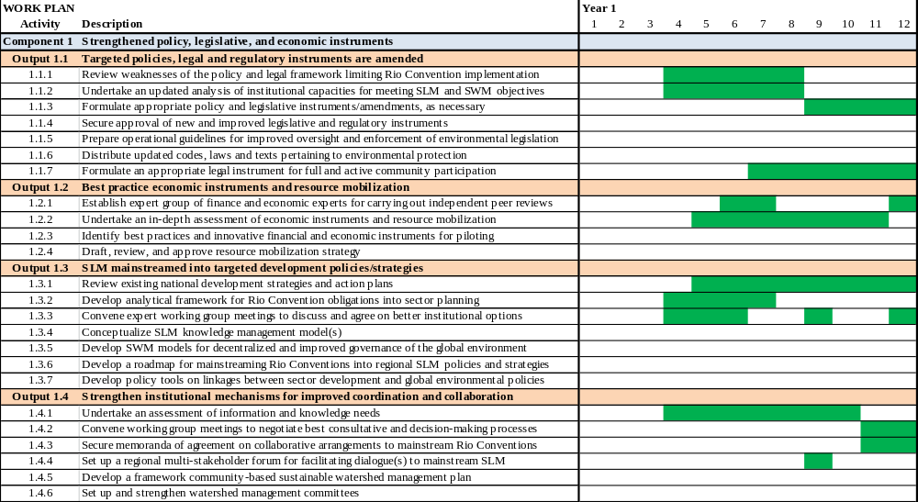

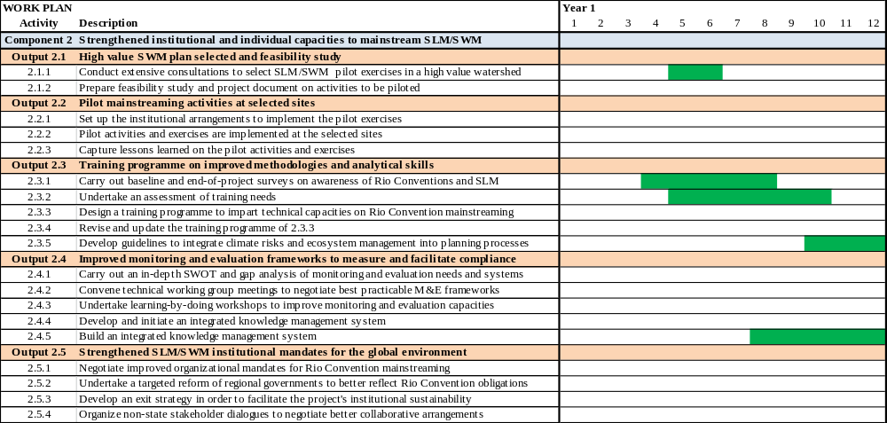

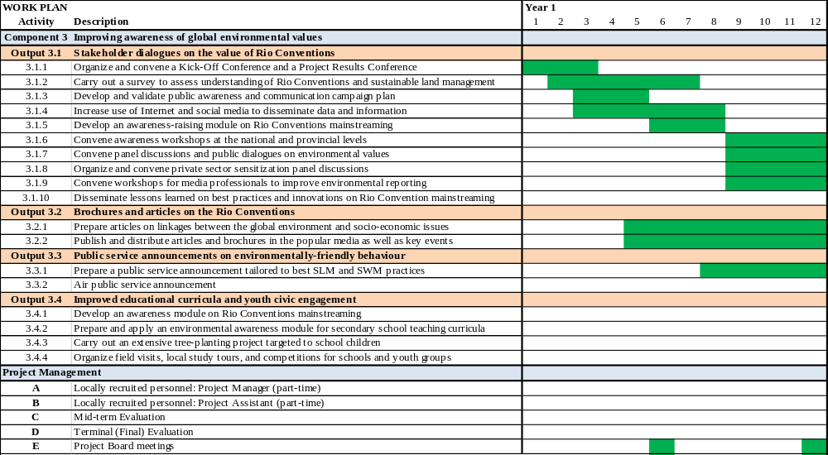

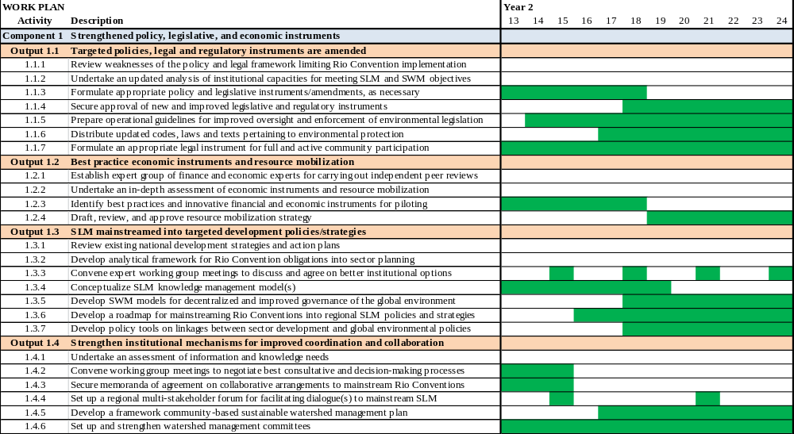

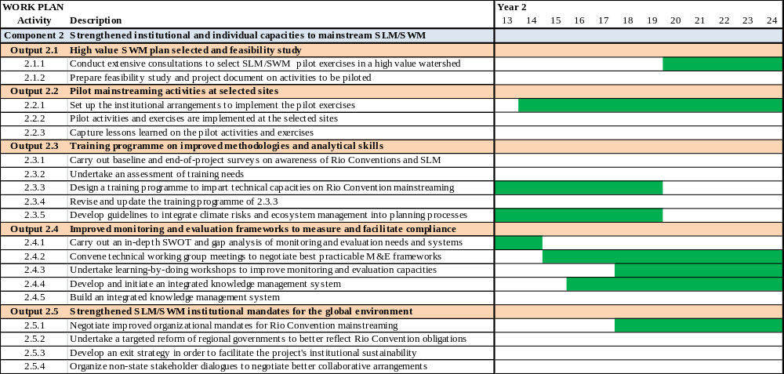

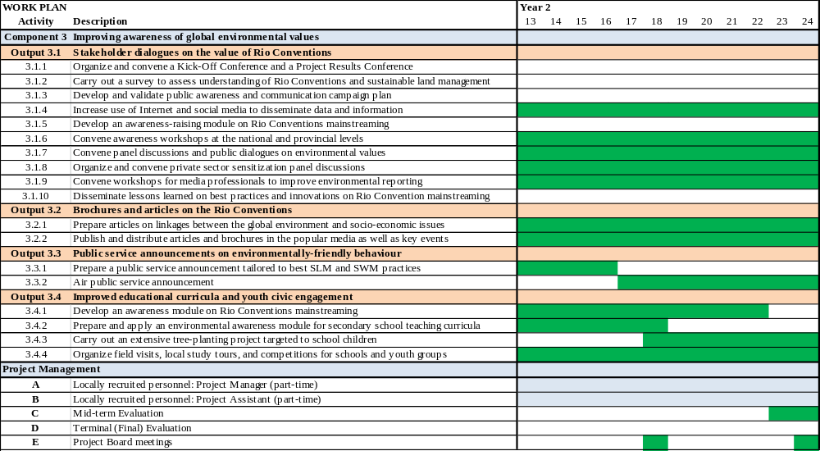

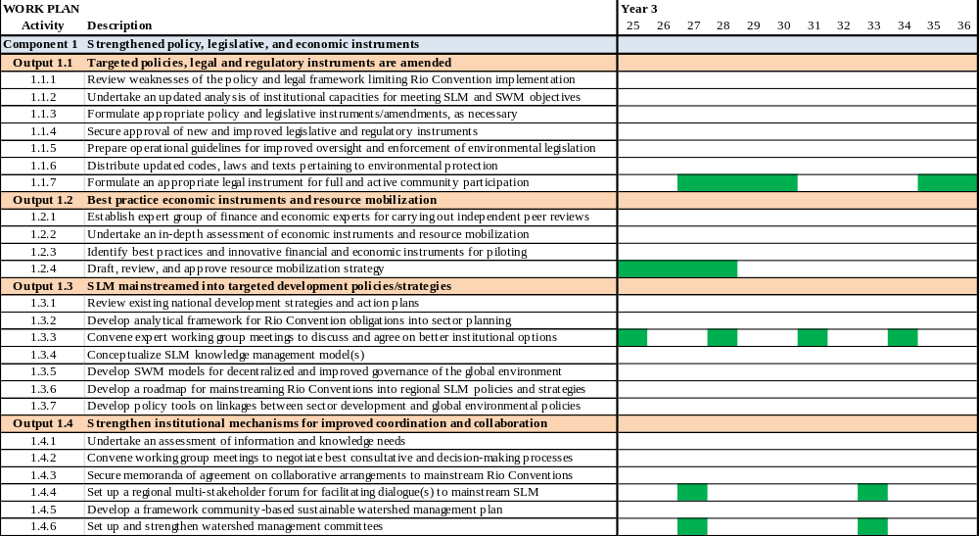
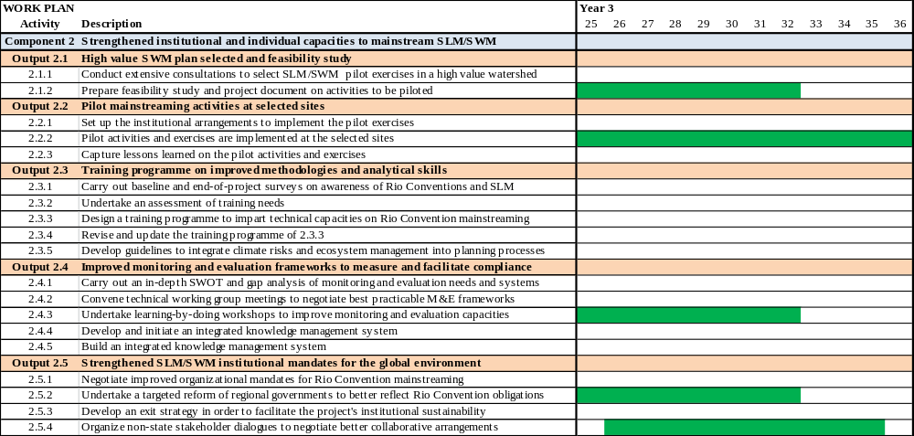
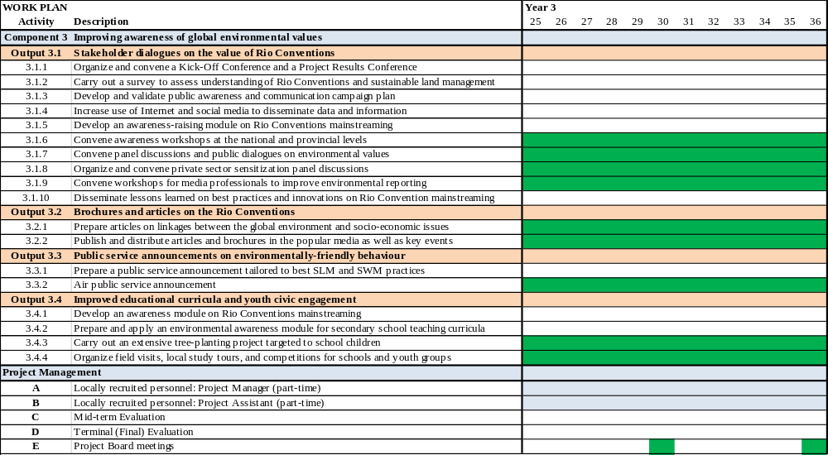
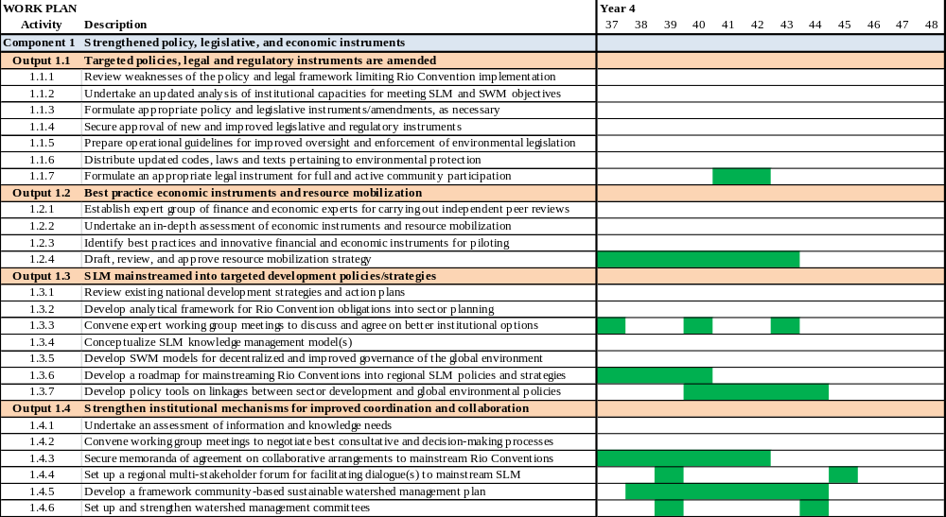
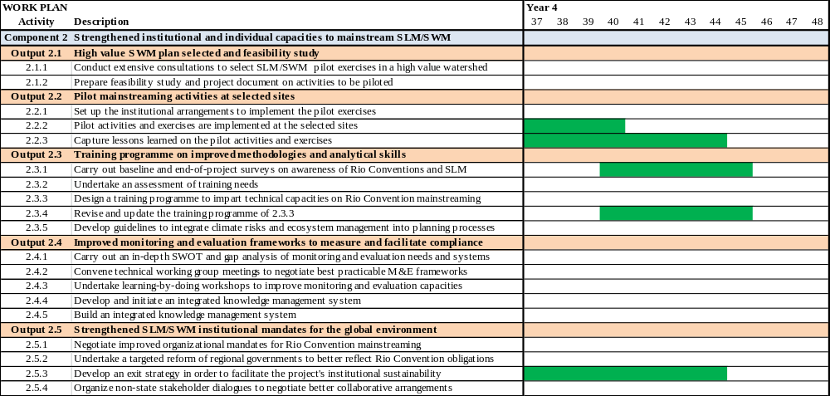
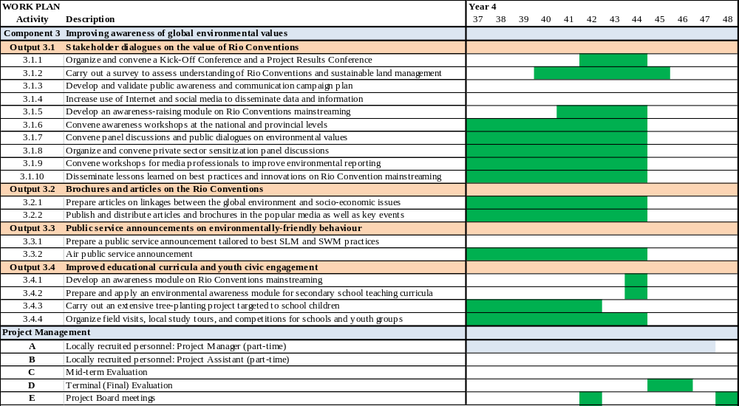

Annex 7: Outcome Budget (GEF Contribution and Co-financing)
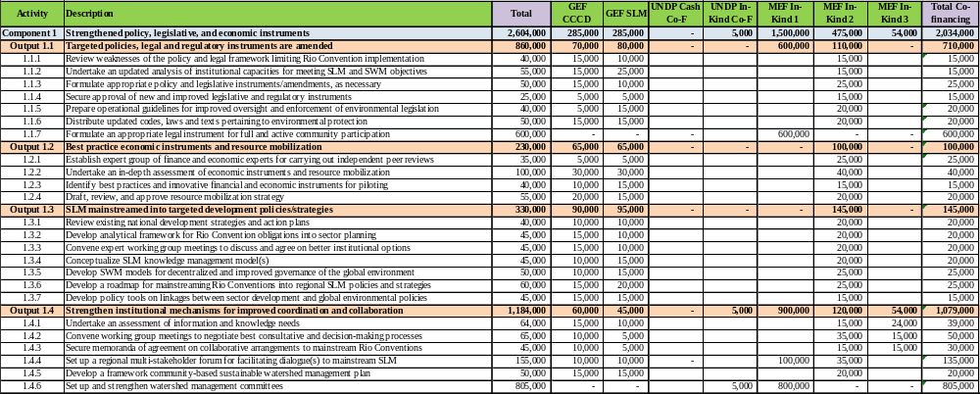

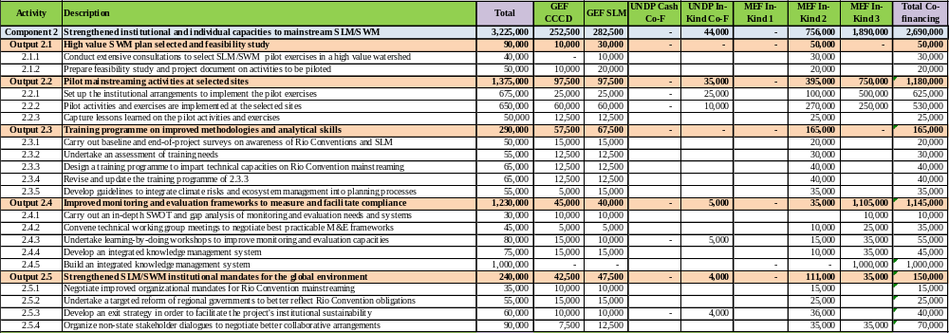

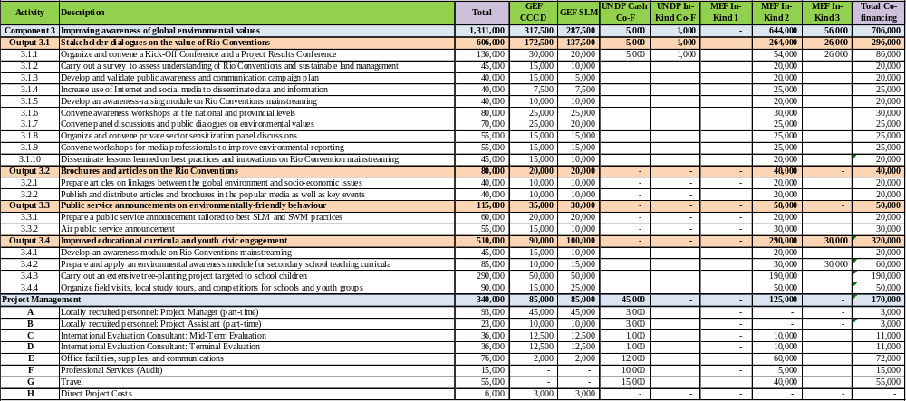

Annex 8: Terms of References
The following Terms of Reference outlines the general responsibilities to be carried out by consultants contracted under the project. With the exception of the international experts and specialists, all other project consultants should ideally be Indonesian nationals. However, experts from the region may be recruited in the event that a suitable national consultant could not be found. Rates will be based on UNDP Indonesia standards for the recruitment of regional consultants, but ideally at a rate that is not significantly greater than that of the national consultant rates in order for the project to remain cost-effective.
Background
Indonesia completed its National Capacity Self-Assessment (NCSA) in 2005. The NCSA processes identified priority thematic issues that cut across the Rio Conventions, which include: deforestation, land, coastal and marine degradation, and drought and floods. The NCSA identified three types of barriers that explain Indonesia difficulty in fulfilling the obligations of the Rio Conventions, namely: systematic, institutional, and individual barriers. The main barriers at the system level include inadequate policy, law, regulation, and implementation. More specifically, these barriers consist of non-legally binding formal documents, only partial implementation of the action plan for each convention, political statements endorsed by government institutions that do not support the goals of the convention, and the fact that the legislative and regulatory frameworks remain weak.
While Indonesia has undertaken numerous efforts to address these barriers, Indonesia is still suffering from bottlenecks that hamper the effective implementation of the Rio Conventions. As a follow-up to these recommendations and with the assistance of UNDP, the government formulated a new project concept to meet the priority need to strengthen capacities for improved decision-making. This capacity development priority was selected by the government on the basis of the government’s commitment to improve implementation of key national policies.
Project Goal and Objectives
The goal of this project is for Indonesia to meet global environmental obligations through the management of their watersheds in their own national interest. To this end, the project will focus on the development and improvement of a selected watershed management plan. The project’s objective remains the same as stated in the PIF, but can be more accurately reworded as “to strengthen targeted legal and regulatory frameworks as well as economic incentives to meet global environmental outcomes through sustainable watershed management.”
Project Strategy
This project was designed in consultation with representatives of key stakeholders in order to strengthen the collaborative approach that belies project legitimacy. This same approach will be critical as the project is implemented and used to rationalize the appropriate modifications of project activities within the framework of the project objective. The adaptive collaborative management approach, if properly adhered to, will help strengthen the relevance and resilience of the project and sustainability of the project results in the face of unforeseen events and unintended consequences arising from policy interventions.
Like other cross-cutting capacity development projects, this project offers cost-effectiveness and a more holistic approach to strengthen sustainable capacities. This is achieved by directing more focused efforts to shared capacity needs. Specifically, CCCD projects direct focused attention to eliminating or reducing capacity bottlenecks that may not otherwise be sufficiently addressed by focal area (thematic) projects.
This project aims to strengthen Indonesia’s absorptive capacities that are necessary to sustain environmental outcomes. Unlike other larger focal area projects, these outcomes are not limited to one specific Rio Convention, but instead address all three. The overall sustainability of CCCD projects is fortified by their emphasis on adaptive collaborative management (ACM), which places a high value on stakeholder engagement
This project will be among the set of innovative and transformative projects under the Global Environmental Facility (GEF) that will demonstrate the pursuit of sustainable development through sectoral policies that help better deliver global environmental benefits as well as meeting their national socio-economic objectives. In Indonesia’s case, this will be by mainstreaming and strengthening global environmental values into a high priority sustainable watershed management plan. This will necessitate complementary and parallel mainstreaming exercises with other national and regional development plans and programmes. At the end of the project, a key set of foundational capacities are expected to be delivered by improving procedures and analytical skills for monitoring and measuring global environmental outcomes. This will be supported by improved policy and legal instruments, such as by-laws.
The transformative nature of this project rests largely on negotiating coordination and collaboration agreements among agencies and non-state stakeholders. The project seeks to facilitate improved collaboration and engagement of stakeholders with comparative expertise and knowledge that is intended to yield better decisions, policies, information and knowledge to apply best practices. The ability of the project to transform the current culture of competitiveness among government agencies and non-state stakeholders is expected to facilitate greater validity and legitimacy of the policy and decision-making.
Project Outcomes and Components
At the end of the project, activities are expected to result in a set of improved capacities to meet and sustain Rio Convention objectives. This project will have strengthened and helped institutionalize commitments under the Rio Conventions by mainstreaming global environmental values within a high value sustainable watershed management plan under the GEF Operational Programme on Land Degradation. These same and related capacities will be reinforced by strengthening the policy and legislative framework supporting Rio Convention mainstreaming; strengthening institutional arrangements, e.g., mandates, coordination and adaptive collaborative management procedures; and extensive training and awareness-raising through learning-by-doing workshops and dialogues. Together, these capacity building activities are expected to strengthen the institutional sustainability of conservation and sustainable management practices to produce and maintain global environmental values. The project’s outcome indicators are:
- A key of Indonesia’s legislative, regulatory, and economic instruments will have been strengthened in a way that catalyzes effective Rio Convention implementation at the national level
- The strengthening of institutional and individual capacities to mainstream global environmental values and best practice sustainable land and watershed management will help Indonesia implement the Rio Convention in a more cost-effective manner
- A significant improvement in the awareness of how protecting global environmental values through sustainable watershed management will contribute to a paradigm shift in more environmental friendly attitudes and behaviour
This project will be implemented in three linked project components:
- Strengthened policy, legislative, and economic instruments
- Strengthened institutional and individual capacities to mainstream SLM/SWM
- Improving awareness of global environmental values

Responsibilities
National Project Director (NPD)
The Government of Indonesia must appoint a national director for this UNDP-supported project. The National Project Director supports the project and acts as a focal point on the part of the Government. This responsibility normally entails ensuring effective communication between partners and monitoring of progress towards expected results.
The National Project Director is the party that represents the Government’s ownership and authority over the project, responsibility for achieving project objectives and the accountability to the Government and UNDP for the use of project resources.
In consultation with UNDP, the Ministry of Environment and Forestry, as the lead concerned ministry, will designate the National Project Director from among its staff at not lower than the Deputy Minister or Head of Directorate level. The National Project Director will be supported by a part-time National Project Manager. The NPD will have the following duties and responsibilities:
- Assume overall responsibility for the successful execution and implementation of the project, accountability to the Government and UNDP for the proper and effective use of project resources)
- Serve as a focal point for the coordination of projects with other Government agencies, UNDP and outside implementing agencies;
- Ensure that all Government inputs committed to the project are made available;
- Supervise the work of the National Project Manager and ensure that the National Project Manager is empowered to effectively manage the project and other project staff to perform their duties effectively;
- Select and arrange, in close collaboration with UNDP, for the appointment of the National Project Manager (in cases where the he/she has not yet been appointed);
- Supervise the preparation of project work plans, updating, clearance and approval, in consultation with UNDP and other stakeholders and ensure the timely request of inputs according to the project work plans;
- Represent the Government institution (national counterpart) at the tripartite review project meetings, and other stakeholder meetings.
The National Project Director may not receive monetary compensation from project funds for the discharge of his/her functions.
A Project Manager will be locally recruited to oversee the project implementation on a part-time basis under the guidance of the NPD, and with the support of UNDP Indonesia. He/she will be recruited for the duration of the project at an estimated 30% of his/her time. This will total an approximate 60 person-weeks. In addition to overseeing the implementation of the project’s capacity development activities, the project management will carry out the monitoring and evaluation procedures per UNDP agreed policies and procedures. These include:

- Oversee the day-to-day monitoring of project implementation
- In consultation with stakeholders, recommend modifications to project management to maintain project’s cost-effectiveness, timeliness, and quality project deliverables (adaptive collaborative management) to be approved by the Project Board
- Prepare all required progress and management reports, e.g., APR/PIR and project initiation report
- Support all meetings of the Project Board
- Maintain effective communication with project partners and stakeholders to dissemination project results, as well as to facilitate input from stakeholder representatives as project partners
- Support the independent terminal evaluation
- Ensure full compliance with the UNDP and GEF branding policy
The Project Manager can not be a current government employee, and must possess at least ten (10) years’ of professional experience in public administration of environmental issues: at least two (2) of these years must include experience managing a successful capacity development project in the environmental or social field. He/she should possess at minimum a Master’s degree in natural resource or environmental sociology, public administration, or public policy. He/she must have an excellent working knowledge of both English and Bahasa Indonesia.
Project Assistant
The Project Assistant will support the Project Manager in the carrying out of his/her duties, which will include:
- Organizational and logistical issues related to project execution per UNDP guidelines and procedures
- Record keeping of project documents, including financial in accordance with audit requirements
- Ensure all logistical arrangements are carried out smoothly
- Assist Project Manager in preparation and update of project work plans in collaboration with the UNDP Country Office
- Facilitate timely preparation and submission of financial reports and settlement of advances, including progress reports and other substantial reports
- Report to the Project Manager and UNDP Programme Officer on a regular basis
- Identification and resolution of logistical and organizational problems, under the guidance of the Project Manager
The Project Assistant will have at least five (5) years’ experience in supporting the implementation of UNDP implemented projects, with preference in environment and natural resource management projects.
National Consultant on the Convention on Biological Diversity
This national consultant will be responsible for those project activities that require expertise on interpreting and translating CBD obligations into national programmable activities. The consultant will prepare the appropriate technical background studies, as well as also serve as a facilitator in the trainings on using data and information relevant to meeting biodiversity conservation objectives, with particular emphasis on endangered endemic species and their ecosystems. The CBD national consultant will have at least 10 years of work experience in biodiversity conservation programming and project implementation. At least the last two (2) years of experience include active involvement in CBD negotiations He/she will have a PhD in natural resource management, with a specialization directly related to biodiversity conservation in Indonesia and/or the neighboring region. Under the supervision of the Project Manager, the specialist will coordinate his/her work with that of other national experts and specialists. This includes coordinating activities with those under implementation by the development partners.
International Specialist on the Convention on Biological Diversity
This international specialist will be responsible for undertaking those project activities that require expertise on interpreting and translating CBD obligations into national programmable activities. The specialist will prepare the appropriate technical background studies, as well as also serve as a co-facilitator in the trainings on the using data and information relevant to meeting biodiversity conservation objectives, with particular emphasis on endangered endemic species and their ecosystems. The CBD specialist will have at least 10 years of work experience, of which at least the last two (2) years include active involvement in CBD negotiations. He/she will have a PhD in natural resource management, with a specialization directly related to biodiversity conservation in Indonesia and/or the surrounding region. Under the supervision of the Project Manager, the specialist will coordinate his/her work with that of other national experts and specialists. This includes coordinating activities with those under implementation by the development partners. An estimated 15 weeks have been estimated for undertaking project activities.
National Consultant on the Convention on Desertification and Drought
This national consultant will be responsible for those project activities that require expertise on interpreting and translating CCD obligations into national programmable activities. The national consultant will prepare the appropriate technical background studies, as well as also serve as a facilitator in the trainings on using data and information relevant to meeting land degradation objectives, with particular emphasis on sustainable land management and land degradation.
The CCD national consultant will have at least 10 years of work experience, of which at least the last two (2) years include active involvement in CCD programming and project implementation. He/she will have a PhD in natural resource management, with a specialization directly related to land management issues in Indonesia and/or the surrounding region. Under the supervision of the Project Manager, the specialist will coordinate his/her work with that of other national experts and specialists. This includes coordinating activities with those under implementation by the development partners.
International Specialist on the Convention on Desertification and Drought
This international specialist will be responsible for undertaking those project activities that require expertise on interpreting and translating CCD obligations into national programmable activities. The specialist will prepare the appropriate technical background studies, as well as also serve as a co-facilitator in the trainings on the using data and information relevant to meeting biodiversity conservation objectives, with particular emphasis on sustainable land management and land degradation.
The CCD specialist will have at least 10 years of work experience, of which at least the last two (2) years include active involvement in CCD negotiations. He/she will have a PhD in natural resource management, with a specialization directly related to land management issues in Indonesia and/or the surrounding region. Under the supervision of the Project Manager, the specialist will coordinate his/her work with that of other national experts and specialists. This includes coordinating activities with those under implementation by the development partners. An estimated 15 weeks have been estimated for undertaking project activities.
National Consultant on the Framework Convention on Climate Change
This national consultant will be responsible for those project activities that require expertise on interpreting and translating FCCC obligations into national programmable activities. The national consultant will prepare the appropriate technical background studies, as well as also serve as a facilitator in the trainings on using data and information relevant to meeting climate change mitigation and mitigation objectives, with particular emphasis on endangered endemic species and their ecosystems.
The FCCC national consultant will have at least 10 years of work experience, of which at least the last two (2) years include active involvement in FCCC programming and project implementation. He/she will have a PhD in a field directly relevant to climate change science, with a specialization directly related to mitigation and adaptation strategies relevant to Indonesia and/or the surrounding region. Under the supervision of the Project Manager, the specialist will coordinate his/her work with that of other national experts and specialists. This includes coordinating activities with those under implementation by the development partners.
International Specialist on the Framework Convention on Climate Change
This international specialist will be responsible for undertaking those project activities that require expertise on interpreting and translating FCCC obligations into national programmable activities. The specialist will prepare the appropriate technical background studies, as well as also serve as a co-facilitator in the trainings on the using data and information relevant to meeting climate change mitigation and mitigation objectives, with particular emphasis on endangered endemic species and their ecosystems.
The FCCC specialist will have at least 10 years of work experience, of which at least the last two (2) years include active involvement in FCCC negotiations. He/she will have a PhD in a field directly relevant to climate change science, with a specialization directly related to mitigation and adaptation strategies relevant to Indonesia and/or the surrounding region. Under the supervision of the Project Manager, the specialist will coordinate his/her work with that of other national experts and specialists. This includes coordinating activities with those under implementation by the development partners. An estimated 15 weeks have been estimated for undertaking project activities.
Environmental Sociologist (National)
The Environmental Sociologist will contribute to the stakeholder consultations and policy dialogues to ensure that socio-economic and gender issues are fully addressed. This specialist will also work with other consultants and project management in the design and implementation of awareness-raising and training activities to ensure the appropriate design of the pilot platforms at the national and sub-national levels. This will include the high school competitions and education curricula. The Environmental Sociologist will have a PhD in environmental sociology, with demonstrated experience in constructing and implementing surveys, as well as their statistical analysis on trends in environmental values and attitudes.
Public Administration Expert (National)
The individual recruited as the Public Administration Expert will be recruited for an estimated 150 days. He/she will work with the Project Manager as well as the other national specialists to assess and institutionalize the environmental data management system within Ministry of Environment and Renewable Energy as well as with the partner government departments and other stakeholder organizations’ information systems. He/she will work with the information technology and knowledge management specialist to undertake the in-depth baseline assessment of the current management information systems in Indonesia as well as to design the institutional architecture of the environmental data management system. This expert will also work with the legal expert to assess and recommend institutional and associated regulatory reforms to be submitted for Parliamentary approval, as well as work of the Rio Convention experts through the expert working groups, as well serve as a resource person and facilitator for the training and learn-by-doing working groups.
The Public Administration Expert will have a post-graduate degree in public administration or related field, and have a minimum of ten (10) years’ experience in progressively responsible and substantive areas in environmental and natural resource governance programming and planning.
Policy / Legal Expert/Environmental Lawyer
The Policy/Legal Expert/Environmental Lawyer will contribute to the substantive work under the project by assessing the policy and legal implications of national implementation of the Rio Conventions, in particular the collaboration among key agencies and other stakeholder organizations. The expert will work with the Public Administration expert as well as with the others, as appropriate to draft and negotiate the Memoranda of Agreement to share data and information, as well as draft the bills that need Project Board approval.
This expert will have a post-graduate degree in law, with a specialization on environmental law and policy of Indonesia. He/she will have to have a minimum of ten (10) years’ experience in progressively responsible and substantive areas in environmental and natural resource governance programming and planning. An estimated 30 weeks have been estimated for undertaking project activities by this national expert. The types of activities that he/she will undertake substantive project activities may include:
- Preparing technical materials and facilitating the expert working group meetings
- Undertake an in-depth baseline analysis of information needs, sources and flows to implement environmental legislation
- Facilitate negotiations among line ministries on cooperative agreements (memoranda of agreement)
- Undertake an in-depth analysis of environmental legislation and compliance
- In collaboration with other national consultants, undertake an analysis of best practices and lessons learned
- Lead drafter of technical guidelines for the strategic implementation of environmental legislation
- In collaboration with other national consultants, draft recommended monitoring and compliance reforms
- In collaboration with other national consultants, undertake an assessment of existing guidelines, tools and resources
- In collaboration with other national consultants, prepare a comprehensive training programme and targeted training modules
- In collaboration with other national consultants, draft operational guidelines for coordinated monitoring and compliance
- In collaboration with other national consultants, support sub-contracted NGO to carry out broad-based survey
- Contribute to the preparation of the public awareness implementation plan
- Contribute to the preparation of articles on legislative responses for Rio Convention implementation
- Contribute to the preparation and implementation of the secondary school competitions on the Rio Conventions
- In collaboration with other national consultants, prepare a global environmental education module for secondary schools
- In collaboration with other national consultants and the sub-contracted video production, prepare the narrative for the public service announcement
- In collaboration with other national consultants, undertake an in-depth financial and economic analysis of environmental monitoring and compliance
- In collaboration with other national consultants and based on consultations with stakeholders and the expert working group members, facilitate meetings and at least one workshop to select best practice and innovative financial and economic instruments to piloted
- Contribute to the development of the environmental legislation website and Facebook

The Policy/Legal Expert/Environmental Lawyer will have a post-graduate degree in law, with a specialization on environmental law, as well as have a minimum of ten (10) years’ experience in progressively responsible and substantive areas in environmental and natural resource governance programming and planning.
International Forest Specialist
The International Forest Specialist will prepare the appropriate technical background studies, and serve as a technical consultant and liaison with industry and governmental services. The specialist will assist in program planning, policy, and procedural development for SLM activities and reforestation activities. He /she will contribute to the identification of best practices for forestry management, and working with other specialists, negotiate from a technical perspective how to best integrate Rio Convention obligations into the sustainable watershed management plan
Additionally, the specialist will advise and assist in all areas of responsibility. The specialist will visit the project area to finalize the formulation of the project related issues of forestry management, as needed.
The International Forest Specialist is to have at least ten (10) years of relevant experience in forestry issues, and trained in ecology, and or conservation management. He /she will work closely with the Forestry Specialist.
Forestry Specialist
This national consultant will be responsible for those project activities that require expertise on forestry. The consultant will assist in the preparation of the appropriate technical background studies, as well assist as a facilitator in the trainings on SLM/SWM relevant to meeting land degradation objectives. The specialist will assist in program planning, policy, and procedural development for SLM activities and reforestation activities. He /she will contribute to the identification of best practices for forestry management, and working with other specialists, negotiate from a technical perspective how to best integrate Rio Convention obligations into the sustainable watershed management plan
The Forestry Specialist is to have at least ten (10) years of relevant experience in Indonesia’s forestry issues, and trained in ecology, and or conservation management. The Forestry Specialist will work with the International Forest Specialist.
International Expert on Watershed Management
The International Expert on Watershed Management will be responsible for undertaking those project activities that require expertise on watershed management. The specialist will negotiate from a technical perspective how to best integrate Rio Convention obligations into the sustainable watershed management plan. The specialist will visit the project area to finalize the formulation of the project related issues of watershed management, as needed.
The International Expert on Watershed Management is to have at least ten (10) years of relevant experience in watershed issues, and trained as a hydrologist, or hydrologic engineer. He /she will work closely with the Hydrology Specialist.
Hydrology Specialist
This Specialist will be considered to be an expert of hydrology management issues, which includes taking a holistic and comprehensive approach to water resource management. He/she will be considered to have a widely accepted good reputation among his/her peers in Indonesia. The specialist will contribute to the integration of the Rio Conventions into the sustainable watershed management plan. The Specialist will work with the International Expert on Watershed Management and have at least ten (10) years of relevant experience in hydrology issues, and be trained as a hydrologist or hydrologic engineer.
Gender Specialist
The Gender Specialist will have at least eight (8) years of progressively responsible professional experience working on gender responsive programming in development and/or environmental settings. Proven experience combining formal expertise on gender mainstreaming and gender equality with experience of applying these concretely to specific environmental programmes sectors, plans, and policies. Proven experience developing gender training tools, and delivering trainings on gender-responsive programming. A Masters or Advanced Degree in a related subject area is required.
International Technical Specialist
An international technical specialist will be recruited to provide necessary technical advisory services on the implementation of key project activities, in particular the review of recommendations to integrate and institutionalize Rio Convention obligations within the environmental data management system, among other substantive activities, as appropriate. These services will be provided over the course of the three-year implementation period to provide technical backstopping to help ensure the timely and high quality project delivery.
International Evaluation Consultant
The international evaluation consultant will be an independent expert that is contracted to assess the extent to which the project has met project objectives as stated in the project document and produced cost-effective deliverables. He/she will produce a mid-term and a final evaluation, with the input and support of the National Project Director, National Project Manager, and national consultants. The consultant will also rate capacities developed under the project using the Capacity Development Scorecard.
The Terms of Reference for the International Evaluation Consultant will follow the UNDP/GEF policies and procedures, and together with the final agenda will be agreed upon by the UNDP/GEF RCU, UNDP Indonesia, and the Project Team. The evaluation reports will be cleared and accepted by UNDP (Country Office and Regional Coordination Unit) before being made public.
Environmental Education Specialist
The Environmental Education Specialist will work with other project consultants to undertake a number of key project analyses, as well as support the other project consultants to construct deliverables such as the public awareness and communication campaign, assessment of training needs, and the secondary school curricula. He/she will also design the learning-by-doing workshops to ensure that they are structured to foster critical thinking among workshop participants.
Given the comparative advantages of a number of NGOs in Indonesia, a NGO may be recruited to carry out a number of the public awareness and advocacy activities. The Environmental Education Specialist and/or the selected NGO(s) will be responsible for the following activities:

- Support the Lead Sector Consultant in facilitating collaborative and consultative teamwork for the targeted mainstreaming of Rio Conventions into sectoral policies, programmes, plans, and/or legislation, along with other national consultants
- Undertake an assessment of training needs
- Design a targeted training programme to support the sectoral mainstreaming exercises at the regional level
- Identify best practices and cull lessons learned from the sectoral mainstreaming exercises at the regional level
- Prepare a public awareness implementation plan to promote Rio Convention mainstreaming into sectors
- Design plan for secondary school competitions on Rio Conventions and facilitate their implementation in consultation with teachers and secondary school decision-makers
- Prepare a global environmental education module for secondary school students to gain a more comprehensive and in-depth understanding of global environmental issues and how local values, attitudes and behaviour affect global environmental outcomes
- Prepare narrative script for a Public Service Announcement (PSA) on Rio Convention mainstreaming that will be used by a professional video production company to produce for radio and television
- Prepare a comprehensive training programme for Rio Convention mainstreaming as part of the long-term training needs to catalyze the implementation of the National Sustainable Development Strategy

The Environmental Education Specialist will have a post-graduate degree in K-12 education, preferably a PhD, with demonstrated experience in developing national education policies, programmes, and plans as well as the development of secondary school curricula on environmental studies. He/she will have experience in facilitating expert and stakeholder working groups in the collaborative drafting of sector policies.
Graduate Students/NGOs
Graduate students will be contracted to prepare articles on Rio Convention mainstreaming for publication in the popular press and brochures. The graduate students must have good working knowledge of English. NGOs may also be sub-contracted to prepare articles. Graduate students must be enrolled in a post-graduate degree-seeking in a field related to the sectoral mainstreaming exercises.
Video Production Company
A video production company will be sub-contracted to produce a high-quality public service announcement (PSA) for both radio and television. This company will have had at least five (5) years’ experience in video production and will advise the Project Coordinator and UNDP on the best strategy for airing the Public Service Announcement.

Annex 9: Agreement on the provision of support services (Draft)
AGREEMENT BETWEEN UNDP AND THE GOVERNMENT FOR THE PROVISION OF SUPPORT SERVICES

- Reference is made to consultations between officials of the Government of Indonesia/ Ministry of Environment and Forestry (hereinafter referred to as “the Government”) and officials of UNDP with respect to the provision of support services by the UNDP country office for nationally managed programmes and projects. UNDP and the Government hereby agree that the UNDP country office may provide such support services at the request of the Government through its institution designated in the relevant programme support document, as described below.
- The UNDP country office may provide support services for assistance with reporting requirements and direct payment. In providing such support services, the UNDP country office shall ensure that the capacity of the Government-designated institution is strengthened to enable it to carry out such activities directly. The costs incurred by the UNDP country office in providing such support services shall be recovered from the administrative budget of the office.
- The UNDP country office may provide, at the request of the designated institution, the following support services for the activities of the programme:
- Identification and/or recruitment of project personnel and technical expertise;
- Procurement of goods and services to undertake agreed activities;
- Administration of the donor contribution;
- Management of grant agreements and related disbursements for project-related activities (to be specified in the project details).

- The procurement of goods and services and the recruitment of programme personnel by the UNDP country office shall be in accordance with the UNDP regulations, rules, policies and procedures. Support services described in paragraph 3 above shall be detailed in an annex to the programme support document or project document, in the form provided in the Attachment hereto. If the requirements for support services by the country office change during the life of a programme or project, the annex to the programme support document or project document is revised with the mutual agreement of the UNDP resident representative and the designated institution.
- The relevant provisions of the Revised Basic Agreement for Technical Assistance signed 29 October 1954 between the United Nations, the International Labour Organisation, the Food and Agriculture Organisation of the United Nations, the United Nations Educational, Scientific and Cultural Organisation, the International Civil Aviation Organisation, and the World Health Organisation and the Government of the Republic of Indonesia, the Standard Agreement on Operational Assistance signed 12 June 1969 between the United Nations, the International Labour Organisation, the Food and Agriculture Organisation of the United Nations, the United Nations Educational, Scientific and Cultural Organisation, the International Civil Aviation Organisation, the World Health Organisation, the International Telecommunication Union, the World Meteorological Organisation, the International Atomic Energy Agency, the Universal Postal Union, the Inter-Governmental Maritime Consultative Organisation and the United Nations Industrial Development Organisation and the Government of the Republic of Indonesia and the Agreement signed 7 October 1960 between the United Nations Special Fund and the Government of the Republic of Indonesia including the provisions on liability and privileges and immunities, shall apply to the provision of such support services.
- The Government shall retain overall responsibility for the nationally managed programme through its designated institution. The responsibility of the UNDP country office for the provision of the support services described herein shall be limited to the provision of such support services detailed in the annex to the programme support document.
- Any claim or dispute arising under or in connection with the provision of support services by the UNDP country office in accordance with this letter shall be handled pursuant to the relevant provisions of the above mentioned agreements.
- The manner and method of cost-recovery by the UNDP country office in providing the support services described in paragraph 3 above shall refer to the latest UNDP Universal Price List (UPL).
- The UNDP country office shall submit progress reports on the support services provided and shall report on the costs reimbursed in providing such services, as may be required.
- Any modification of the present arrangements shall be effected by mutual written agreement of the parties hereto.
- If you are in agreement with the provisions set forth above, please sign and return to this office two signed copies of this letter. Upon your signature, this letter shall constitute an agreement between your Government and UNDP on the terms and conditions for the provision of support services by the UNDP country office for nationally managed programmes and projects.

________________________
Signed on behalf of UNDP

Beate Trankmann
Country Director
UNDP Indonesia

[Date]

__________________
Signed on behalf of the Government of Indonesia

Ir. Bambang Hendroyono, MM
Secretary-General, Ministry of Environment and Forestry, Indonesia

[Date]

Description of UNDP Country Office Support Services (COSS)

Reference is made to consultations between the Ministry of Environment and Forestry, the institution designated by the Government of Indonesia and officials of UNDP with respect to the provision of support services by the UNDP country office for the nationally managed project Capacity Development for Implementing Rio Conventions through Enhancing Incentive Mechanisms for Sustainable Watershed/Land Management (PIMS 5224).

In accordance with the provisions of the letter of agreement signed on [signature expected in July 2015] and the project document, the UNDP country office shall provide support services for the Project as described below.

Based on the request from the Ministry of Forestry, support services to be provided on the basis of Country Office Support Services (COSS) for the following project activities:

Support services  (insert description) | Schedule for the provision of the support services | Cost to UNDP of providing such support services (where appropriate) | Amount and method of reimbursement of UNDP (where appropriate)
Hiring of project management staff | Will be determined during the inception of the project | Using the latest Universal Price List | Will be deducted from the project management budget
Purchase of goods such as equipment, computers, and printing publication | Will be determined during the inception of the project | Using the latest Universal Price List | Will be deducted from the project management budget
Hiring of consultants | Will be determined during the inception of the project | Using the latest Universal Price List | Will be deducted from the project management budget
 |  | Total: up to USD 6,000

Assistance may consist of any other form which may be agreed by the Ministry of Forestry and UNDP.

Description of functions and responsibilities of the parties involved:

- Ministry of Forestry to determine the type of services to be provided by UNDP, in line with AWPs.
- Ministry of Forestry will be consulted by UNDP in the process of providing the support services.
- UNDP will update Ministry of Forestry quarterly, on the costs of the provision of these services.

All decisions related to support services provided by UNDP shall be made upon agreement/approval by the Ministry of Forestry.

Annex 10: Supplemental Provisions to the Project Document
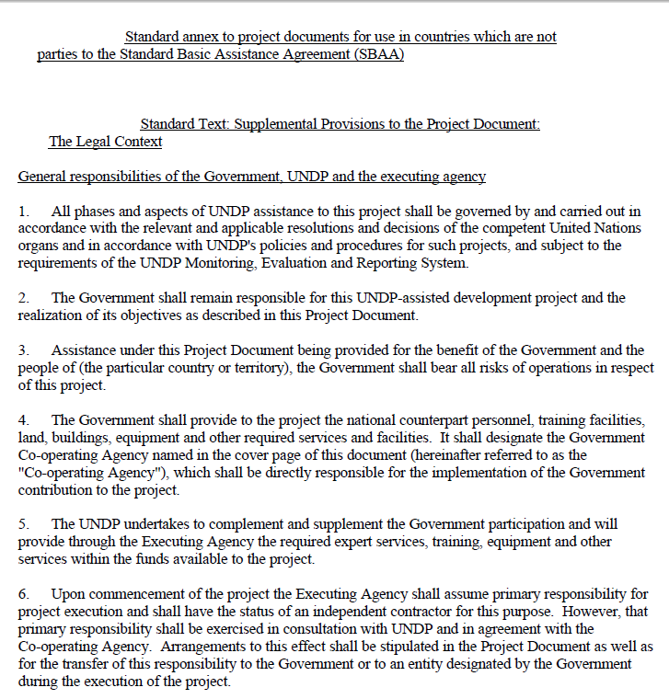
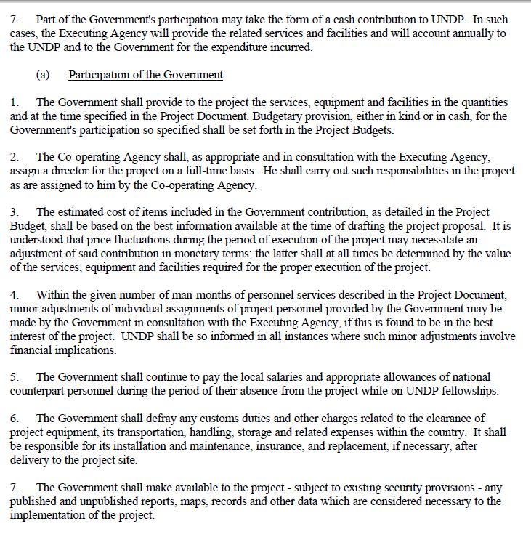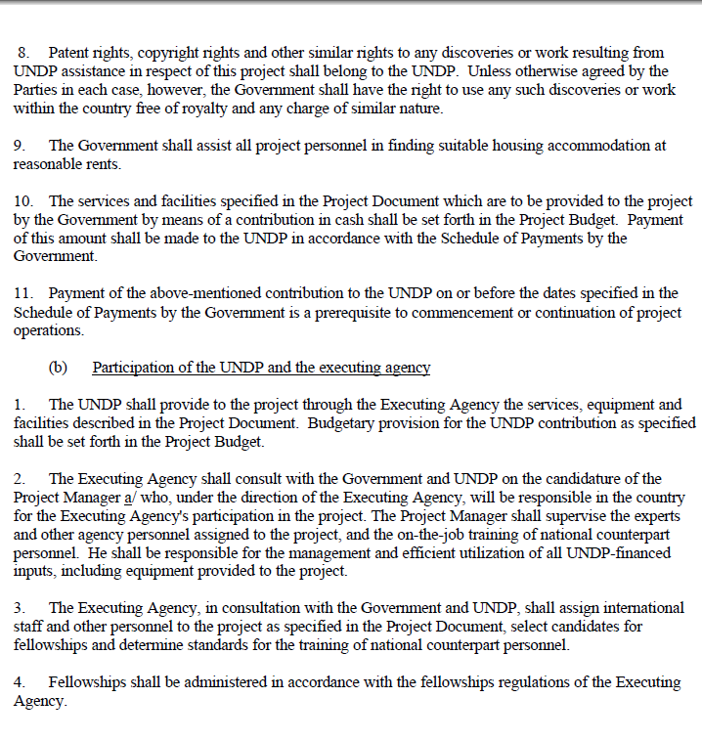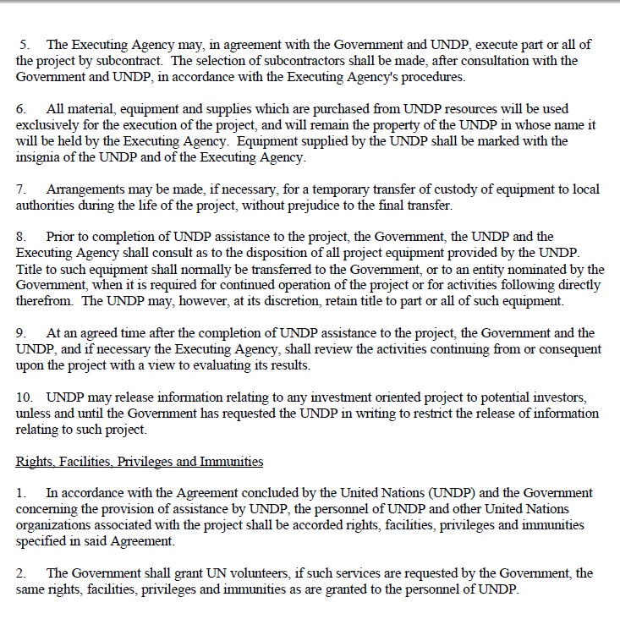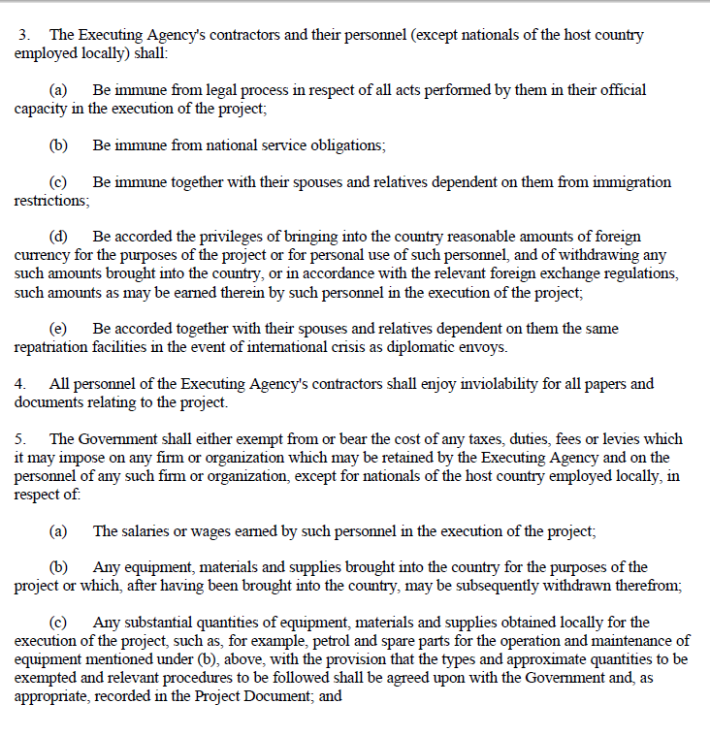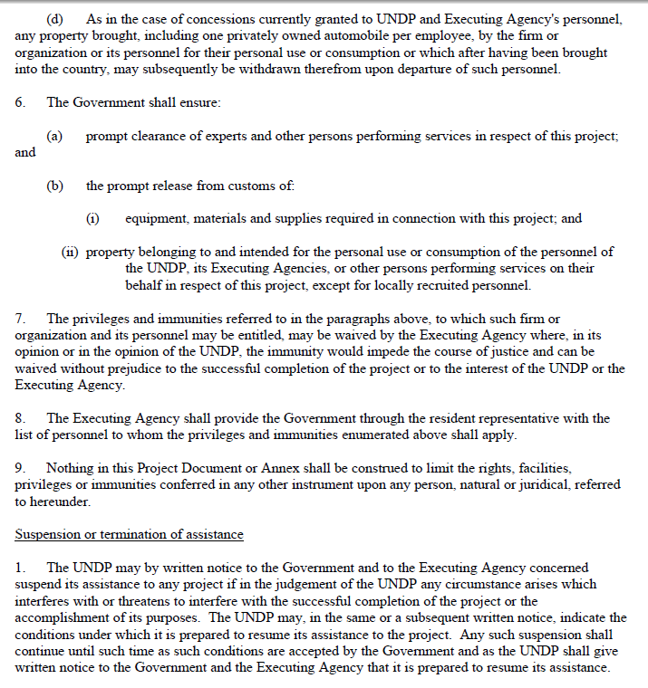

Annex 11: Site Selection Process
As part of the project implementation, the PPG Team has conducted a focus group discussion on 17 May 2015. The group agreed on using the following indicative activities that would promote the synergy of three Rio Conventions:

    - The activities would reduce pressures on natural resources on the watershed from competing land uses in the wider landscape through development and piloting integrated approaches to sustainable land management that includes the obligations under the three Rio Conventions;
    - There is an early application of innovative financing mechanism for sustainable forest management;
    - The activities would protect upper-catchments from erosion by protecting biodiversity, increasing capacity of carbon removal, and restoring carbon sinks as well as increasing climate resiliency and land; and
    - Availability an effective use of land/spatial planning to protect biodiversity, prevent land degradation and avoid carbon emissions from forestry and peatland, which is the highest carbon source for Indonesia.
The group came up with the following eight criteria for the site(s) selection that would support implementation of the activities:
- Location: the site must be located at a district and/or provincial level to test the possible options to strengthen legal/regulatory framework and economic instruments for effective implementation of the Rio Conventions;
- The existence of relevant institutions that are working on selected targets of Rio conventions. Existing regulations and programs to address the Rio Conventions are in place, and there is high or strong commitment of high level of stakeholders;
- Representation of ecosystem types, such as the existence of protected and production areas within the watershed that are being threatened by degraded land and high level of land pressures such as land conversion, habitat degradation, and other encroachment;
- Demonstration of global environmental benefits, such as reducing biodiversity loss, increasing land productivity, and reducing GHG emission, as well as improving carbon stock and sink;
- Provision of co-benefits, such as contribution to socio-economic development of local community, and to knowledge management;
- Inclusiveness of the process, i.e., potential involvement of local community, civil society and private sector in Public Private Partnerships (PPPs);
- Promotion of sustainability and replicability: potential for successful implementation of the project activities, and demonstration of positive impact during the project period; and
- The level of implementation feasibility, meaning that there is availability of co-financing resources.

To follow up these criteria, the team selected three watersheds as potential sites for the project: Serayu watershed in Central Java; Brantas watershed in East Java; and Dodokan-Moyosari watershed in West Nusa Tenggara. All three are among the seven national priority watersheds that are identified in 2015-2019 Medium-Term National Development Plan.

The National PPG team organized the field visits to the three watershed areas to assess and verify their eligibility and suitability with the project goal and objective(s). The site visits was conducted on 19 to 23 May 2015. Besides visiting the field, the team had opportunities to discuss the prospective project with local authorities, including senior officials and Head of the Watershed Agency, Head of Provincial Forestry Service, Head of Regional Development Plan, head of the villages, Heads of Provincial Watershed Community Forum, as well as local communities. Issues and challenges, including threats and opportunities were discussed during the meeting both in the office, and discussion at the field.

During the validation workshop on 27 and 28 May 2015, representatives of the three watersheds presented their views and arguments on reasons for selecting each of the respective watersheds. The following table summarizes their compliance with the criteria, and their views and the arguments as well.

Table: Rating of the three selected watersheds per the selection criteria

Name of the watershed | Location | Catchment basin | Criteria |  |  |  |  |  |  |  | Remark
Name of the watershed | Location | Catchment basin | 1 | 2 | 3 | 4 | 5 | 6 | 7 | 8 | Remark
Serayu-Opak-Progo | Central Java |  | X | X | X | - | X | X | X | - | High erosion rate, high accessibility, population pressure. SWAT analysis has been undertaken.
Brantas | East Java |  | X | X | X | X | X | X | X | X | Frequent land erosion due to improper agriculture practices, flooding, dense populated area - about 20 million people, threat of three active volcanoes. Will be designated as one of the world biosphere reserves by UNESCO
Dodokan Moyosari | West NTB | - Babak  - Kokok Songgen  - Kali Sokong  - Renggung/ Kali Perempung | X | X | X | - | X | X | X | - | On-going REDD+ project, Agroforestry has been developed and institutionalized to secure biodiversity, potential PES scheme in the future.

During the PPG Validation Workshop, presentations were made on these three sites to participants to provide further details of the site visits and explain the comparative advantages of each for the project. Notwithstanding, the selection of the watershed for the project was not made during the project development phase. Instead, once the project is underway, further consultations will confirm the watershed to be selected for the mainstreaming of global environmental values into a sustainable watershed management plan and the pilot and demonstration activities.

Annex 12: GEF Land Degradation Tracking Tool
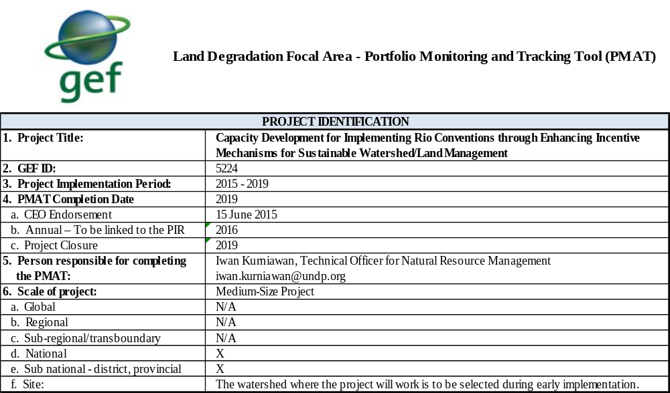

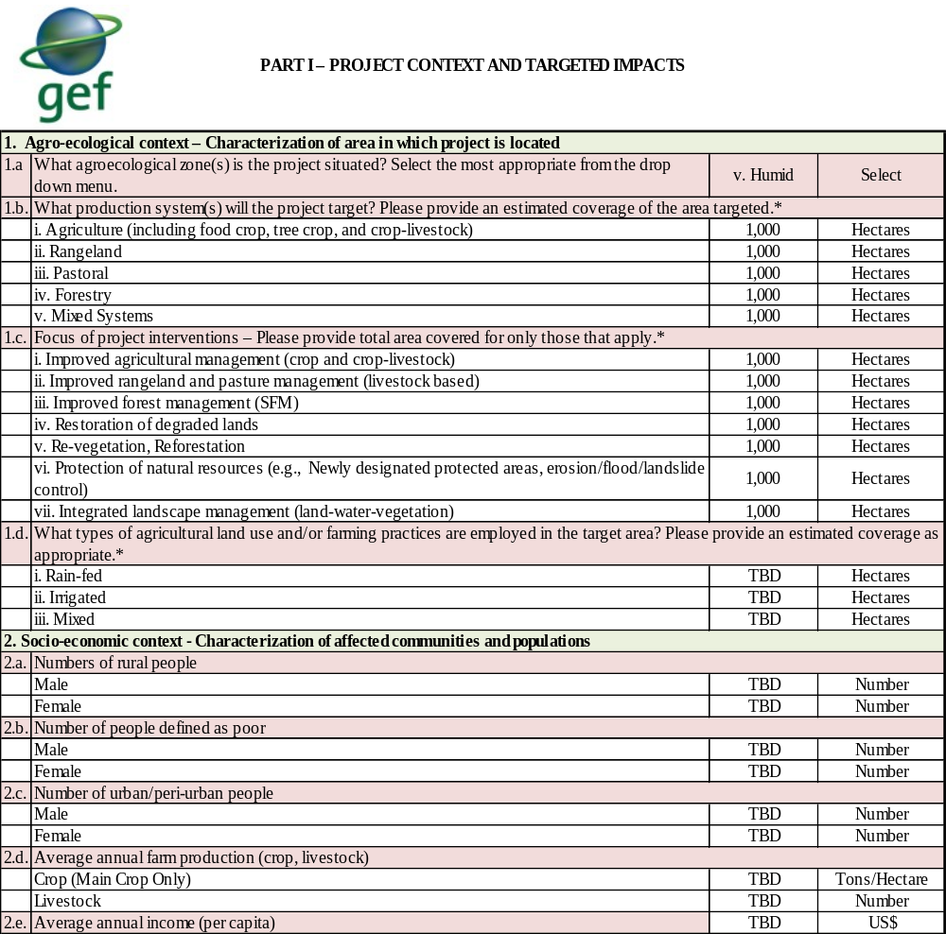

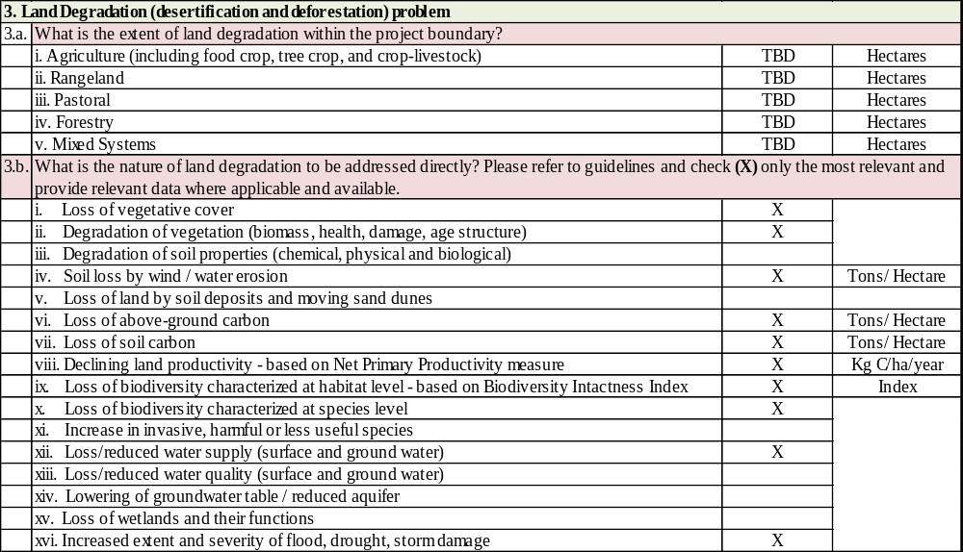

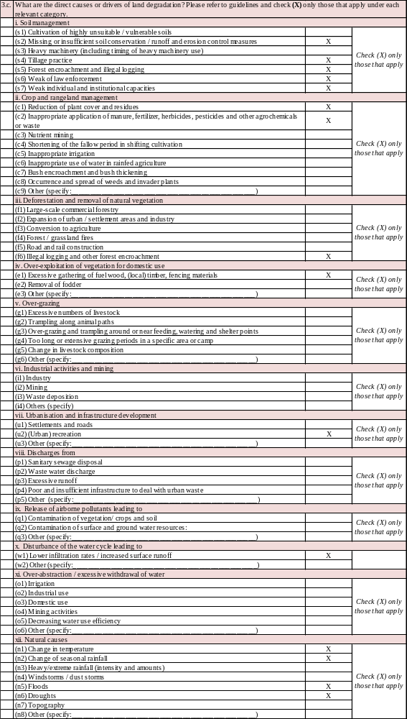

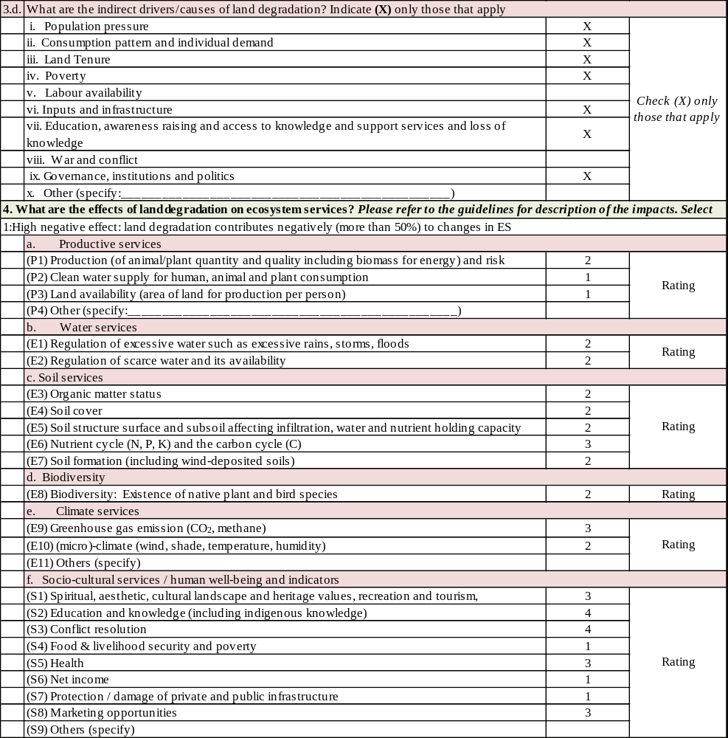
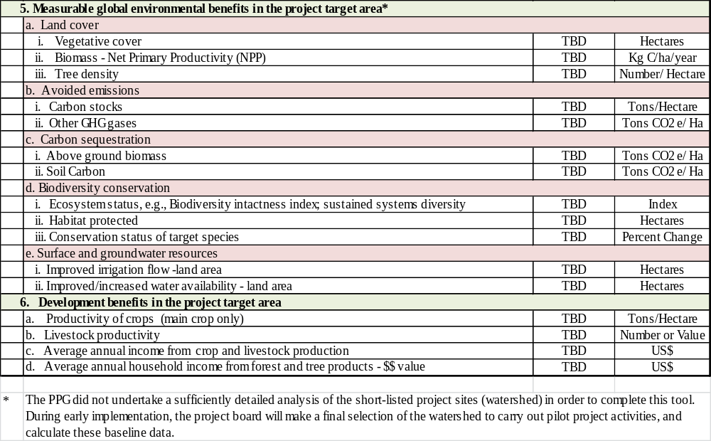

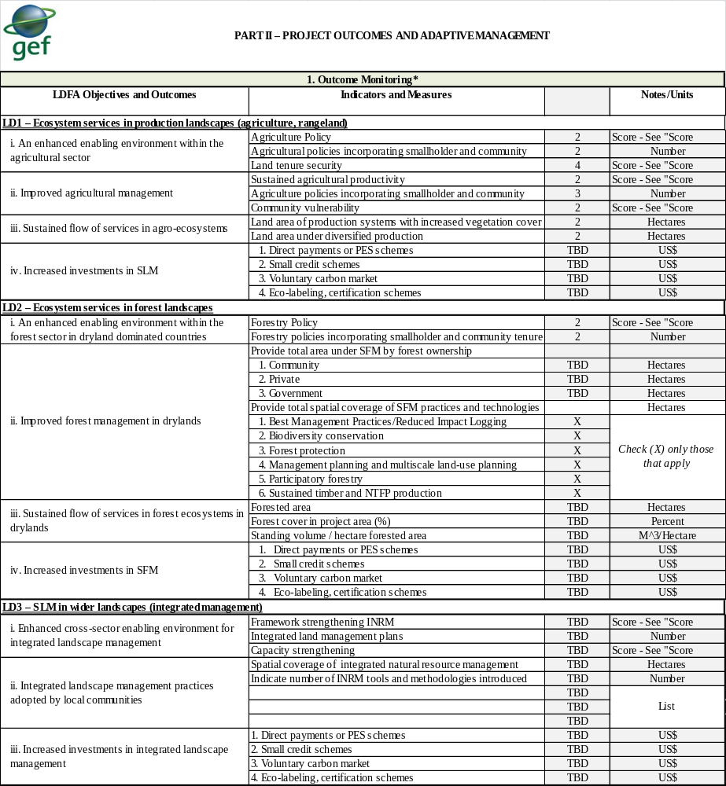

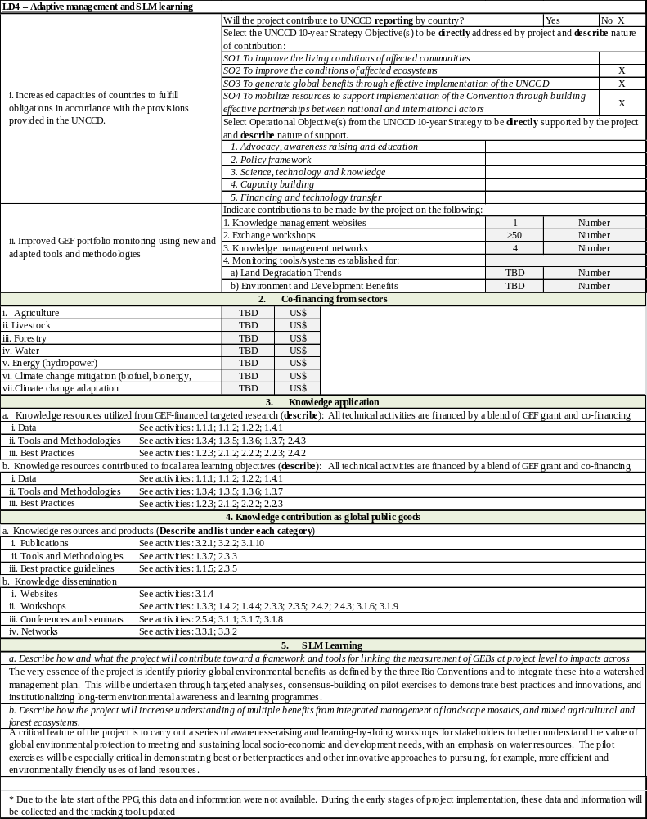

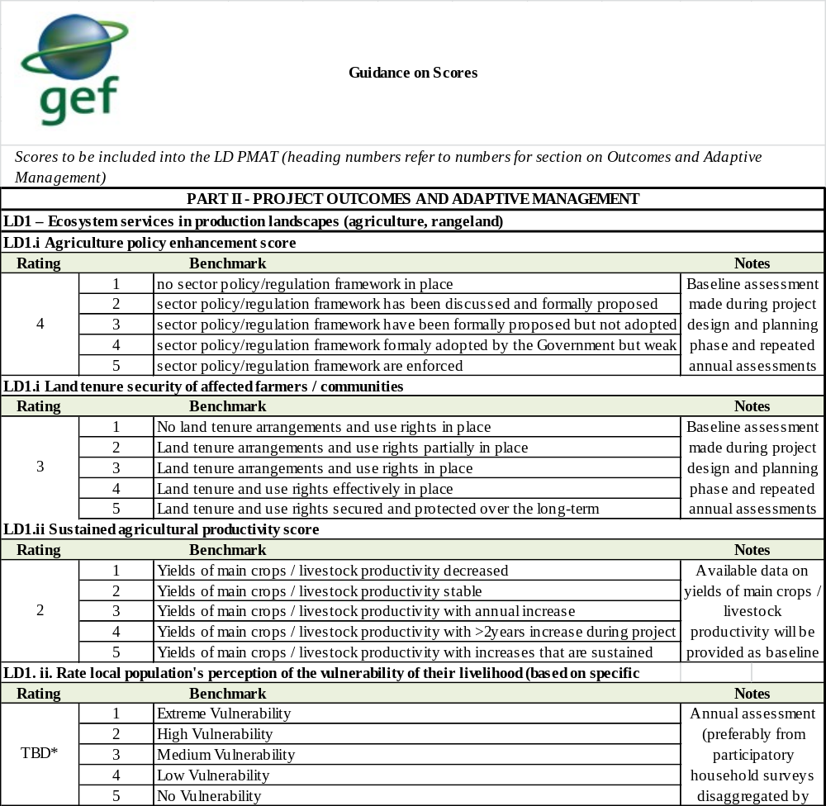

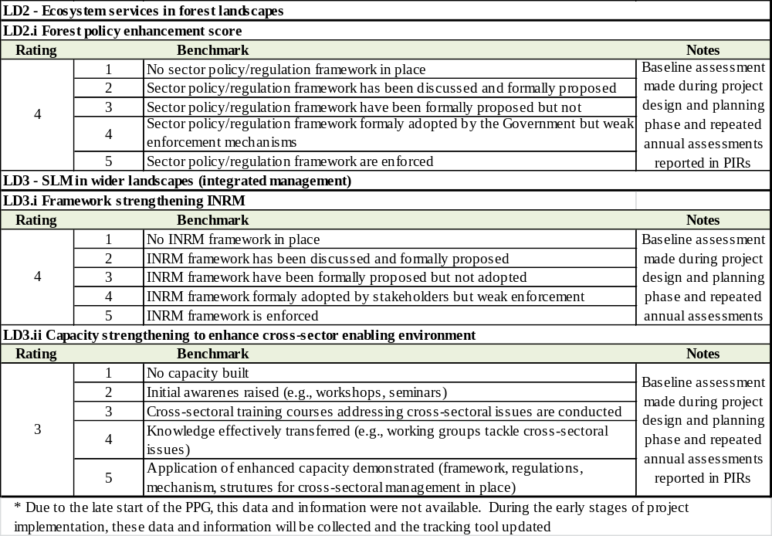

Annex 13: References

Bellamy, J.-J., & Hill, K. (2010). Monitoring Guidelines of Capacity Development in Global Environment Facility Projects. New York: UNDP.
Demetriades, J. (2007). Gender Indicators: What, Why and How? . BRIDGE.
FAO, GEF. (2014). Mainstreaming Biodiversity Conservation and Sustainable Use into Inland Fisheries Practices in Freshwater Ecosystems of High Conservation Value.
FMER. (2013). Integrated water resources management: From research to implementation (4th ed.). Leipzig: Helmholtz Centre for Environmental Research.
GEF. (2011). GEF policies on environmental and social safeguards and gender mainstreaming. Washington, D.C.: Global Environment Facility.
GEF. (2011). Instrument for the Establishment of the Restructured Global Environment Facility. Washington, D.C.: Global Environment Facility.
GEF. (2013). Mainstreaming Gender at the GEF. Washington, D.C.: Global Environment Facility.
GEF. (2014). Summary of the negotiations of the Sixth Replenishment of the GEF Trust Fund. Washington, D.C.: Global Environment Facility.
GEF. (2015). Sustainable Land Management Financing in the GEF. The Global Environment Facility.
GoI; UN. (2012). United Nations Partnership For Development Framework 2011- 2015 Indonesia. National Development Planning Agency (BAPPENAS). Jakarta: Government of Indonesia; United Nations.
Hill, K., Rife, M. J., & Twining-Ward, T. (2015). The strategic value of GEF-funded cross-cutting capacity development projects. New York: UNDP.
Ko, I. K., Choi, D. J., & Triwecko, R. (2011). Final Reporting Workshop for the 2010 Knowledge Sharing Programme.
Lang, C. (2015, January 30). Indonesia’s decision to put the REDD+ Agency in the Ministry of Environment and Forestry is “not in accordance” with Norway’s US$1 billion REDD deal. Retrieved April 24, 2015, from REDD Monitor: http://www.redd-monitor.org/2015/01/30/indonesias-decision-to-put-the-redd-agency-in-the-ministry-of-environment-and-forestry-is-not-in-accordance-with-norways-us1-billion-redd-deal/
Ministry of Forestry. (2011). National Forestry Plan 2011-2030. Jakarta: Government of Indonesia.
Moser, A. (2007). Gender and Indicators Overview Report. BRIDGE, UNDP,Institute of Development Studies.
National Council on Climate Change. (2010). Setting a course for Indonesia’s green growth.
ODI/CDKN. (2014). The IPCC's Fifth Assessment Report: What's in it for South Asia (Executive Summary). London, England: Overseas Development Institute and Climate and Development Knowledge Network.
OECD. (2015). Social Institutions and Gender Index (SIGI). Retrieved April 2015, from Indonesia: try/indonesia
Rahmawati, F., Yustika, A. E., Ashar, K., & Santoso, D. B. (2014). The institutional coordination of Brantas Watershed Management. Journal of Economics and Sustainable Development, 207-215.
Republic of Indonesia. (2015). Draft Indonesia 1st Biennial Update Report.
State Ministry of Environment, U. (2005). National Capacity Self-Assessment Final Report. Jakarta.
UNDP. (2013). Human Development Report 2013 The Rise of the South:Human Progress in a Diverse World Explanatory note on 2013 HDR composite indices Indonesia.
UNDP. (2015). Strengthening Forest Area Planning and Management in Kalimantan . GEF.
UNDP/GEF. (2014). Enhancing the Protected Area System in Sulawesi for Biodiversity Conservation.
UNICEF Indonesia. (2012). Issue Briefs: Maternal and child health.
UN-REDD Programme. (2012). Women Organizing for Change in Agriculture and Natural Resource Management. FAO, UNDP, UNEP.
World Bank. (2012). FY2013-2015 Country Partnership Strategy for Indonesia.
World Bank. (2014a, October 01). Indonesia Overview. Retrieved 1 March, 2015, from The World Bank: http://www.worldbank.org/en/country/indonesia/overview

SIGNATURE PAGE

GOVERNMENT OF INDONESIA

Project Title: Capacity Development for Implementing Rio Conventions through Enhancing Incentive Mechanisms for Sustainable Watershed/Land Management
UNPDF Outcome (s)/Indicator (s): Outcome 5: Strengthened climate change mitigation and adaptation and environmental sustainability measures in targeted vulnerable provinces, sectors and communities
Expected CP Outcome(s): 2.1 Responsible national institutions and relevant stakeholders are more effective in managing environmental resources
Expected CPAP Output(s): 2.1.1 Government, private sector and CBO partners have coherent and effective policy frameworks, action plans, implementing arrangement and funding arrangement to sustainably manage terrestrial ecosystems
Executing Entity/Implementing Partner: Ministry of Environment and Forestry
Implementing Entity/Responsible Partners: United Nations Development Programme
Total resources required : US$ 7,480,000
Total allocated resources : US$ 7,480,000
- Regular UNDP (TRAC) : US$ 50,000
- Other:
  - GEF : US$ 1,880,000
  - Government
  - Cash : US$ 0
  - In-kind : US$ 5,500,000
  - UNDP In-kind : US$ 50,000

Programme Period :
Strategic Plan Outputs (2014-2017) : 1.3 & 2.5
Atlas Award ID : TBC
Project ID : TBC
PIMS # : 5224
Start date : 2015
End Date : 2019
Management Arrangements : NIM
PAC Meeting Date : TBD

Agreed by (Government):

NAME SIGNATURE Date/Month/Year

Agreed by (Ministry of Environment and Forestry):

NAME SIGNATURE Date/Month/Year

Agreed by (UNDP):

NAME SIGNATURE Date/Month/Year

Reducing emissions from deforest and forest degradation
This working group is known as “Tim Nasional Percepatan Penanggulangan Kemiskinan” in Indonesian
Consultations during the PPG revealed a misunderstanding of the GEF incremental cost approach, wherein parallel and baseline co-financing are used to connote leveraged co-financing.
The project objective as stated in the PIF is: “Cross-cutting capacities to comply with the Rio Conventions enhanced through strengthening of legal/regulatory frameworks and economic incentives”
See point 4 in the GEF Secretariat Review Sheet, dated 10 June 2014.
These are examples of focal area outcome indicators.
The GEF STAR allocation refers to the System for the Transparent Allocation of Resources that determines the amount of resources GEF recipient country may receive during a given replenishment period. See https://www.thegef.org/gef/pubs/STAR
S=Specific; M=Measurable; A=Attributable; R=Relevance and Reliable; T=Time-bound
Ratings will be based on a set of 12 criteria on a scale of 1 to 5.
OECD may be consulted for a range of environmental policy tools. See http://www.oecd.org/env/tools-evaluation/
Meeting minutes includes records of key meetings such as local, regional and national consultations regarding inputs on the design and implementation of the relevant output and associated activities. Meetings may be individual or group meetings, with government officials or non-state stakeholders.
These will be monitored by the UNDP Regional Coordination Center and Headquarters.
Targeted Resources against the Core: These are cash funds managed by UNDP to implement development objectives under the UNPDF.
The UNDP co-financing letter dated 22 May 2015 does not identify the source of in-kind co-financing
See paragraph 2, page 12 of the GEF Instrument.
See paragraph 21(a), page 6 of the GEF Instrument.
Letter dated 9 June 2015.
Letter dated 22 May 2015
Ibid.
Prohibited grounds of discrimination include race, ethnicity, gender, age, language, disability, sexual orientation, religion, political or other opinion, national or social or geographical origin, property, birth or other status including as an indigenous person or as a member of a minority. References to “women and men” or similar is understood to include women and men, boys and girls, and other groups discriminated against based on their gender identities, such as transgender people and transsexuals.
In regards to CO_{2,} ‘significant emissions’ corresponds generally to more than 25,000 tons per year (from both direct and indirect sources). The Guidance Note on Climate Change Mitigation and Adaptation provides additional information on GHG emissions.
Forced evictions include acts and/or omissions involving the coerced or involuntary displacement of individuals, groups, or communities from homes and/or lands and common property resources that were occupied or depended upon, thus eliminating the ability of an individual, group, or community to reside or work in a particular dwelling, residence, or location without the provision of, and access to, appropriate forms of legal or other protections.

